Project Report

|  |  |
| --- | --- |
| **Product Name** | Applied Degree in Software Engineering (BDSE) |
| **Qualification Name** | Applied Degree in Software Engineering/ Higher Diploma in Software Engineering |
| **Assignment title** | Meals on Wheels Web Application |
| **Module Name (BDSE)** | Develop Enterprise Applications |

|  |  |  |  |
| --- | --- | --- | --- |
| **Student Name** | | **Assessor Name** | |
| **Muhammad Kemal** | |  | |
| **Date issued** | **Completion date** | | **Submitted on** |
| June 13, 2023 | July 07, 2023 | | July , 2023 |

|  |  |
| --- | --- |
| **Project Title** | Meals on Wheels Web Application |

|  |
| --- |
| **Learner declaration** |
| I certify that the work submitted for this assignment is my group work, and research sources are fully acknowledged.    Student signature: Date: July 07, 2023 |

**MEALS ON WHEELS**

**Summative Assessment**



**MUHAMMAD KEMAL (BDSE-0922-084)**

**SOFTWARE ENGINEERING**

**LITHAN EDUCLAAS**

**(2023)**

Contents

**1.0 Introduction** 1

**1.1 Project background** 1

**1.2 Pain points** 1

**1.3 Project Objectives** 7

**1.4 Project Goals** 7

**1.5 Project Scope** 7

**2.0 Project Initiation** 8

**2.1 Enlist Project stakeholders** 8

**2.2 Feasibility Study** 8

**2.3 Design considerations (UI/UX)** 16

**2.4 Dependencies** 18

**2.5 Project Assumptions** 19

**2.6 Project Constraints** 22

**2.7** **Project Milestones** 24

**2.8 Project Deliverables** 29

**2.9 Functional descriptions** 30

**2.10 Risk Analysis and Evaluation** 31

**2.10.4. Risk Response Analysis** 37

**3.0 User and System Requirements** 39

User Requirements 39

**SDLC (software development life cycle)** 40

**3.1 SDLC** 40

**3.2 SDLC models** 41

**3.3 SDLC chosen Method – Waterfall methodology** 50

**3.3 Manpower Requirement** 53

**3.4 H/w (Hardware) Requirements:** 53

**3.5 S/w (Software) Requirements:** 54

**3.6** **DB Design: ERD diagram and EERD(Physical diagram)** 55

**4.0 Project Team** 57

**4.1 Team member’s information** 57

**4.2 Team member’s roles and responsibilities** 57

**4.3 Your task** 61

**4.4 Tools and Technology** 61

**5.0 Project planning** 62

**5.0.1 WBS and Gantt chart-group level** 62

**Merry O Meal Project Schedule** 63

**5.0.2 Budget analysis** 65

**5.0.3 Communication matrix:** 69

**5.0.4 Module Test Plans** 70

**6.0: Project Design** 75

**6.1 Application Flowchart** 75

**6.2 Use Case Diagram** 81

**6.3 Module Storyboard** 82

**7.0 Project Stakeholder presentation** 88

Observation And Witness Records 88

**8.0 Project execution** 88

**9.0 Unit Testing** 88

**Test Analysis** 89

**Conclusion** 89

**Application Future recommendations** 89

**Bibliography** 89

# **1.0 Introduction**

## **1.1 Project background**

The "Meals On Wheels" project aims to meet the needs of eligible adults who cannot cook for themselves due to age, illness, or disability. MerryMeal, a nonprofit, has teamed with food service companies nationwide to deliver hot lunches to members' homes efficiently. In addition, frozen meals are offered to members on weekends and outside of a 10-kilometer range from contracted cooks. As a full-stack web developer at Unity One Solutions, we have been assigned to design and create a software solution for this project.

This is the list of users who will interact with the system :

* + 1. Members: Adults who meet the requirements and need meal services but cannot prepare food due to age, disease, or disability. They will communicate with the system to register, supply particular requirements, and access meal services.
    2. Caregivers: People in charge of caring for the members and aiding them in running their food services. Caregivers will communicate with the system to help members register, update information, and organize food deliveries.
    3. Partners: Food service providers and organizations partnered with Meals on Wheels to support meal delivery operations. Partners will interact with the system to register, provide their details, and collaborate in meal planning, preparation, and delivery.
    4. Volunteers: Individuals who volunteer their time and services to assist Meals on Wheels in various meal delivery and serve the meal. Volunteers will interact with the system to register, provide their information, and participate in delivering meals or cooking meals for members.
    5. Donors/Supporters: Individuals or organizations interested in supporting the Meals on Wheels project cause through financial contributions. Donors and supporters will interact with the system to make donations, view fundraising efforts, and see the members.
    6. Administrators: Staff responsible for managing and overseeing the operations of Meals on Wheels. Administrators will have privileged access to the system to manage user accounts, monitor meal deliveries, evaluate needs, generate reports, and ensure effective program management.

## **1.2 Pain points**

A pain Point is a specific problem from the customer's perspective in the business. However, not all prospects will be aware of the pain point they are experiencing, which can make business with these individuals difficult. We effectively help your chances realize they have a problem and convince them that your product or service will help solve it.

Here are the four main types of pain points:

1. Financial Pain Points: Your prospects' money on their current supplier, solution, or products is too much, and they want to cut back.
2. Productivity Pain Points: Your prospects desire to be more productive with their time or feel they are wasting it with their present supplier, solution, or products.
3. Process Pain Points: Includes anything related to how your business interacts with customers, whether it is how you connect customers to the correct department, how you handle support tickets, or even how you handle internal communications.
4. Support Pain Points: A sound customer care system is essential for any company. According to studies, one out of every three clients may consider quitting your firm after one poor customer care experience out of every three clients may consider terminating your firm after one poor customer care experience. Customers may become irritated and leave your app or website if they need help to get the help they need due to frequent issues like slow response times and ignorance about the product.

The following provides an overview of the fundamental SWOT Analysis associated with Merry Meals.

**SWOT ANALYSIS**

SWOT analysis was first introduced by Albert S. Humphrey, who used this technique in the 1960s when he initiated a research project being undertaken at the Stanford Research Institute. Since then, SWOT analysis has slowly begun to be widely recognized by wide circles and is gradually being used by business people to use these analysis methods to grow and develop their respective companies. When analyzed together, a SWOT framework can paint a bigger picture of where you are and how to reach the next step.

SWOT analysis is a strategic planning method that considers and evaluates four main components, namely:

1. Strengths

The component in the first SWOT analysis is strengths, or we can interpret it as strength. From here, we can see how far the factors are the strengths of the business or project we are working on.

2. Weaknesses

The component in the second SWOT analysis is a weakness, or we can interpret it as a weakness. From here, we can see the factors that are weaknesses in the business or project we are working on.

3. Opportunities

The component in the third SWOT analysis is opportunities, or we can interpret them as opportunities. From here, we can see how far the factor has become opportunities in the business or project e are working on.

4. Threats

The component in the fourth SWOT analysis is opportunities or what we can interpret as threats. From here, we can see how far the factors threaten the business or project we are working on.

This is **SWOT Analysis** for **Meals on Wheels:**

1. **Strengths**
   * + 1. We are very concerned about consumer needs.
       2. We are very concerned about the nutritional content of the food that will be given to consumers.
       3. We can reach consumers who are more than 10 kilometers away.
       4. Because it is online-based, our services will save time.
       5. Our Application is suitable for the target market
       6. MerryMeal is a reputable charity with expertise in cooking and delivering meals to eligible needy adults.
2. **Weaknesses**
   * + 1. Because the distance between the driver and the kitchen is likely to be far, there is a possibility that the food will be delivered late.
       2. The service for Hot Meals is only available on weekdays, so members who require Hot Meals weekend meals may not be adequately supported.
       3. Members who live more than 10 kilometers from the kitchen may receive frozen meals, which could degrade the food's quality and freshness.
3. **Opportunities**
   * + 1. We are a Pioneer Organization online-based charity program.
       2. This app can offer a productive platform for registering and managing their information, simplifying operations for members, caregivers, partners, and volunteers.
       3. By offering a platform for donors to promote MerryMeal's cause, this app can aid fundraising efforts.
       4. There is no strict competition in the program that we make
       5. The government highly supports our program
4. **Threats**
   * + 1. The rapid development of technology is beyond our control
       2. Other charitable organizations offering similar services may pose a competitive threat to MerryMeal.
       3. The need for donors for this charity program will cause a deficit in money and supply.

**MOST Analysis:**

MOST Analysis is a strategic framework used to analyze and align critical components of an organization or project. It stands for Mission, Objectives, Strategies, and Tactics.

* **Mission:**Defines the overriding direction and purpose of the organization and should position the business to succeed.
* **Objectives:** These are the statements of specific outcomes that are to be achieved by the organization. Objectives should be SMART– Specific, Measurable—achievable, Realistic, and Timely.
* **Strategy:** Determines an organization's long-term direction and scope, giving it an edge in a changing environment to accomplish its goals. The strategy contains options to help meet the business objectives.
* **Tactics:** The short-term operational plans and projects that will implement the strategy.

The **MOST Analysis**for **Meals on Wheels**

1. Mission: The mission of Meals on Wheels is to provide hot and nutritious meals to qualified adults living at home who cannot cook for themselves or maintain their nutritional status due to age, disease, or disability.
2. Objectives:
   * + Increase the number of registered members and caregivers by 20% within the first year of implementing the application.
     + Improve the efficiency of menu planning and preparation processes to ensure timely and appropriate meal delivery.
     + Enhance the meal delivery management system to track and monitor delivery routes, ensuring the quickest and most efficient service.
     + Establish a robust fundraising module to attract donors and supporters, aiming to raise 30% more funds than in previous years.
     + Implement a reassessment system to evaluate the changing needs of members and provide appropriate meal options accordingly.
     + Develop a comprehensive management information system to enable effective monitoring and decision-making for the organization.
3. Strategies:
   * + The application uses user-friendly interfaces and intuitive workflows to encourage ease of use and adoption by members, caregivers, partners, and volunteers.
     + Collaborate with food service providers nationwide to ensure quick and reliable meal delivery to members, especially those living more than 10 kilometers away.
     + Leverage technology advancements to streamline processes and minimize delays in meal delivery, addressing the potential weakness of late food delivery.
     + Develop partnerships with local businesses and organizations to promote Meals on Wheels' cause and generate support and funding.
     + Regularly assess the application's performance and gather user feedback to make continuous improvements and enhancements.
     + Maintain a strong relationship with government entities to ensure ongoing support and collaboration for the program.
4. Tactics:
   * + Implement a user-friendly and responsive web and mobile application for seamless registration, meal selection, and communication.
     + Integrate GPS tracking and optimization algorithms to optimize delivery routes and minimize delivery times.
     + Establish partnerships with reputable food suppliers to maintain the quality and freshness of meals, especially for members receiving frozen meals.
     + Leverage social media and online platforms to create awareness and engage potential donors and supporters.
     + To efficiently utilize the application's features, provide comprehensive training and support to volunteers, partners, and caregivers.

**VMOST Analysis**

VMOST Analysis expands upon the MOST Analysis framework by including Vision as an additional component. It stands for Vision, Mission, Objectives, Strategies, and Tactics.

* **Vision:**This is the organization's purpose regarding its values or how it goes about doing business. It should inspire staff and help customers understand why they would want to use the company's products or services.
* **Mission:**Defines the overriding direction and purpose of the organization and should position the business to succeed.
* **Objectives:** These are the statements of specific outcomes that are to be achieved by the organization. Objectives should be SMART– Specific, Measurable—achievable, Realistic, and Timely.
* **Strategy:** Achieves an edge in a changing environment to accomplish organizational goals by defining an organization's long-term direction and scope. The plan includes options to support achieving the corporate goals.
* **Tactics:** The short-term operational plans and projects that will implement the strategy.

**The VMOST Analysis**for **Meals on Wheels**

1. Vision: To become the leading online-based charitable organization providing hot and nutritious meals to qualified adults in need, positively impacting their lives and well-being.
2. Mission: The mission of Meals on Wheels is to leverage technology and community support to ensure the delivery of hot and nutritious meals to eligible adults living at home who cannot cook or maintain their nutritional status due to age, disease, or disability.
3. Objectives:
   * + Increase the number of registered members and caregivers by 20% within the first year of implementing the application.
     + Improve the efficiency of menu planning and preparation processes to ensure timely and appropriate meal delivery.
     + Enhance the meal delivery management system to track and monitor delivery routes, ensuring the quickest and most efficient service.
     + Establish a robust fundraising module to attract donors and supporters, aiming to raise 30% more funds than in previous years.
     + Implement a reassessment system to evaluate the changing needs of members and provide appropriate meal options accordingly.
     + Develop a comprehensive management information system to enable effective monitoring and decision-making for the organization.
4. Strategies:
   * + The application uses user-friendly interfaces and intuitive workflows to encourage ease of use and adoption by members, caregivers, partners, and volunteers.
     + Collaborate with food service providers nationwide to ensure quick and reliable meal delivery to members, especially those living more than 10 kilometers away.
     + Leverage technology advancements to streamline processes and minimize delays in meal delivery, addressing the potential weakness of late food delivery.
     + Develop partnerships with local businesses and organizations to promote Meals on Wheels' cause and generate support and funding.
     + Regularly assess the application's performance and gather user feedback to make continuous improvements and enhancements.
     + Maintain a strong relationship with government entities to ensure ongoing support and collaboration for the program.
5. Tactics:
   * + Implement a user-friendly and responsive web and mobile application for seamless registration, meal selection, and communication.
     + Integrate GPS tracking and optimization algorithms to optimize delivery routes and minimize delivery times.
     + Establish partnerships with reputable food suppliers to maintain the quality and freshness of meals, especially for members receiving frozen meals.
     + Leverage social media and online platforms to create awareness and engage potential donors and supporters.
     + To efficiently utilize the application's features, provide comprehensive training and support to volunteers, partners, and caregivers.

**PESTLE Analysis**

PESTLE Analysis is a framework used to analyze external factors that can influence the success of a project or organization. It stands for Political, Economic, Sociocultural, Technological, Legal, and Environmental.

* Political: Government's influence on industry's economy.
* Economy: Direct and long-term impact on company's performance. Social: Cultural trends, demographics, population analysis.
* Technology: Technological innovations that impact business operations.
* Environmental: Influences from the surrounding environment (climate, geography).
* Legal: Internal and external rules affecting the business environment.

**The PESTLE Analysis**for **Meals on Wheels**

* Political:
  + Government support and funding can positively impact the program's reach and sustainability.
  + Food safety and handling regulatory standards must be observed to achieve compliance and preserve the program's reputation.
* Economic:
  + Economic conditions may influence the availability of funds and resources for the program.
  + Changes in food prices and inflation rates can impact the budget for meal preparation and delivery.
* Sociocultural:
  + Societal awareness and support for charitable causes can contribute to increased participation and funding.
  + Members ' cultural preferences and dietary requirements must be considered when planning menus and meal options.
* Technological:
  + Advancements in technology can enhance the efficiency and effectiveness of the application, such as GPS tracking for delivery management.
  + Keeping up with technological trends and security measures is essential to maintain users' trust and protect their personal information.
* Legal:
  + Compliance with data protection and privacy laws is crucial to safeguard user data and maintain legal standards.
  + Following health and safety regulations in food preparation, handling, and delivery is essential to ensure the well-being of members.
* Environmental:
  + Environmental factors may impact the availability and affordability of ingredients for meal preparation.
  + Emphasizing sustainable practices, such as minimizing food waste and using eco-friendly packaging, can align with environmental values and attract support.

## **1.3 Project Objectives**

1.3.1 Analyze Meals on Wheels business requirements: To pinpoint the precise requirements and difficulties Meals on Wheels encounters in successfully providing meals to its members, the project will conduct a complete analysis of its operations, procedures, and data kinds.

1.3.2 Develop an appropriate software solution: Create precise design plans and blueprints for software solutions based on the investigation. Creating a strong framework for development, includes specifying system architecture, user interface design, database structure, and other technical standards.

1.3.3 Implement a functional business application: The project includes the creation and implementation of a proper application that enables Meals on Wheels to manage a number of its operational aspects, including member and caregiver registration, partner and volunteer registration, fundraising, menu planning and preparation, meal delivery management, food safety management, need assessments, and a management information system for efficient management.

1.3.4 Evaluate application performance and identify improvements: The project team will assess how well the produced application performs compared to its design goals. Analysis of performance-influencing factors, identification of strengths and deficiencies, and suggestions for future growth and improvement are all included in the review.

## **1.4 Project Goals**

Meals on Wheels aims to provide a hot lunch meal for eligible adults who are too old, have an illness, or have a disability, to maintain a healthy diet. Meals on Wheels is a charitable organization partnered with several food and donation service providers. A sitter manages food service, and riders will deliver food company. The company also accepts those who wish to volunteer as riders or partners to help with charity.

## **1.5 Project Scope**

**System Overview -** The application will have the following functionality:

1. Members and Caregivers registration with their requirements

2. Partners and Volunteers registration with their details

3. Fundraising through Donors / Supporters

4. Menu Planning and Preparation

5. Meal Delivery Management of partners and riders

6. Food Safety Management

7. Reassessment of need evaluation, and,

8. Management Information System for effective management

# **2.0 Project Initiation**

## **2.1 Enlist Project stakeholders**

2.1.1. Sponsor of Merry on Wheels application.

* + 1. Mr. David, Project Manager of Unity One Solution.
    2. Member of Merry Meals charity organization as a client.
    3. Merry Meals project team member.

## **2.2 Feasibility Study**

Feasibility studies are conducted to assess the feasibility of successful software project implementation. This establishes the viability of the proposed project. Typically, this analysis is carried out following the collection of project requirements. It assesses a number of factors, including the software's direct and indirect advantages to the business, the viability and applicability of suggested software-related solutions, the capacity to achieve project deadlines, and the availability of sufficient resources. The cost of completing the project is also estimated, considering things like hardware, software license, development and testing, project management, and organizational effort. The study then makes an estimate of the price of system upkeep following development and deployment. Additionally, it evaluates the proposed system's legality and assures adherence to established standards.

* + 1. **Technical Feasibility**

This kind of feasibility study depends on the business's technical capabilities. A technical feasibility study can help a business determine whether its technical capabilities match the project's resource needs and can turn the idea into the best operating system. The technical feasibility study also includes evaluating the software, hardware, and other technical aspects announced during the project planning stage.

* + - 1. **Familiarity with the application**

Familiarity with the application refers to the knowledge and experience of the project stakeholders with the proposed software application, "Meals on Wheels." In this case, the stakeholders include the sponsor of the application, Mr. David (the project manager of Unity One Solution), Merry Meals charity organization members, and Merry Meals project team members. It is crucial to assess their familiarity with the application's specific requirements, functionalities, and objectives. This familiarity will contribute to effective communication, collaboration, and decision-making throughout the project.

**Familiarity with technology**

On the other hand, familiarity with technology relates to a stakeholder's knowledge and experience with the technical aspects of a software project. This includes their understanding of the project's specified hardware, software, and network requirements. Assessing a stakeholder's familiarity with the technology helps identify potential challenges or training needs in using the required technology effectively. This ensures that stakeholders have the necessary skills to work with the hardware, software, and network components involved in the project.

* + - 1. **Project Size**

The estimated project size is 20MB

* + - 1. **Hardware, Software, and Network requirement**

**This is the Technical Feasibility for Meals on Wheels**

1. Hardware Requirements

|  |  |  |  |
| --- | --- | --- | --- |
| **No** | **Hardware** | | |
| **Type** | **Server** | **Client** |
| 1 | Processor | Intel Xeon Silver 4210 2.2GHz Turbo 3.2GHz | Intel Core i3 |
| 2 | Memory | 32 GB | 8 GB |
| 3 | Hard Drive | 4 TB | 1 TB |
| 4 | SSD | 2TB NVMe Gen. 4 | Sata |
| 5 | Network | Gigabit Network | Gigabit Network |
| 6 | Monitor | Asus TUF VG328H1B 31.5" | Monitor 24” |
| 7 | PSU | Seasonic Prime Titanium TX-1000 - 1000W 80+ Titanium Certified | Standard PSU |
| 8 | Keyboard & Mouse | USB Mouse Keyboard | USB Mouse Keyboard |

1. Software Requirements

|  |  |  |
| --- | --- | --- |
| **No** | **Software** | **Functionality** |
| 1 | Windows 10 | Operating System |
| 2 | Bootstrap, CSS, React JS, Spring Boot | Web Creation |
| 3 | MySQL Workbench | Database Server |
| 4 | Apache Tomcat / Apache Maven | Web Server |
| 5 | Axure | Design |
| 6 | Google Chrome, Mozilla Firefox, Microsoft Edge | Web Browser |

1. Network Requirements

|  |  |  |
| --- | --- | --- |
| **No** | **Network Device** | **Functionality** |
| 1 | Switch | Cable connecting network from workstation |
| 2 | UTP Cable | Connecting Medium |
| 3 | RJ 45 Connector | Cable connecting network with LAN Card |

1. Contractors

|  |  |  |
| --- | --- | --- |
| **No** | **Schedule** | **Contractor** |
| 1 | June 15, 2023 - July 07, 2023 | Unity One Solution |

1. Skills & Human Resource

|  |  |  |
| --- | --- | --- |
| **No** | **Requirements** | **Skills** |
| 1 | UI/UX Designer | Axure |
| 2 | Web Developer | HTML, CSS, JavaScript, Bootstrap, React JS, Java, Spring Boot, Database, DBMS. |

* + 1. **Operational feasibility**

Operational feasibility is a crucial aspect of assessing the implementation of a proposed system to determine if it can be successfully executed and fulfill the project's objectives optimally. This analytical study aims to verify whether the project plan aligns with business requirements, effectively improves processes, reduces costs, and enhances organizational efficiency. It plays a vital role during the project development analysis stage by evaluating the extent to which the proposed system meets the requirements. By conducting an operational feasibility study, organizations can gain valuable insights into the feasibility and viability of implementing the project successfully.

|  |  |  |
| --- | --- | --- |
| **No** | **Requirements** | **Descriptions** |
| 1 | Performance | Can serve 750 requests at once. |
| 2 | Information | Five decimal precision information that is more accurate. |
| 3 | Economy | Costs incurred are relatively lower due to errors reporting can be minimized. |
| 4 | Control | System control is carried out by limiting user rights. Each Role has its access. |
| 5 | Efficiency | Because using a database can prevent duplicate data entry, saving more time. |
| 6 | Services | The level of satisfaction with services can be increased because the system presents information in a consistent format. |
| 7 | Operational Feasibility Value | It is a locally based system (for organizations only) with a Layout as standard as possible, so it has a value of 8.5. |

* + 1. **Economic feasibility**

Economic feasibility is a critical aspect of assessing the feasibility of a project, ensuring that the expected benefits outweigh the anticipated costs within an acceptable timeframe. Performing a Cost Benefit Analysis helps evaluate the economic viability by considering the costs of the system and the benefits of implementing it. To accurately estimate economic feasibility, it is critical to consider the costs associated with implementing and maintaining the system. These estimates can be initially developed based on experience and then refined by incorporating various inputs and factors. By analyzing the economic aspects thoroughly, the decision maker can determine whether the benefits expected from the project justify the costs within the stipulated timeframe, enabling an informed decision on its feasibility.

**Cost Benefit Analysis**

* **Cost analysis**

|  |  |  |
| --- | --- | --- |
| List of costs needed | Description of activity | Total cost in a month |
| Requirement gathering | Conducting requirement-gathering sessions with stakeholders | $730 |
| Hardware | Purchase the necessary hardware for the software system | $9200 |
| Software | For operating this system | $1820 |
| Hosting | Setting up the application's hosting infrastructure with Niagahoster | $450 |
| Maintenance | Ongoing support and maintenance for software Meals on Wheels | $650 |
| Design Implementation | Designing and implementing the user interface and system functionalities for Meals on Wheels | $1000 |
| Human resource | Hire and manage the development team and other personnel as required | $5250 |
| Marginal/urgent cost | Costs that may be incurred during the project that are unexpectedly high or urgent | $2000 |
| Total cost | Sum of all the costs mentioned above | $21100 |
| Total cost expected |  | $23000 |

* **Benefit analysis**

|  |  |  |
| --- | --- | --- |
| Benefit gotten |  | Const / Month |
| Direct benefit | $4500 amount. Now $26500 as a donation | $26500 |
| Indirect benefit | Overall performance on the website is $400, now $850 | $850 |

* **Return in investment**

ROI = 29.64%

* + - 1. **Direct Cost and Benefit**

Tangible and intangible costs and benefits are as follows:

1. Tangible Direct Cost: Costs for requirements gathering ($730), hardware purchase ($9,200), software license ($1,820), hosting infrastructure setup ($450), maintenance ($650), design implementation ($1,000), human resources costs ($5,250), and marginal/urgent costs ($2,000) are just a few of the project's actual direct expenses. $21,100 was spent overall on tangible direct costs.
2. Tangible Direct Benefit: The tangible direct benefit to this project is the donations received, which increase from $4,500 to $26,500 monthly. This significant increase in donations has directly contributed to the growth and financial sustainability of the organization.
3. Intangible Direct Benefit: The intangible direct benefit is the improvement in overall performance on the website, which has increased from $400 to $850. This enhancement in performance positively impacts the user experience, customer satisfaction, and brand reputation.
   * 1. **Schedule feasibility**

Schedule feasibility refers to evaluating the likelihood of the project being completed within the planned timeframe and scheduled deadlines. This involves assessing the likelihood of meeting organizational deadlines and the constraints to implementing changes. If a project is likely to be completed on time, it is considered to have high schedule feasibility. This process involves analyzing potential timeframes and completion dates of critical activities in the project, ensuring they align with predetermined organizational deadlines. By assessing the feasibility of the schedule, the project manager can determine the feasibility of completing the project within the planned timeframe and make decisions regarding project scheduling and resource allocation.

Here's a schedule feasibility for Meals on Wheels from June 15, 2023, to July 7, 2023:

**Week 1 Requirement Gathering and Project Proposal(June 15-20):**

1. Understand MerryMeal's business requirements.
2. Conduct initial research and analysis.
3. Begin drafting the design proposal.
4. Identify the suitable development environment.
5. Finalize the design proposal and submit it.

**Week 2 Design (June 21-27):**

1. Review potential software tools, techniques, and methodologies.
2. Decide on the preferred devices and methods.
3. Start developing a use case diagram, flowchart, database and DBMS
4. Begin designing the module until finished.

**Week 3 Implementation (June 28 - July 5):**

1. Start the development of the application.
2. Implement the members and caregivers registration feature.
3. Work on partners' and volunteers' registration functionality.
4. Complete the development of the application.
5. Finalize the fundraising module and menu planning features.

**Week 4 Final tasks: (July 6-7):**

1. Implement meal delivery management and food safety management functionalities.
2. Perform internal testing and bug fixes.
3. Prepare the evaluation report and installation guidelines.
4. Review the application's performance and identify any risks.
5. And after this week, we are serve and maintaining the application
   * 1. **Risk Feasibility**

List of possible risk feasibility will be conducted:

* Technological Risk: These risks involve poor-quality code and potential security vulnerabilities in applications. The likelihood of this risk occurring is assigned a value of 4, and the consequence is given a value of 5. This results in an extreme level of risk. Strict security practices must be adopted to mitigate this risk, and regular system monitoring must be implemented to reduce the risk of technology failure or vulnerabilities.
* Physical Risk: This risk pertains to the damage or loss of hardware, infrastructure, or data centers used in application development. The likelihood is rated at 3, and the consequence is rated at 4, leading to a high-risk level. Physical safeguards such as property insurance and fire suppression systems should be implemented to address this risk. Regular data backups should also be performed to minimize the risk of physical damage and data loss.
* Human Factor Risk: This risk involves human errors in the application's development, testing, or operation. The likelihood is rated at 4, and the consequence is placed at 3, resulting in a high-risk level. Proper training should be provided to the development team, and rigorous testing procedures should be implemented to reduce the risk of human error.
* Economic Risk: This risk is related to changes in market conditions that may affect the funding and operational continuity of the application. Probability is rated 3, and consequence is rated 3, leading to a high level of risk. Flexible financial strategies must be developed to mitigate these risks, and partnerships with food providers can be forged to address economic risks.
* Natural Risk: This risk involves natural disasters that can disrupt physical infrastructure and food delivery services. The likelihood is rated 1, and the consequence is rated 5, resulting in a moderate level of risk. To address this risk, a safe physical workspace must be created for team members to prevent a small disaster from escalating into a major disaster. Employment insurance can also be applied to stakeholders contracts to mitigate the impact of potential losses.
* Political Risk: This risk relates to a government banning one of the software or platforms used in the development process. The likelihood is rated at 1, and the consequence is rated at 3, resulting in a low-risk level. To address this risk, the reasons behind the ban should be evaluated. Consulting with legal experts and establishing communication with relevant government authorities can help explore possible solutions and alternative options to comply with regulations.
  + 1. **Legality Feasibility**

This assessment investigates whether any aspect of the proposed project conflicts with legal requirements such as zoning laws, data protection laws or social media laws. Let's say a company wants to build a new office building at a certain location. This feasibility study can reveal that a company has chosen a location unsuitable for its business type.

## **2.3 Design considerations (UI/UX)**

In our project, we have a specific task assigned to each member. I will be identifying the UI/UX considerations based on my responsibilities. My focus areas include the login system with role-based access control, donation management, member management, menu/order management, driver management, and the overall system interface. Considering these aspects, I aim to create an intuitive and visually appealing interface that ensures smooth navigation, clear content presentation, and efficient functionality for administrators. I divide the UI/UX consideration into the following area:

* + 1. **Menu Bar (Navbar / Navigation)**
* Navigation should be intuitive and easy to understand, allowing administrators to access different management functionalities easily.
* Ensure that the menu items, such as Donation Management, Member Management, Menu/Order Management, Driver Management, and Information System Management, are labeled and organized logically.
* Consider using familiar icons or symbols representing each management functionality for better usability.
  + 1. **Content**

The main content of the Meals on Wheels application provides some information related.

* **Layout and design clarity**
* Use a clean and organized layout that makes it easy for administrators to find and interact with the content related to donations, member information, menu/orders, and driver management.
* Prioritize important information, such as donation details, member profiles, and menu options, and make them visually prominent.
* **Functionality**
* Provide straightforward and intuitive controls for managing donations, including viewing, editing, and deleting donation records.
* Ensure smooth data entry and manipulation when managing member information, registrations, and profiles.
* Implement user-friendly interfaces for creating, modifying, and deleting menu options.
* Enable efficient assignment of drivers or riders to delivery tasks with straightforward controls and status indicators.
* **Responsiveness**

The most crucial aspect of modern design is responsiveness;

* Ensure the interface adapts well to different screen sizes and devices, allowing administrators to manage the system from various devices.
* Optimize the user experience on mobile devices through responsive design techniques.
* **Short** **Loading** **Time (performance)**

Optimize the system's performance to provide fast response times and minimize loading times for a seamless user experience while managing donations, members, menus, drivers, and system information.

* + 1. **Visual Design**
* **Unity**
* Maintain a consistent visual style throughout the application, ensuring all management interfaces share a cohesive design.
* Use a cohesive color scheme, typography, and imagery that align with the purpose of the system.
* **Balance**
* Distribute elements evenly within each management interface, creating a visually balanced layout.
* Avoid clutter and excessive white space, providing a clean and organized visual presentation.
* **Contrast**
* Ensure sufficient contrast between text and background colors to enhance readability, especially for important information and actions.
* Use contrast to highlight essential elements or actions, making them stand out within the interfaces.
* **Scale**
* Use appropriate sizing for elements to create a visually pleasing hierarchy and facilitate easy recognition of essential elements.
* Ensure that essential elements, such as buttons for critical actions, are appropriately sized and visually distinct.
* **Dominance**
* Emphasize essential elements, such as immediate actions or system notifications, using visual cues like color, size, or placement.
* Guide the user's attention to critical actions and information by strategically placing dominant elements within the interfaces.

In conclusion, UI/UX considerations strongly emphasize the need for user-friendly navigation, unambiguous information arrangement, seamless functionality, responsive design, and attractive visual design. We want to create an interface that provides easy access to management functionalities, a clear display of the content, efficient task management controls, responsiveness across devices, and an aesthetically acceptable and appealing design by emphasizing these characteristics.

## **2.4 Dependencies**

* + 1. **Logical dependencies**

Logical dependencies are relationships between tasks or components within a project that determine the order in which they must be completed. For example, if Task B relies on Task A being finished first, they have a logical dependency. Identifying and managing these dependencies is important for a smooth workflow and to prevent issues or delays in the project.

* Complete the Software Design Document.
* Complete Feasibility study.
* Prioritize and planning
* Complete Research and Development
* Complete Design and Prototyping
* Complete Testing for Quality Assurance
* Deployment and Maintenance
  + 1. **Resource dependencies**

Resource dependencies in a project refer to the specific resources, such as personnel, equipment, facilities, funding, or external services, that are required for successful project execution. These resources must be available, allocated, and managed effectively to ensure the project progresses as planned.

* Meal availability is contingent on funding raised through donors or supporters.
* Meal delivery depends on the volunteer's partner and rider.
  + 1. **External dependencies**

External dependencies in a project refer to the reliance on factors or entities outside of the project itself. These dependencies can include third-party vendors, suppliers, partners, stakeholders, or external systems. Managing external dependencies involves considering the impact and interactions with these external factors and ensuring effective communication, coordination, and integration to keep the project on track.

* Natural disasters that make delivery delays.
* Server down because of too many orders delays the order
* Lagging internet speed that causes errors in orders
* Unwanted accidents to drivers
* Human errors in completing orders

## **2.5 Project Assumptions**

The Merry Meals company has several important project assumptions. First, they assume that they have adequate human resources to carry out tasks related to the project. Second, they assume that they have a sufficient budget to support the project's development and implementation. Third, they assume that they have access to and can use the necessary technology for the project. Lastly, they assume that they can engage and obtain support from relevant stakeholders. It is important to verify and update these assumptions as the project progresses.

* + 1. **Resources**

Possible Resources will be taken from Merry Meals Application

* Project Team: A dedicated team of professionals with expertise in software development, user interface design, database management, and quality assurance will work on various aspects of the application's development.
* Programmers and Developers: Skilled programmers and developers will be responsible for coding, programming, and implementing the functionalities of the Merry Meals Application.
* UI/UX Designers: User Interface (UI) and User Experience (UX) designers will focus on creating an intuitive and visually appealing interface for the application, ensuring a seamless and enjoyable user experience.
* Database Administrators: Database administrators will manage the database infrastructure, ensuring efficient data storage, retrieval, and security for the application.
* Quality Assurance Team: A dedicated team of quality assurance professionals will test and validate the application to ensure its functionality, reliability, and user-friendliness.
* Project Manager: A project manager will oversee the overall coordination, planning, and execution of the Merry Meals Application project, ensuring that it aligns with the objectives and timelines set forth.
  + 1. **Finance**

Possible finance will be taken in Merry Meals Application

* Internal funding: Merry Meals can allocate funds from its internal resources or existing budget to support the development and implementation of the application.
* External funding: Merry Meals may explore external financing options such as loans or investment partnerships to secure additional financial resources for the application.
* Human resource budget for all Unity One staff: The company can allocate a specific portion of the budget to cover the costs related to human resources, including salaries, benefits, and training expenses for the Unity One staff involved in the Merry Meals Application.
  + 1. **Partner**
* Food Safety System Certification (FSSC) Compliant Food Production Partners: Merry Meals can collaborate with food production companies that adhere to FSSC standards. This partnership ensures that the food produced for Merry Meals' application meets rigorous food safety requirements, ensuring high-quality and safe products for the customers.

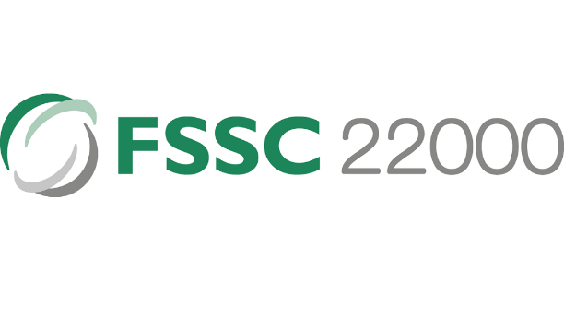

* HALAL Certified Suppliers: Merry Meals can partner with suppliers who have obtained HALAL certification. This certification ensures that the ingredients used in the food production process comply with halal regulations, catering to the dietary needs and preferences of customers who follow halal guidelines.



* + 1. **Project**
* Merry Meals Website Maintenance: The company plans to conduct ongoing maintenance for the Merry Meals website. This maintenance will ensure the website remains functional, up-to-date, and optimized for a seamless user experience.
* SSL Certification: Merry Meals aims to obtain SSL certification for their website. This certification guarantees secure communication between the website and its users by encrypting data transmitted over the internet. It enhances data protection and builds trust among users.
* Daily Backups: Merry Meals will implement a daily backup system for their website. This process will ensure that all website data and information are regularly backed up within a timeframe of 10 hours. It provides an additional layer of data protection and facilitates quick recovery in case of any unforeseen issues or data loss.
* One-Month Range of Work: The project is estimated to be one month, encompassing various stages such as development, testing, and implementation. The timeline allows for adequate planning, resource allocation, and progress monitoring throughout the project.
* Developer-Conducted Testing: The project’s testing phase will be conducted by the developer responsible for the Merry Meals website. This includes thorough testing of different functionalities, user interactions, and performance to ensure that the website meets quality standards and functions as intended.

## **2.6 Project Constraints**

Project constraints refer to the limitations or risks that arise due to limited resources or external requirements. These constraints can be internal, such as budget constraints or skill limitations, or external, such as regulatory requirements or market conditions. Understanding project constraints is crucial for identifying risks and taking appropriate measures to manage them in order to achieve project success.

**FSSAI FOOD LICENSE**

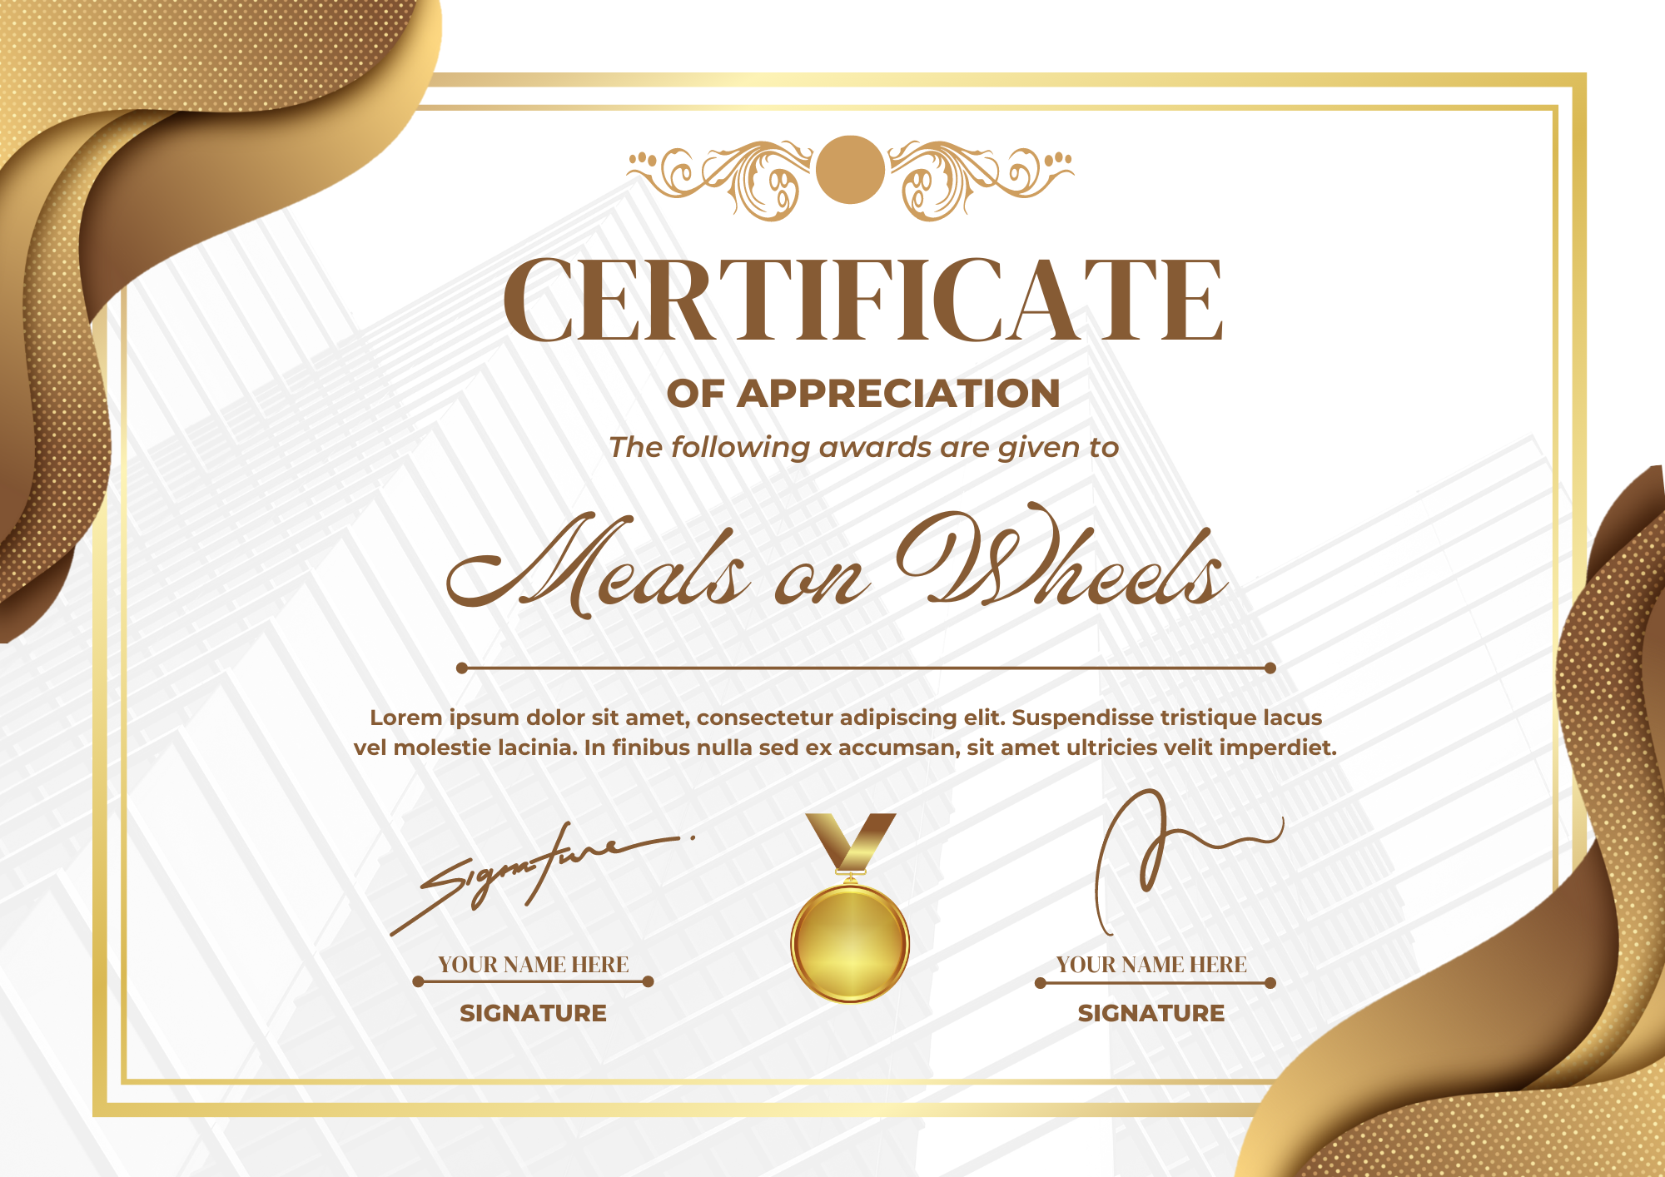

( Figure 1 : FSSAI FOOD LICENSE )

* + 1. **Client**
* Delivery Radius for Hot Meals: Hot meals can only be delivered within a 10 KM radius. This constraint sets a maximum distance for the delivery of hot meals.
* Frost meals can be delivered above a radius 10 KM.

Delivery Radius for Frost Meals: Frost meals can be delivered beyond a 10 KM radius. This constraint establishes a minimum distance for the delivery of frost meals.

* Service Availability Constraint: The delivery service is available daily except for Saturdays and Sundays. This constraint restricts the availability of the service to specific days of the week, potentially affecting delivery schedules and customer expectations.
* Different ages of customers will be considered in developing the Merry on Wheels website to avoid misleading or misunderstanding.
  + 1. **Time**
* The Merry on Wheels website development must be completed within a timeframe of 1 month. This constraint sets a limited time for designing, developing, and launching the website.
  + 1. **Scope**
* Inability to Complete Project Scope in Case of Budget Increase: The previously defined project scope for Merry on Wheels cannot be accomplished if there is a budget increase or costs exceed the initial calculations. This constraint emphasizes that if there is a significant cost increase, certain parts of the project scope may need to be reduced or re-evaluated to maintain a balance between cost and scope.
  + 1. **Cost**
* Cost constraint in a project refers to the limitation on the project budget. It involves managing and controlling project expenses to ensure that the project is completed within the approved budget. Adhering to the cost constraint is crucial for project success and requires careful budget planning, estimation, and monitoring to prevent cost overruns. The project can achieve its desired outcomes by optimizing the use of available resources and maintaining financial feasibility while staying within the defined cost boundaries.
  + 1. **Resources**
* Limitations of Software, Technology, and Hardware: The Merry Meals project faces constraints in terms of software, technology, hardware, and other required resources. This constraint implies that the available resources for the project are limited, whether in terms of quantity, quality, or technological capabilities.
  + 1. **Environment**
* Comfortable Working Conditions for the Development Team: The development team requires a comfortable and supportive working environment to carry out their tasks. This constraint emphasizes the importance of providing adequate facilities and a suitable working environment for the team to work effectively and efficiently.
* Fast Communication Among Team Members and Clients or Other Stakeholders: Team members must communicate quickly and effectively with clients or other relevant parties. This constraint highlights the importance of having an efficient and reliable communication system to ensure smooth information exchange between the team and stakeholders.
  + 1. **Skill**
* The Personnel Skill in Java: Personnel with skills in the Java programming language must meet the project's skill requirements. This constraint emphasizes the importance of ensuring that assigned personnel have the knowledge and skills required for development using the Java programming language.
  + 1. **Man Power**
* Team Proficient Team Members in Java: Team members must possess proficiency in the Java programming language. This constraint emphasizes the importance of team members with a strong understanding and skillset in the Java programming language.

## **Project Milestones**

* + 1. **Requirement gathering**

The Merry Meal project manager will speak with Merry Meal's employees and stakeholders to find out what they envision. The Merry Meal Project must be able to provide free food services to people in need, such as older people or people with disabilities. They can order the food through a website. Then later, there will be several menus on the website that we can choose from with the applicable terms and conditions. To be able to order on the website, the person must first register on the website as a member. After registering, the member can choose the food on the menu list. The admin sends a message to the Partners to prepare hot food if it is under ten kilometers. The partner will prepare cold food if the distance is more than ten kilometers. After that, the admin will choose an available driver to send the food. After that, the driver will pick up the food and send the food to the member. On the website, people can donate their money, people can participate in these activities as volunteers, and choose to be caregivers or drivers. The website must be secure so that it cannot be hacked by hackers and maintain the data security of members, caregivers, partners, volunteers -the website must be secured so that it cannot be hacked by hackers and maintain the data security of members, caregivers, partners, volunteers must be packed safely - food is labeled haram and halal.

* + 1. **Validate expectations for requirements**

Informed of the requirements after the project manager has compiled all of the requested requirements and listed them in a document. Informed of the requirements after the project manager had compiled all the requested needs and listed them in a document.

* + Members and Caregivers registration with their requirements.
  + Partners and Volunteers registration with their details.
  + Fundraising through Donors / Supporters.
  + Menu Planning and Preparation.
  + Meal Delivery Management of partners and riders.
  + Verified that admins can message partners to prepare hot meals if they are less than ten kilometers away, and partners will prepare cold meals if they are more than ten kilometers away.
  + Food is labeled haram and halal.
  + Food Safety Management.
  + website security and data for all users.
  + Reassessment of need evaluation.
  + Management Information System for effective management
    1. **Predevelopment planning**

The project manager will assign each team member their task and duties once the requirements and development plan have been finalized.

|  |  |
| --- | --- |
| Team Member | Task |
| Agung Yuda P. | Manage the Administrator's functions. |
| Muhammad Kemal | Manage the Partner’s functionality |
| M. Reihan Z.A | Manage the Member and Donor functionalities. |
| Rafael Richie S.U | Manage the Caregivers functionality |
| Rocky Ramdhan Setiawan | Manage the Volunteer’s functions. |

* + 1. **Implementation**

The implementation phase marks the beginning of the project's development, building upon the groundwork laid during the predevelopment stage. During this phase, the following activities will be carried out:

* + - 1. Creating a web-based application: The development team will build the web application based on the identified requirements and design specifications. This involves designing and implementing the user interface, system functionalities, and database components necessary to support the application's features.
      2. Registration functions: The implementation will include the development of registration functionalities for various stakeholders, such as members, partners, caregivers, and volunteers. This will enable them to create accounts and provide the required information to participate in the Meals on Wheels program effectively.
      3. Donation processing: The implementation will integrate donation processing features. This functionality will enable donors and supporters to contribute funds to the Merry Meals organization through a secure and user-friendly platform.
      4. Food menu lists: The implementation phase will involve creating a menu planning and preparation system. This functionality will allow the organization to manage and update the menu options available to members, ensuring a diverse and nutritious meal selection.
      5. Food delivery safety: The implementation will include features and protocols to ensure food delivery safety. This may involve incorporating guidelines for handling, packaging, and transporting meals to maintain their quality and adhere to food safety standards.
      6. Management information systems: The implementation will encompass developing a management information system. This system will give the organization valuable insights and data on program performance, member needs reassessment, and overall operational effectiveness.
    1. **Quality Assurance testing**

Quality assurance testing plays a crucial role in ensuring the reliability and effectiveness of the developed product or system. After the implementation phase, the following activities will be carried out to ensure that the product aligns with the specified requirements:

1. Verification: involves a thorough inspection to determine whether the product or deliverables meet predetermined requirements. This includes reviewing functionality, design, and implementation against specified specifications.
2. Validation: The validation process focuses on ensuring that the product or deliverables meet the needs of the end users and align with the desired business objectives. It involves assessing user satisfaction, usability, and the overall alignment of the product with the intended purpose.
3. Functional Testing: Functional testing is performed to verify whether the system or application functions correctly based on the predetermined specifications. It involves executing test cases that cover all the functional requirements, ensuring that each component operates as intended.
4. Non-Functional Testing: Non-functional testing evaluates the system's non-functional aspects, including performance, security, reliability, and scalability. This testing ensures that the system can handle the expected workload, is secure against potential threats, operates reliably, and can accommodate future growth and increased usage.
5. Integration Testing: Integration testing focuses on testing the interactions between different system components or modules to ensure they are properly integrated. It verifies that data and control flow between the parts is seamless and that the integrated system functions as a cohesive unit.
   * 1. **User Acceptance testing**

User Acceptance Testing (UAT) is an essential phase in the project, conducted after completing Quality Assurance testing. During this phase, the individuals involved in the project can test the created website and provide valuable feedback to ensure its alignment with the desired goals and requirements. The primary objective of UAT is to determine whether the website meets the expectations and needs of its intended users.

The participants in the testing process will engage with the website, assessing its various functionalities and features. They will specifically focus on registration pages for members, partners, caregivers, and volunteers, evaluating whether they fulfill the specified requirements. Additionally, they will examine the effectiveness of the donation process and test the security system's functionality to ensure that it operates as intended.

Feedback from the participants will be gathered to identify any areas that require improvement or adjustment. This feedback may encompass usability, user experience, functionality, and any other relevant aspects of the website. By actively involving the project stakeholders and obtaining their feedback, the development team can address any issues or concerns, ensuring that the final product meets the expectations and requirements of the users.

User Acceptance Testing helps validate the website's usability and effectiveness from the end-users perspective. It provides an opportunity to identify gaps or shortcomings and make necessary enhancements before the website is officially launched. By incorporating user feedback, the project team can optimize the website's performance, functionality, and overall user experience, resulting in a final product that meets the expectations of all stakeholders..

* + 1. **Deployment**

The last step is to deploy the website so that it is open to the public when all the earlier processes have been finished and there are no more demands or jobs left undone.

The website is set up during deployment to go live on the chosen server or hosting platform. This includes adding the appropriate files, setting up the necessary options, and ensuring the website is operational and accessible.

To ensure that all features and capabilities are operating correctly in the live environment, conducting a last round of testing is advised before making the website accessible to the general public. This aids in locating any unforeseen problems or discrepancies that might have occurred throughout the deployment procedure.

The website can be officially published and made available to the intended users once the testing phase is through and every aspect is operating as intended. This entails typically tying the website's URL to the domain name so that users of web browsers may access and navigate the site.

Deployment signifies the culmination of the development process, as the website is now ready for users to interact with and fulfill its intended purpose. Monitoring the website's performance and addressing any user feedback or issues that may arise post-deployment is essential to ensure optimal functionality and user satisfaction.

By following a well-planned and executed deployment process, the website can be successfully launched, providing value and meeting the needs of its intended audience.

* + 1. **Support**

During the support phase, after website implementation, Merry Meal's development team will diligently provide ongoing support and maintenance. This includes monitoring the website for bugs and resolving them promptly to ensure smooth operation. They will perform routine maintenance activities, apply necessary updates and patches, and optimize performance. Users will be offered technical assistance, answering their questions and solving problems. Feedback from users will be collected and used for future improvements while staying updated with technological advances to ensure the website remains relevant and user-friendly. The support phase ensures website stability, functionality, and user satisfaction, providing lasting value to the Merry Meal organization and its users.

## **2.8 Project Deliverables**

* + 1. **Internal deliverables**
* Web design proposal and software design document (SSD)
* Web design proposal: a thorough description of the online application for Meals on Wheels suggested design. The visual design, user interface components, and interaction design are all included.
* Software Design Document (SSD): A thorough document detailing the architecture, parts, and design of the Meals on Wheels web application It covers database designs, user interface designs, subsystem designs, and system requirements.
  + 1. **External deliverables**
* Finish Meals on Wheels web application

The website lets people place meal orders, sign up as members, give money, and volunteer their services. It has every feature and capability listed in the project requirements.

* + 1. **Planning deliverables**
* Project Scope

A document defining the boundaries and objectives of the Meals on Wheels project. It outlines the features, functionalities, and constraints of the web application.

* Budget

A financial plan detailing the estimated costs and resources required for developing and implementing the Meals on Wheels web application. It includes development, hosting, maintenance, and other project-related expenses.

* Project schedule

A timeline that outlines the key milestones, tasks, and dependencies for developing and delivering the Meals on Wheels web application. It provides a roadmap for the project's execution and helps track progress.

## **Functional descriptions**

|  |  |  |  |
| --- | --- | --- | --- |
| No | User type | Description | Roles based access |
| 1 | Member | Members are people who need help or support | * Register * Login * Order and view meals * Update profile * Track the Meals |
| 2 | Care giver/Drivers | Merry on Wheels support teams help the members | * Register * Login * See the status of the food made * Processing ordered meals in partners |
| 3 | Partners | Preparing the food | * Register for partnership * Login |
| 4 | Volunteers | Participate in Charity activities in Meals on Wheels. | * Register * Login * View Other member, update profile |
| 5 | Donator / supporter | A person who regularly makes donations in the form of money | * Register * Login * Donate |
| 6 | Administrator | Manage almost the entire running of the website | * Register * Login * Manage donation * Manage member * Manage menu / order * Manage driver * Manage information systems |

## **2.10 Risk Analysis and Evaluation**

Risk is the possibility of an event or condition occurring that may result in a negative impact or loss. Risk involves uncertainty, where the outcome or consequences of an event cannot be predicted with certainty.

* + 1. **Identify possible area of risk in the application development**

a) Data security: Risk of leakage or misuse of customer personal data, such as address, telephone number or financial information.

b) System integration: Risk of difficulty or failure in integrating the application with existing systems at MerryMeal or food service providers.

c) Reliance on third parties: Risk of dependence on third party service providers, such as delivery service providers, which may experience technical problems or service failures.

d) Application performance: Risk of slow or unresponsive application performance when used by users, especially when there is a spike in order traffic.

e) Scalability: The risk of the application being unable to handle the rapid increase in the number of users or orders, especially when entering a new market or when there is a significant increase in demand.

f) Functional errors: The risk of bugs or errors in application functions that may cause harm or inconvenience to the user.

* + - 1. **Internal risk**
* **Technology Risk**

Risks associated with hardware or software failures used in application development, such as server failures, security vulnerabilities, or compatibility issues.

* **Physical Risk**

Risks related to damage or loss of hardware or physical infrastructure used in the development or operation of applications, for example, damage due to natural disasters or criminal acts.

* **Human Factor Risk**

Risks associated with human error in the development, testing or operation of applications, such as programming errors, lack of expertise or unintentional actions that may result in loss or system failure.

* + - 1. **External Risk**
* **Political Risk**

Risks related to changes to government policies or regulations that may affect the operation of the application, for example, changes to data privacy regulations or food delivery regulations.

* **Natural Risk**

Risks associated with natural disasters, such as earthquakes, floods, or hurricanes, may disrupt the physical infrastructure or food delivery services, and may affect the availability or quality of food ingredients.

* **Economic risk**

Risks related to economic fluctuations or market conditions that may affect the sustainability of application operations, such as decreased purchasing power or unstable macroeconomic conditions.

* + 1. **Analyze and Evaluate**

|  |  |  |  |
| --- | --- | --- | --- |
| **No** | **Risk type** | **Risk description** | **Risk Impact** |
| **1** | Technological | Poor quality code and security while developing the app. When the quality and safety of a project does not meet stakeholder expectations, there is a significant risk that the project will fail. | Security flaws can result in data breaches, loss of customer information, leak of customer information or even loss of customer trust. This can damage the reputation of the organization and cause financial losses. |
| **2** | Human Factor | Lack of experience, knowledge, or human error in developing or operating the Meals On Wheels app. | Human error can result in data loss, system instability, or functional errors affecting user experience. This may result in additional costs being incurred to repair or resolve problems caused by the error. |
| **3** | Economic | Changes in market conditions may affect the funding and operational sustainability of the Meals On Wheels application. | An increase in purchases of raw materials due to increased market prices can result in financial difficulties and difficulties in keeping the application operational. |
| **4** | Physical | Damage or loss of hardware, infrastructure, or data centers used in developing or operating the Meals On Wheels application. | Hardware damage or loss can result in system crashes, data loss, or service interruption. This can lead to delays in food delivery, customer inconvenience, or decreased trust in the app. |
| **5** | Natural | Natural disasters such as earthquakes, floods, and hurricahat may disrupt physical infrastructure or food delivery services. | Natural disasters can cause damage to infrastructure, interruption of food delivery services, or decrease in the quality of food ingredients. This can result in delivery delays, inconvenience to customers, or even threaten the safety of drivers, volunteers, partners and even members. |
| **6** | Political | One of the team members' governments banned one of the software or platforms. | If any software or platform used during the development phase is banned, the developer must find an alternative to the banned application and adapt and learn it all over again. This would also cause a significant delay in the project's progress. |

* + 1. **Prepare Risk Matrix**

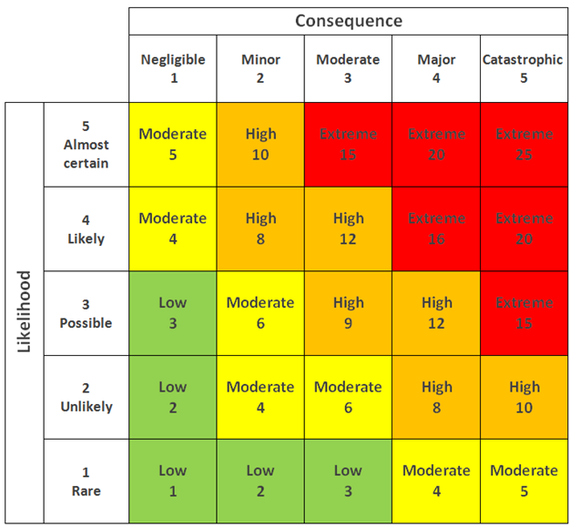

|  |  |  |  |  |  |  |
| --- | --- | --- | --- | --- | --- | --- |
| **No** | **Risk type** | **Risk description** | **Likelihood (1-5)** | **Consequence (1-5)** | **Risk rating** | **Risk level** |
| 1 | Technological | Poor quality code when developing applications. When a project's quality does not meet stakeholder expectations, there is a significant risk of failure. Poor quality code can occur for various reasons, including project underestimation and developers rushing to complete iterations. | 4 | 5 | 20 | Extreme |
| 2 | Physical | Risks related to damage or loss of hardware, infrastructure or data centers used in the development or operation of the Meals On Wheels application | 3 | 4 | 12 | High |
| 3 | Human Factor | Risks related to human error in the development, testing or operation of Meals On Wheels applications, such as programming errors, team communication failures or user errors. | 4 | 3 | 12 | High |
| 4 | Economic | Changes in market conditions may affect the funding and operational sustainability of the Meals On Wheels application. | 3 | 3 | 9 | High |
| 5 | Natural | Natural disasters such as earthquakes, floods, hurricanes that can disrupt physical infrastructure, food delivery services and even cause casualties. | 1 | 5 | 5 | Moderate |
| 6 | Political | One of the team members' governments banned one of the software or platforms. | 1 | 3 | 3 | Low |

### **2.10.4. Risk Response Analysis**

|  |  |  |  |
| --- | --- | --- | --- |
| **No** | **Risk type** | **Risk description** | **Risk Response Plan** |
| **1** | Technological | Technology risks related to technology system failures or vulnerabilities used in Meals On Wheels application development, such as security vulnerabilities, hardware failures, or compatibility issues | Adopt strict security practices and regularly monitor systems to reduce the risk of technology failure or vulnerabilities. |
| **2** | Human Factor | Risks related to human error in the development, testing or operation of Meals On Wheels applications, such as programming errors, team communication failures or user errors. | Provide proper training to the development team and implement rigorous testing procedures to reduce the risk of human error. |
| **3** | Economic | Changes in market conditions that may affect the funding and operational sustainability of the Meals On Wheels application. | Building a flexible financial strategy and forging more partnerships with food providers to address economic risks. |
| **4** | Physical | Risks related to damage or loss of hardware, infrastructure or data centers used in the development or operation of the Meals On Wheels application | Secure physical safeguards such as property insurance and fire suppression systems, and perform regular data backups to reduce the risk of physical damage and data loss. |
| **5** | Natural | natural disaster come that caused a lots damage to the workstation and perhaps loose many human resources. | Create a safe physical workspace for team members to prevent minor disaster yet further to major disaster. Apply job insurance to sateholder’s contract |
| **6** | Political | One of the team members' governments banned one of the software or platforms. | To address a government ban, there are several steps we can take. First, evaluate the reasons behind the ban to understand why it was imposed. It's also a good idea to consult a legal expert to get advice on the best action. We can consider appealing the ban or finding ways to improve compliance with the regulations. Establishing communication with the relevant government authorities is crucial to address concerns and find possible solutions. Lastly, explore alternative options or partnerships that comply with the regulations. |

# **3.0 User and System Requirements**

## User Requirements

|  |  |  |
| --- | --- | --- |
| No. | Feature | Description |
| 1 | Register Member | Members can register their details to become a part of the Meals on Wheels program. |
| 2 | Register Partner | Partners can register their information to collaborate with Meals on Wheels for meal preparation and delivery. |
| 3 | Register Caregiver / Driver | Caregivers or drivers can register their details to assist in meal delivery to the members. |
| 4 | Register Volunteer | Individuals interested in volunteering for Meals on Wheels can register their information. |
| 5 | Login Member | Registered members can log in to access their account and place meal orders. |
| 6 | Login Partner | Registered partners can log in to access their account and receive meal preparation requests. |
| 7 | Login Caregiver / Driver | Registered caregivers or drivers can log in to access their account and view assigned delivery tasks. |
| 8 | Login Volunteer | Registered volunteers can log in to access their account and view volunteer opportunities. |
| 9 | Member order meals | Registered members can log in and place their meal orders for specific days. |
| 10 | Partner receive and cook the meals | Partners can log in, receive meal preparation requests, and cook the meals accordingly. |
| 11 | Driver deliver the meals | Assigned drivers can log in, view delivery tasks, and ensure timely and efficient meal delivery. |
| 12 | Donor donate the money | Donors can contribute funds to support the Meals on Wheels program. |
| 13 | Admin manage member | Administrators can manage member-related information, including registration, profiles, and services. |
| 14 | Admin manage donation | Administrators can manage and track donations received from donors. |
| 15 | Admin manage meals | Administrators can manage meal-related information, including menu planning and nutritional content. |
| 16 | Admin manage order | Administrators can manage member meal orders and track their status. |
| 17 | Admin manage partner | Administrators can manage partner-related information, including registration and collaboration details. |
| 18 | Admin manage caregiver / driver | Administrators can manage caregiver or driver-related information, including registration and assignments. |
| 19 | Login Admin | Administrators can log in to access the administrative panel for overall management and system control. |
| 20 | Admin can accept or reject partner and caregiver | Administrators have the authority to review partner and caregiver registrations and decide whether to accept or reject them. |

## **SDLC (software development life cycle)**

### **3.1 SDLC**

Software applications are developed according to a methodical process called the SDLC (Software Development Life Cycle). It segments the development process into separate stages, each with a unique set of tasks and outputs.

Here's a detailed explanation of how the SDLC typically works:

Requiment gathering : The gathering of stakeholders' needs is the SDLC's first stage. Understanding the software's requirements, goals, and desired functionality is necessary. Project managers, business analysts, and developers collaborate closely with stakeholders to clearly and succinctly articulate the requirements.

System Design: The system design process starts after the requirements have been acquired. During this phase, the development team creates the user interface, database structure, software architecture, and other elements. The objective is to produce a blueprint that describes how the program will be created and how various components will work together.

Implementation: The actual coding and software development happen during this stage. Based on the design criteria, developers use the right programming languages and tools to write code. They adhere to coding standards, best practices, and version control to guarantee code quality, readability, and maintainability.

Testing: The software is tested after the implementation phase to find any flaws or problems and correct them. To verify the software's functionality, performance, and usability, many testing techniques, including unit testing, integration testing, system testing, and user acceptability testing, are used.

Deployment: The software is prepared for deployment after completing the testing phase. The program is installed, set up, and made available to end users in the production environment.

Maintenance: The software then moves into the maintenance phase. Performance, stability, and security of the software are all kept under observation throughout this stage. Users' complaints are addressed, and any necessary changes or improvements are provided. Routine maintenance procedures ensure the longevity and proper performance of the program.

### **3.2 SDLC models**

#### **Waterfall model**

* **What is Waterfall Model?**

The Waterfall method is the earliest SDLC approach used for software development. This method is carried out systematically, starting from the system requirements stage and moving on to the analysis, design, coding, testing/verification, and maintenance stages. Step by step that must be completed one by one.

**Characteristic**

* Sequential and Linear: The development process follows structured and sequential steps.
* Good Documentation: Emphasis on extensive documentation for each phase.
* Limited Customer Engagement: Customer interaction is limited to early and late stages.
* Limited Iteration: Changes can be difficult after the phase is over.
* Predictability and Planning: Enables comprehensive planning based on a clear sequence.
* Suitable for Stable Requirements: Ideal for projects with clear and stable requirements.
* Not Suitable for Complex Projects: Less flexible for projects with complex or changing requirements.
* Verification and Validation: Focus on verification and validation activities in each phase.
* Review and Approval Documented: The review and approval process is important.

**Where do we use it?**

* Requirements are very well documented, clear and fixed.
* Product definition is stable.
* Technology is understood and is not dynamic.
* There are no ambiguous requirements.
* Ample resources with the required expertise are available to support the product.
* The project is short.

**Pros and Cons**

|  |  |
| --- | --- |
| **Pros** | **Cons** |
| 1. Simple and easy to understand and use 2. Easy to manage due to the rigidity of the model. Each phase has specific deliverables and a review process. 3. Phases are processed and completed one at a time. 4. Works well for smaller projects where requirements are very well understood. | 1. No working software is produced until late during the life cycle. 2. High amounts of risk and uncertainty. 3. Not a good model for complex and object-oriented projects. 4. Poor model for long and ongoing projects. |

* **Waterfall Model Structure**

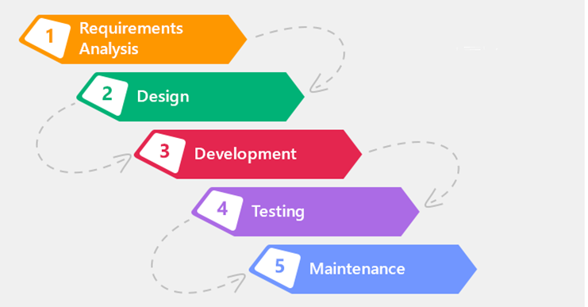

#### **Spiral model**

* **What is the spiral model**

The Spiral Model is a method that can be used in software development. The spiral model is a combination of the prototyping model and the waterfall model. A prototyping model that focuses on presenting or presenting to the user with input and output formats will then evaluate the software. The waterfall model focuses on systematic or sequential software development processes. Spiral pressure model in the risk analysis for each stage.

* **Characteristic**

-Identification: This phase initially involves gathering the business requirements and then identifying system, subsystem, and unit requirements in subsequent spirals. It emphasizes continuous communication between the customer and the system analyst to understand the system requirements. The product is deployed in the identified market at the end of the spiral.

-Design: The Design phase begins with the conceptual design in the baseline spiral and progresses to architectural design, logical design of modules, physical product design, and the final design in subsequent spirals. This phase focuses on developing the design of the software product.

-Construct or Build: The Construct phase involves the production of the actual software product in each spiral. A Proof of Concept (POC) is developed in the baseline spiral to get customer feedback. In subsequent spirals, working models of the software called builds are produced with increasing clarity on requirements and design details. These builds are sent to the customer for feedback.

-Evaluation and Risk Analysis: This phase includes risk analysis, which involves identifying, estimating, and monitoring technical feasibility and management risks such as schedule slippage and cost overrun. After testing the build, the customer evaluates the software and provides feedback at the end of the first iteration.

* **Spiral model structure**

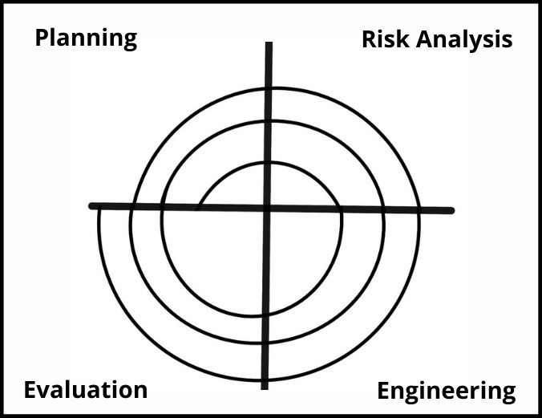

* **When using a spiral model**
* When the creation of a prototype is appropriate.
* When costs and risk evaluation are important.
* For medium to high-risk projects.
* Long-term project commitment is unwise because of potential changes to economic priorities.
* Users are unsure of their needs.
* Requirements are complex.
* New product line.
* Significant changes are expected (research and exploration)

**Pros and Cons**

|  |  |
| --- | --- |
| **Pros** | **Cons** |
| 1. Changing requirements can be accommodated. 2. Allows extensive use of prototypes. 3. Requirements can be captured more accurately. 4. Users see the system early. 5. Development can be divided into smaller parts, and the risky parts can be developed earlier, which helps in better risk management. | 1. It is harder to manage. 2. The project's end may not be recognized right away. 3. It is inappropriate for little-risk or low-risk initiatives and might be costly for modest enterprises. 4. Process is difficult 5. Spiral might continue forever. 6. Numerous intermediary steps necessitate much paperwork. |

#### **V Model**

* **What is V-Model?**

A testing phase is linked to each relevant development step in the V-Model, which is an extension of the waterfall model. This implies that there is a testing phase directly related to every phase of the development cycle. This is a very rigorous strategy, the next phase doesn't begin until the previous phase is finished.

* **Characteristic**
  1. Project and Requirements Planning - Allocate resources: This stage involves planning the project and allocating the resources required for software development. This includes identifying project needs, scheduling, and allocating teams and other resources.
  2. Product Requirements and Specification Analysis - complete specification of the software system: Product requirements analysis is carried out to produce a complete specification of the software system to be developed. This includes determining functional and non-functional requirements and preparing detailed specification documents.
  3. Architecture or High-Level Design - defines how software functions fulfill the design: This stage involves architectural design or high-level design that determines how software functions will fulfill the predefined design. This design provides an overview of the structure and components of the system.
  4. Detailed Design - develop algorithms for each architectural component: At this stage, detailed designs are created for each predefined architectural component. More detailed algorithms and logic are developed for each software component.
  5. Coding - transform algorithms into software: This stage involves implementing software code based on predefined designs and algorithms. The software code is developed according to the relevant programming language.
  6. Unit Testing - check that each module acts as expected: At this stage, the software modules are tested separately to verify that each module functions as expected. This test is carried out at the smallest component level in the software.
  7. Integration and Testing - check that modules interconnect correctly: This stage involves integration testing in which modules that have been tested separately are tested again to verify that they can connect and interact correctly according to the established design.
  8. System and Acceptance Testing - check the entire software system in its environment: At this stage, the software system is thoroughly tested to verify that it functions properly in the intended environment. This test aims to ensure that the system meets the requirements that have been set from the start and can be accepted by users.
  9. Production, Operation, and Maintenance - Provide for enhancement and corrections: This stage involves delivering the software product to the production environment and ensuring smooth operation. This stage also includes software system maintenance, including provision of necessary upgrades and fixes throughout the product life cycle.
* **V model Structure**

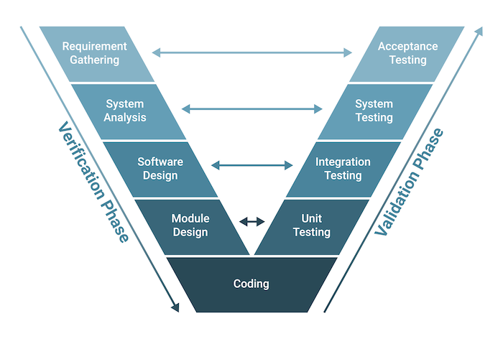

* **When do we use the V model?**
* Excellent choice for systems requiring high reliability – hospital patient control applications.
* All requirements are known up-front.
* When it can be modified to handle changing requirements beyond the analysis phase.
* Solution and technology are known.

**Pros and Cons**

|  |  |
| --- | --- |
| Pros | Cons |
| 1. Emphasize planning for verification and validation. 2. Each deliverable must be testable. 3. Project management can track progress by milestones. 4. Easy to use. | 1. Easily handle concurrent events 2. Handle iterations or phases 3. Easily handle dynamic changes in requirements 4. Contain risk analysis activities requirements |

#### **Agile model**

* **What is the Agile model?**

The Agile model is an incremental software development approach emphasizing flexibility, collaboration, and iterative cycles. It is designed to deliver working software in small increments, with each increment building upon the functionality of the previous one. The Agile model aims to respond quickly to changing requirements and customer feedback, allowing for greater adaptability throughout development.

* **Characteristic**

Key characteristics of the Agile model include:

1. Incremental Development: The software is developed and delivered in small increments or iterations, typically called sprints. Each iteration focuses on specific functionality and is designed to be a complete, usable product.
2. Rapid Cycles: The development process comprises short, time-boxed cycles. These cycles, often from one to four weeks, enable frequent releases and continuous improvement based on customer feedback and changing requirements.
3. Building on Previous Functionality: Each iteration adds new features or enhancements to the existing functionality. The development team aims to deliver a working product at the end of each iteration, ensuring that the software evolves gradually.
4. Thorough Testing: Testing is integral to the Agile model. Each iteration undergoes comprehensive testing to maintain software quality. Testing activities include unit testing, integration testing, and user acceptance testing.
5. Time-Critical Applications: The Agile model is particularly suitable for projects with time-critical requirements or where the business landscape is subject to frequent changes. It allows for quick adaptations, making responding to emerging market needs or technological advancements easier.
6. Extreme Programming (XP): Extreme Programming is one of the methodologies commonly associated with the Agile model. XP emphasizes continuous integration, test-driven development, pair programming, and frequent communication to foster collaboration and deliver high-quality software.

The Agile model promotes an iterative and collaborative approach to software development, ensuring that the final product meets the customer's needs while accommodating changes and improvements throughout the project lifecycle.

* **Agile model structure**

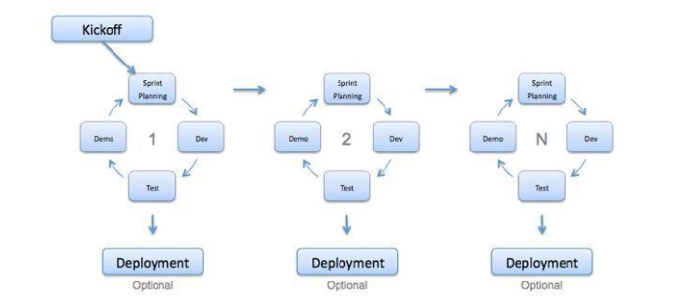

* **When do we use the agile model?**

1. When new changes are needed to be implemented.
2. New changes can be implemented at a minimal cost.
3. Very limited planning is required to get started with the project.
4. Assumes that the end users’ needs are ever-changing in a dynamic
5. business and IT world.
6. Changes can be discussed, and features can be added.
7. This effectively gives customers the finished system they want or need.
8. Get more freedom of time and options.

**Pros and Cons**

|  |  |
| --- | --- |
| **Pros** | **Cons** |
| 1. Implement the simplest solution to today's problem: Agile encourages finding simple and practical solutions to immediate problems rather than over-engineering or overthinking. 2. Customer satisfaction by rapid, continuous delivery of valuable software: Agile focuses on delivering working software in short cycles, enabling frequent customer feedback and ensuring their satisfaction. 3. People and interactions are emphasized rather than process and tools: Agile prioritizes effective communication, collaboration, and teamwork among individuals involved in the project, recognizing their importance over rigid processes or tools. 4. Customers, developers, and testers constantly interact with each other: Agile promotes ongoing interaction and collaboration between the development team, customers, and testers to ensure a shared understanding and alignment of goals. 5. Continuous attention to technical excellence and good design: Agile emphasizes the importance of maintaining technical excellence and incorporating appropriate design principles throughout development. 6. Regular adaptation to changing circumstances: Agile is designed to accommodate changes and adapt to evolving requirements, enabling flexibility and responsiveness. 7. Test-driven development: Agile promotes the practice of writing tests before writing the code, ensuring that the software meets the specified requirements and remains stable during iterative development. 8. Shared code ownership: Agile encourages collective code ownership, fostering collaboration and knowledge sharing among team members. | 1. Difficulty assessing effort for significant deliverables: Estimating effort and timelines can be challenging when dealing with significant deliverables at the beginning of the project. 2. Lack of emphasis on necessary designing and documentation: Agile's focus on iterative development and rapid delivery can sometimes lead to inadequate documentation or a lack of comprehensive design, which may be required for specific projects or organizations. 3. Lack of direction without clear customer representation: Agile heavily relies on customer collaboration and input. If the customer representative is not transparent or available, it can lead to a lack of direction and potential misunderstandings. 4. Decision-making requiring experienced resources: Agile assumes senior programmers or experienced team members can make critical decisions during development. This may limit the involvement or growth opportunities for newer or less experienced programmers. |

### **3.3 SDLC chosen Method – Waterfall methodology**

* **Waterfall Module**

**Front-end Tech**

|  |  |
| --- | --- |
| **HTML** | **Pros:**   * Easy to follow the sequential development process. * Clear documentation can be created for each phase.   **Cons:**   * Limited flexibility for accommodating changes during development. |
| **React JS** | **Pros:**   * Well-defined structure and clear separation of components. * Extensive documentation and community support facilitate the sequential development process.   **Cons:**   * Changes or additions to requirements after the initial phase can be challenging. |
| **VUE js** | **Pros:**   * Clearly defined phases align well with the Waterfall model. * Comprehensive documentation aids in sequential development.   **Cons:**   * Limited flexibility in accommodating changing requirements or iterative development. |
| **Angular Js** | **Pros:**   * Phased development aligns with the Waterfall model. * The well-documented framework supports a systematic approach.   **Cons:**   * Challenging to incorporate changes or feedback once a phase is completed. |

**Back-end Tech.**

|  |  |
| --- | --- |
| Laravel | **Pros:**   * The well-structured framework aligns with the Waterfall model. * Extensive documentation facilitates sequential development.   **Cons:**   * Limited flexibility to accommodate evolving requirements or changes in later stages. |
| Spring Boot | **Pros:**   * Clearly defined phases support the Waterfall model. * Vital documentation and community support aid in sequential development.   **Cons:**   * Challenges arise when accommodating changes or feedback after the initial phase. |
| **Java** | **Pros:**   * Strongly typed language aligns well with the Waterfall model's structured approach. * Extensive documentation and resources support a sequential development process.   **Cons:**   * The rigidity of the Waterfall model may make it challenging to adapt to changing requirements. |

**DATABASE:**

|  |  |
| --- | --- |
| MySQL | **Pros:**   * Well-established and widely used database aligns with the Waterfall model. * A structured approach enables comprehensive planning and documentation.   **Cons:**   * Limited flexibility for accommodating changing database requirements during development. |
| PostgreSQL | **Pros:**   * Clearly defined phases facilitate sequential development. * Comprehensive documentation aids in the Waterfall model's structured approach.   **Cons:**   * Incorporating changes to database requirements after the initial phase can be challenging. |
| SQLite | **Pros:**   * A lightweight and easily integrated database aligns with the Waterfall model's structured approach. * Clear documentation supports sequential development.   **Cons:**   * Limited scalability and flexibility for accommodating evolving database needs. |

**IDE:**

|  |  |
| --- | --- |
| VS code | **Pros:**   * The sequential workflow of the Waterfall model can be quickly followed. * Lightweight IDE facilitates documentation and planning.   **Cons:**   * Occasional crashes or lags may disrupt the sequential development process. |
| INTELLIJ IDE | * **Pros:** * IDE that is comprehensive and enables a systematic approach. * Extensive features and tools aid in sequential development.   **Cons:**   * Higher resource requirements may impact the performance of the Waterfall model. |
| STS | **Pros:**   * Tailored for Spring framework development, aligning with the Waterfall model. * Seamless integration with the Spring ecosystem supports a structured approach.   **Cons:**   * Limited support for other technologies may restrict flexibility in the sequential development process. |

Overall, implementing the Waterfall model with the given technologies can provide a structured and systematic approach to development. The strengths lie in the alignment of the technologies with the sequential nature of the model, comprehensive documentation, and support available. However, the rigidity of the Waterfall model may limit the ability to accommodate changes or evolving requirements, which can be considered a significant drawback in a dynamic and fast-paced development environment.

**Selecting Technologies etc. :**

1. **Front-End Tech: HTML, CSS, JS, React JS, Bootstrap**
2. **Back-end Tech.: Spring Boot**
3. **Database: SQL (MySQL)**
4. **IDEs: VSCode**
5. **Tools: Figma, draw.io, Google document, ERDplus, Axure, Postman.**

### **3.3 Manpower Requirement**

|  |  |
| --- | --- |
| Agung Yuda Pratama | Manage the Administrator's functions. |
| Muhammad Kemal | Manage the Partner’s functionality |
| M. Reihan Zakya A. | Manage the Member and Donor functionalities. |
| Rafael Richie S. A | Manage the Volunteer’s functionality |
| Rocky Ramdhan Setiawan | Manage the Donor’s functions. |

### **3.4 H/w (Hardware) Requirements:**

|  |  |  |  |
| --- | --- | --- | --- |
| No | Hardware | Type | Server |
| 1 | Processor | Intel Xeon Silver 4210 2.2GHz | Intel Core i3 |
| 2 | Memory | 32 GB | 8 GB |
| 3 | Hard Drive | 4 TB | 1 TB |
| 4 | SSD | 2TB NVMe Gen. 4 | SATA |
| 5 | Network | Gigabit Network | Gigabit Network |
| 6 | Monitor | Asus TUF VG328H1B 31.5" | Monitor 24” |
| 7 | PSU | Seasonic Prime Titanium TX-1000 - 1000W 80+ Titanium Certified | Standard PSU |
| 8 | Keyboard & Mouse | USB Mouse Keyboard | USB Mouse Keyboard |
| 10 | Firewall Setting | HTTP | Port 8080 |
| 11 | Firewall Setting | Database | Port 3306 |

### **3.5 S/w (Software) Requirements:**

|  |  |  |
| --- | --- | --- |
| No | Software | Functionality |
| 1 | Windows 10 | Operating System |
| 2 | Bootstrap, CSS, React JS, Spring Boot | Web Creation |
| 3 | MySQL Workbench | Database Server |
| 4 | Apache Tomcat / Apache Maven | Web Server |
| 5 | Axure | Design |
| 6 | Google Chrome, Mozilla Firefox, Microsoft Edge | Web Browser |
| 7 | Github | Version Control |
| 8 | Visual Studio Code, Spring Tools Suite | IDE |
| 9 | JDK 18.0.2.1 | Development Environment |
| 10 | Spring Framework 2.7.13 | Framework |
| 11 | MySQL Server 8.0.31 | Database Server |

### **DB Design: ERD diagram and EERD(Physical diagram)**

**EERD Diagram**

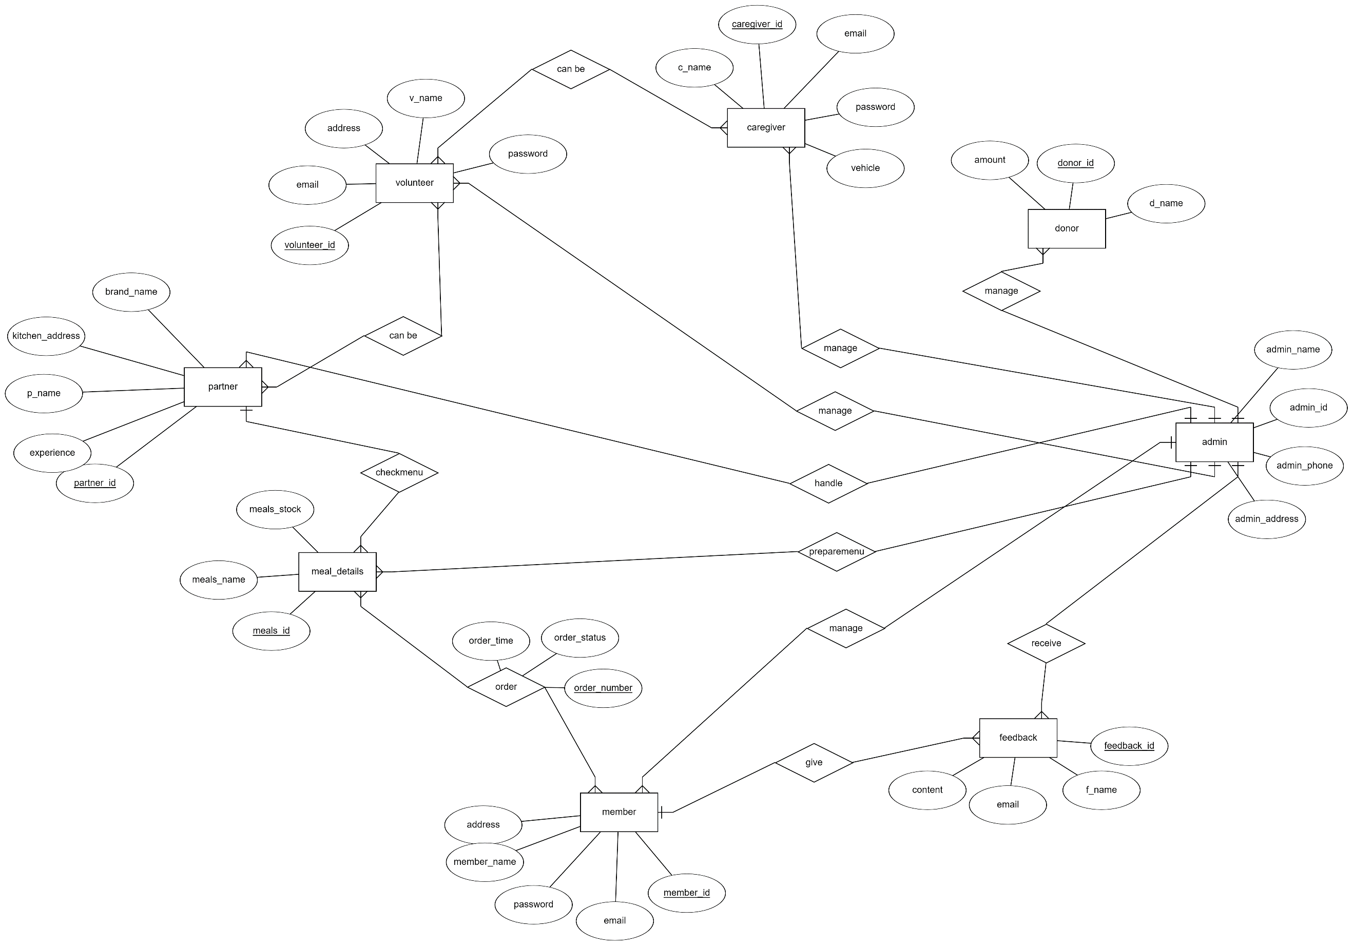

**Physical Diagrram**

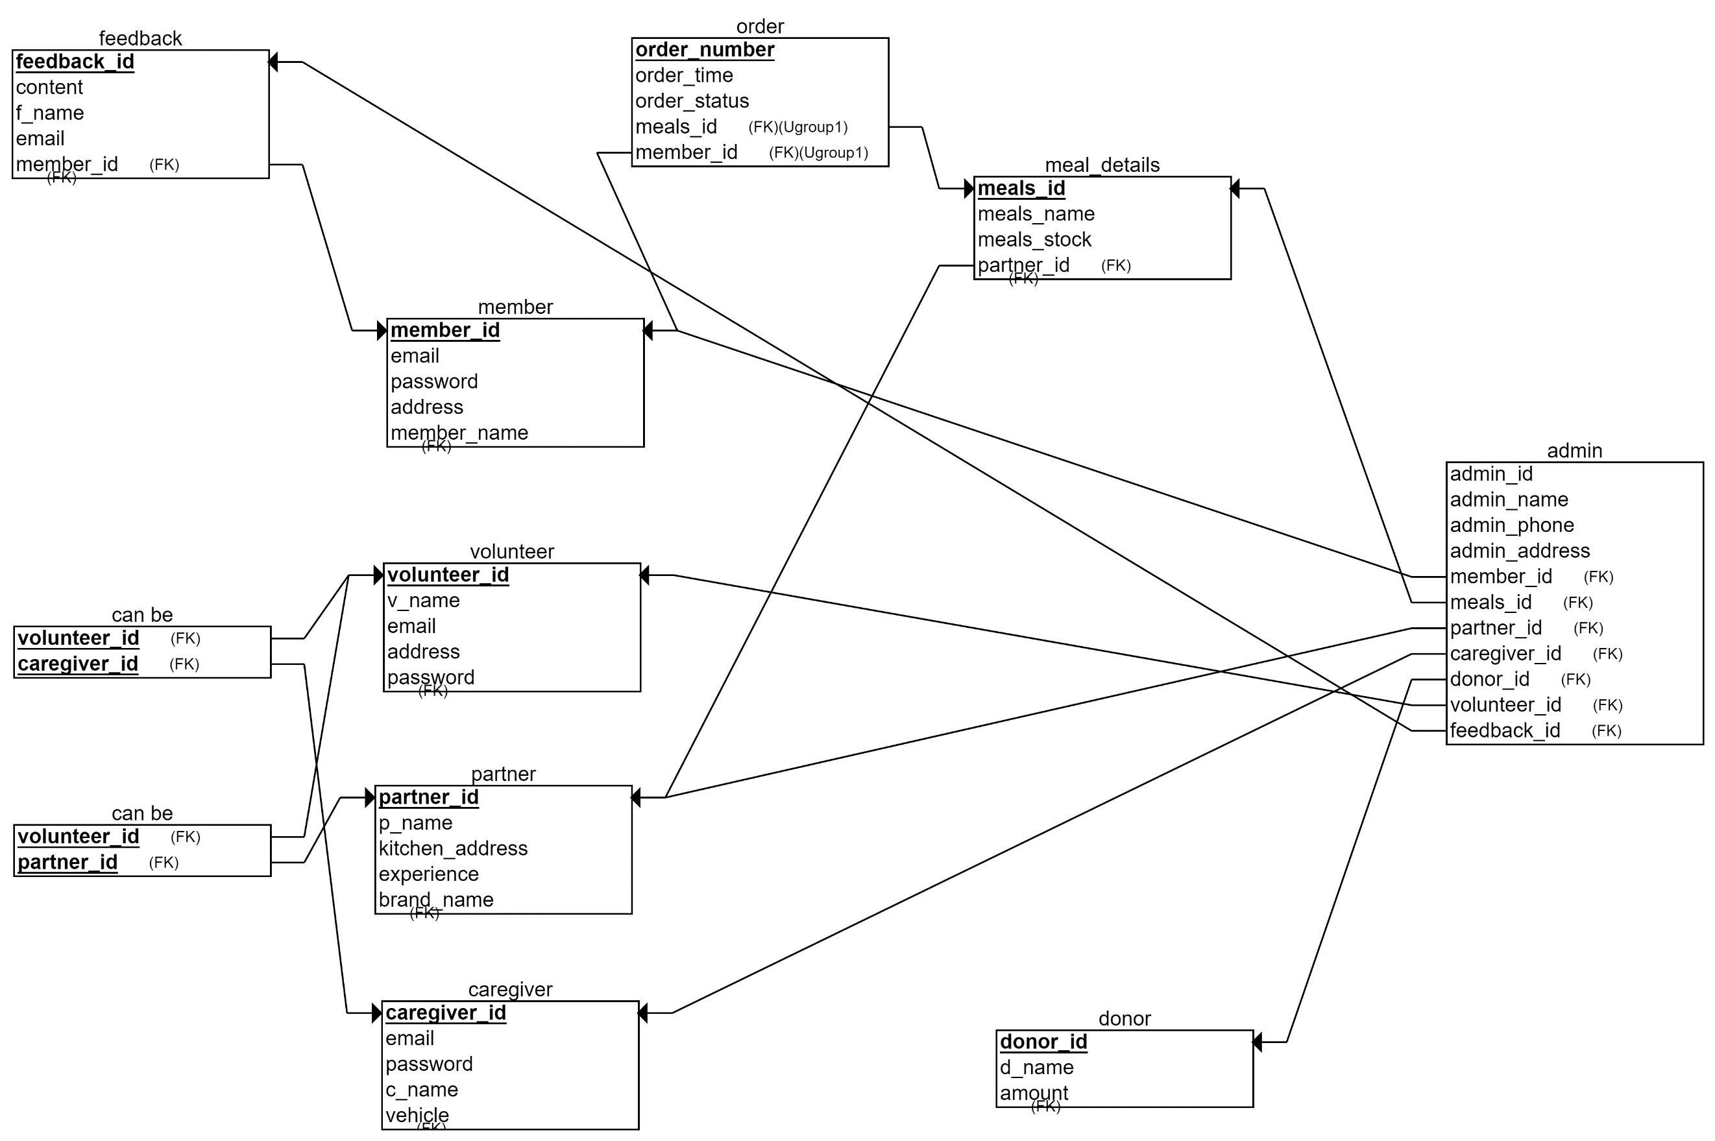

# **4.0 Project Team**

## **4.1 Team member’s information**

|  |  |  |  |
| --- | --- | --- | --- |
| **Partner** | **Learner ID** | **Full Name** | **Group ID** |
| STTB | BDSE-0922-076 | AGUNG YUDA PRATAMA | G04 |
| STTB | BDSE-0922-082 | MOHAMMAD REIHAN ZAKYA ALAWI | G04 |
| STTB | BDSE-0922-084 | MUHAMMAD KEMAL | G04 |
| STTB | BDSE-0922-086 | ROCKY RAMDHAN SETIAWAN | G04 |
| UNPJ | BDSE-0922-031 | RAFAEL RICHIE SOAUDON UDJULAWA | G04 |

## **4.2 Team member’s roles and responsibilities**

|  |  |  |
| --- | --- | --- |
| **Name** | **Module** | **Details Tasks** |
| AGUNG YUDA PRATAMA | Manage the Administrator's functions. | * Develop a login system with role-based access control, allowing only authorized administrators to access the system. * Create a management interface for administrators to manage donations, including viewing and managing donations. * Implement member management functions, enabling administrators to manage member information, registration, and profiles. * Develop menu/order management functions, enabling administrators to create, modify, and delete food choices. * Implement driver management functionality, enabling administrators to assign drivers or riders to delivery tasks. * Create an information system management interface for administrators to manage the entire system effectively. |
| MOHAMMAD REIHAN ZAKYA ALAWI | Manage the Member and Donor functionalities. | * Develop member registration functionality, allowing eligible adults to register as members. * Implement a secure login system for members to access their accounts. * Create views for members to order and view food based on their needs. * Implement the ability for members to update their profiles and track their food delivery. * Develop donation functionality, allowing individuals or organizations to register as donors/supporters. * Implement a login system for donors to access their accounts securely. * Create a view for donors to edit their profiles and send donations to support Meals on Wheels activities. |
| MUHAMMAD KEMAL | Manage the Partners functionality | * Implemented partner registration function, enabling individuals or organizations to register as partners. * Develop a login system for partners to access their accounts securely. * Create a view for partners to view food that has been ordered. * Implement processes to process ordered food according to Meals on Wheels specifications. |
| ROCKY RAMDHAN SETIAWAN | Manage the Volunteers functionality | * Develop volunteer registration functionality, allowing individuals to register as volunteers. * Implement a login system for volunteers to access their accounts securely. * Grant access to their respective roles based on the role they selected during registration (caregiver or rider). * Create a view for volunteer drivers to see their assigned food delivery schedules. * Implement the ability to volunteer as a driver to update delivery status (pick-up, en route, completed). * Develop edit or view profile pages for volunteers to manage their personal information. * Apply the skills of volunteers with kitchens to process ordered food according to Meals on Wheels specifications. |
| RAFAEL RICHIE SOAUDON UDJULAWA | Manage the Caregivers(Rider) functionality | * Implement driver registration functionality, enabling individuals to register as drivers for Meals on Wheels food delivery. * Develop a secure login system for drivers to access their accounts. * Create a view for drivers to see food delivery schedules and set pickup locations. * Implement the ability for drivers to update delivery status (e.g., picked up, on the way, done) for each food delivery. * Integrate a notification system to notify drivers of new delivery assignments or changes to existing deliveries. * Implement features for drivers to view and manage their profile information, including updating contact details or vehicle information. |

## **4.3 Your task**

Manage Administrator Role

1. Understand the business requirements of Meals on Wheels. (First Week)
2. Conduct research and analysis. (First Week)
3. Identify Suitable Development. (First Week)
4. Designing the flowchart of Meals on Wheels. (Second Week)
5. Making Storyboard. (Second Week)
6. Making Usecase Diagram. (Second Week)
7. Making Admin Front End, (Third Week)
8. Backend. (Last Week)
9. Test (Risk). (Last Week)

## **4.4 Tools and Technology**

Front End : HTML, CSS, React JS, Bootstrap

Back End : Spring Boot

DBMS : MySQL Workbench

# **5.0 Project planning**

## **5.0.1 WBS and Gantt chart-group level**

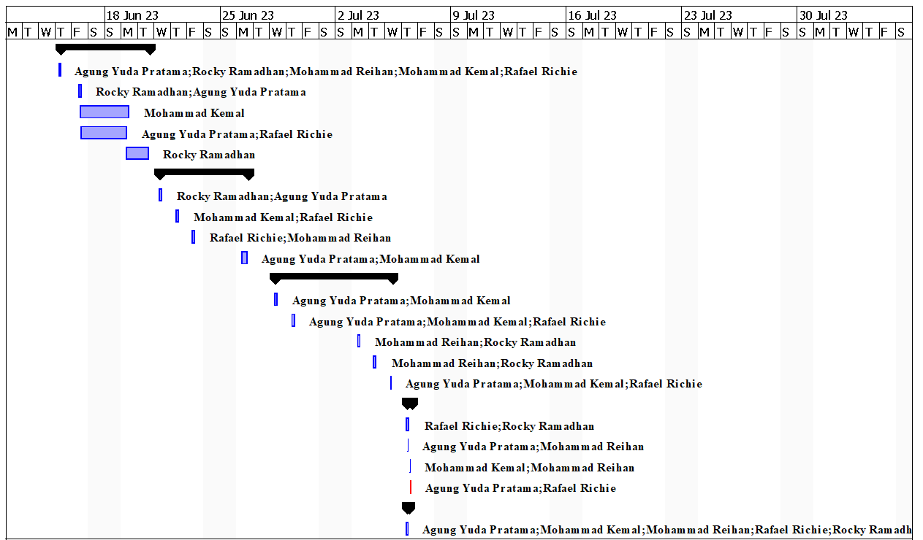

### **Merry O Meal Project Schedule**

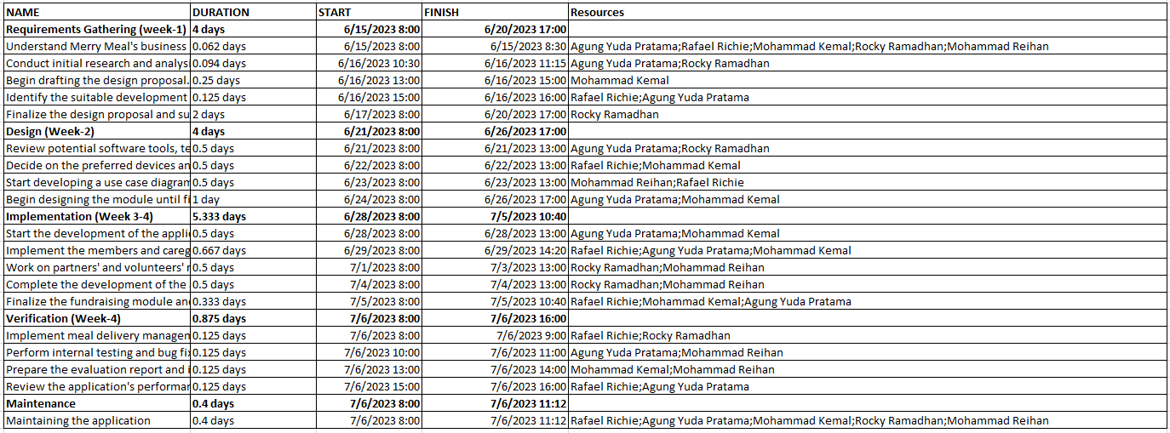

## **Initiation phase:**

1. Business Problem Analysis: The business problem, in this case, is the challenge faced by Meals on Wheels in efficiently providing meals to eligible adults who are unable to cook for themselves due to age, illness, or disability. The project aims to address this problem by designing and creating a software solution that can streamline the operations of Meals on Wheels and enhance their ability to serve their members effectively.
2. Requirement Elicitation and Analysis with Stakeholders: To gather the requirements for the software solution, thorough analysis and discussions need to be conducted with the stakeholders involved in the project. These stakeholders include members, caregivers, partners, volunteers, donors/supporters, and administrators. The requirements should cover member registration, caregiver support, partner collaboration, volunteer management, donation handling, menu planning, meal delivery management, food safety, need assessment, and management information system.
3. Feasibility Study: A feasibility study is necessary to assess the viability and potential success of the proposed software solution. It involves evaluating various factors, including technical feasibility, operational feasibility, economic feasibility, and legal compliance. Technical feasibility assesses whether the required hardware, software, and network infrastructure are available and compatible. Operational feasibility examines how well the proposed system aligns with the organization's needs and processes. Economic feasibility analyzes the costs and benefits of the project. Legal compliance ensures that the system adheres to relevant laws and regulations.
4. Framed SRS (Software Requirements Specification): A Software Requirements Specification (SRS) document should be created based on the requirements gathered and the feasibility study. The SRS outlines the detailed functional and non-functional requirements of the software solution. It serves as a reference for the development team and ensures that everyone involved clearly understands what needs to be implemented.
5. Devised Project Aim, Objective, and Scope: The project aims to design and create a software solution that enables Meals on Wheels to effectively manage their meal delivery operations and serve their members' needs. The objectives include analyzing business requirements, developing an appropriate software solution, implementing the application, evaluating its performance, and identifying areas for improvement. The project scope encompasses member and caregiver registration, partner and volunteer management, fundraising, menu planning, meal delivery management, food safety, need assessment, and a management information system.
6. Enlisted Stakeholders: The stakeholders involved in the project include the sponsor of the Merry on Wheels application, Mr David (Project Manager of Unity One Solution), members of the Merry Meals charity organization, and Merry Meals project team members. These stakeholders will play a crucial role in providing input, making decisions, and ensuring the successful completion of the project.
7. Framed Milestones Plan: A milestones plan should be developed to manage the project effectively. This plan outlines the project's major milestones, deliverables, and timelines. It helps track progress, allocate resources, and ensure the project stays on schedule. The milestones plan should be aligned with the project objectives and consider the dependencies and critical path of the project activities.
8. Risk Analysis: A comprehensive risk analysis should be conducted to identify potential risks and develop mitigation strategies. Risks could include technical challenges, resource constraints, changes in requirements, stakeholder conflicts, or external factors that may impact the project's success. By proactively identifying and addressing risks, the project team can minimize their impact and increase the chances of a successful outcome.

## **Planning:**

1. Design Plan
   1. Fflowchart

**Admin Flowchart**

**Admin Login**

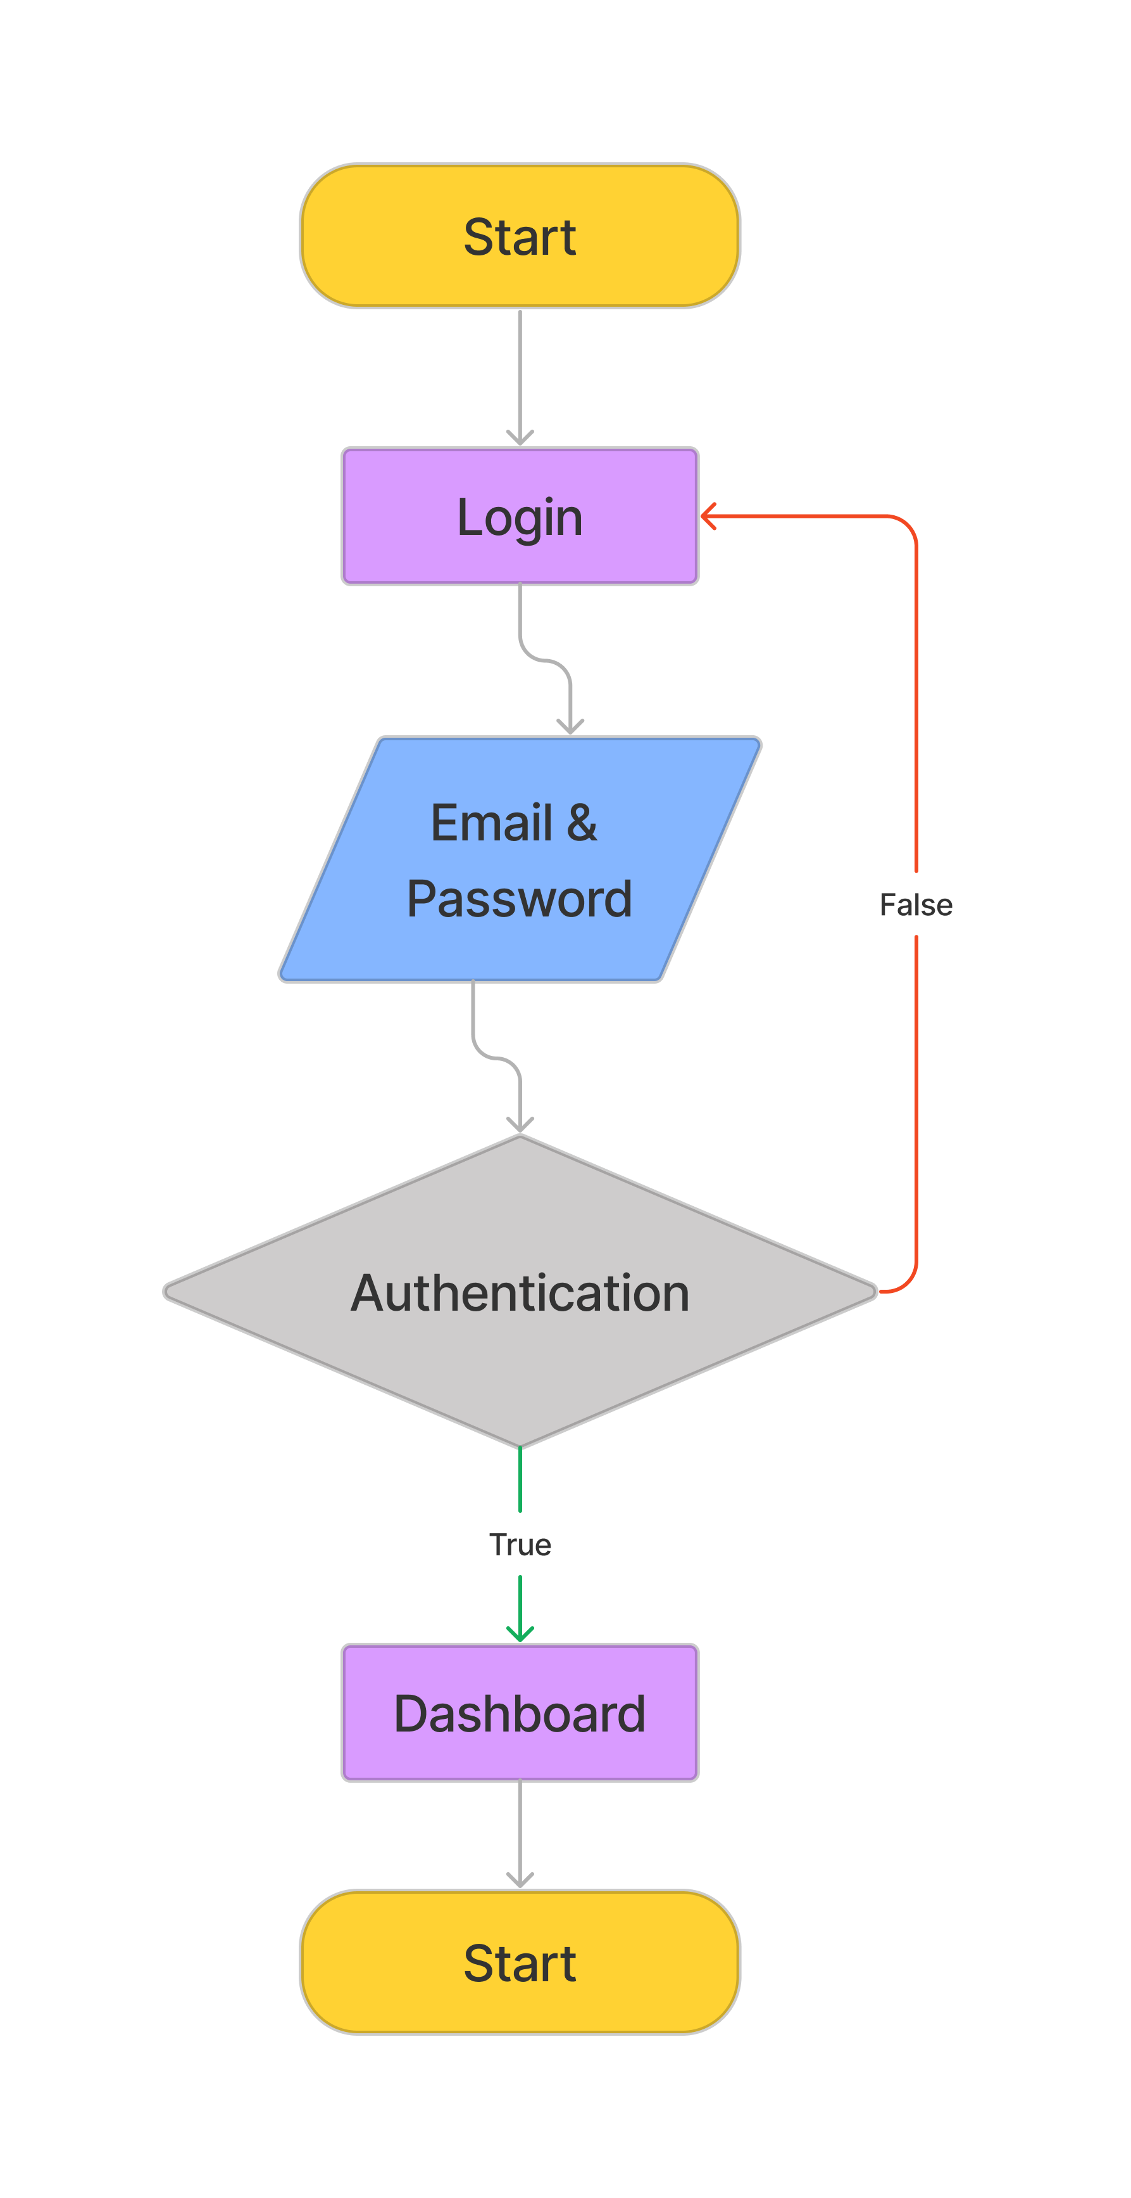

* + - * **Admin Manage Order**

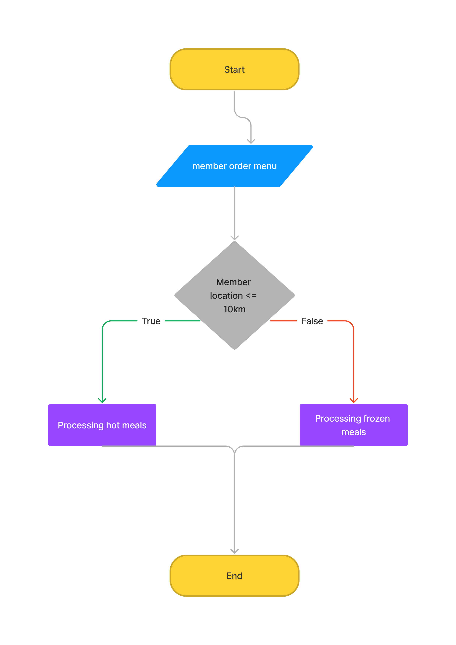

* + - * **Admin CRUD Manage user, driver and meals**

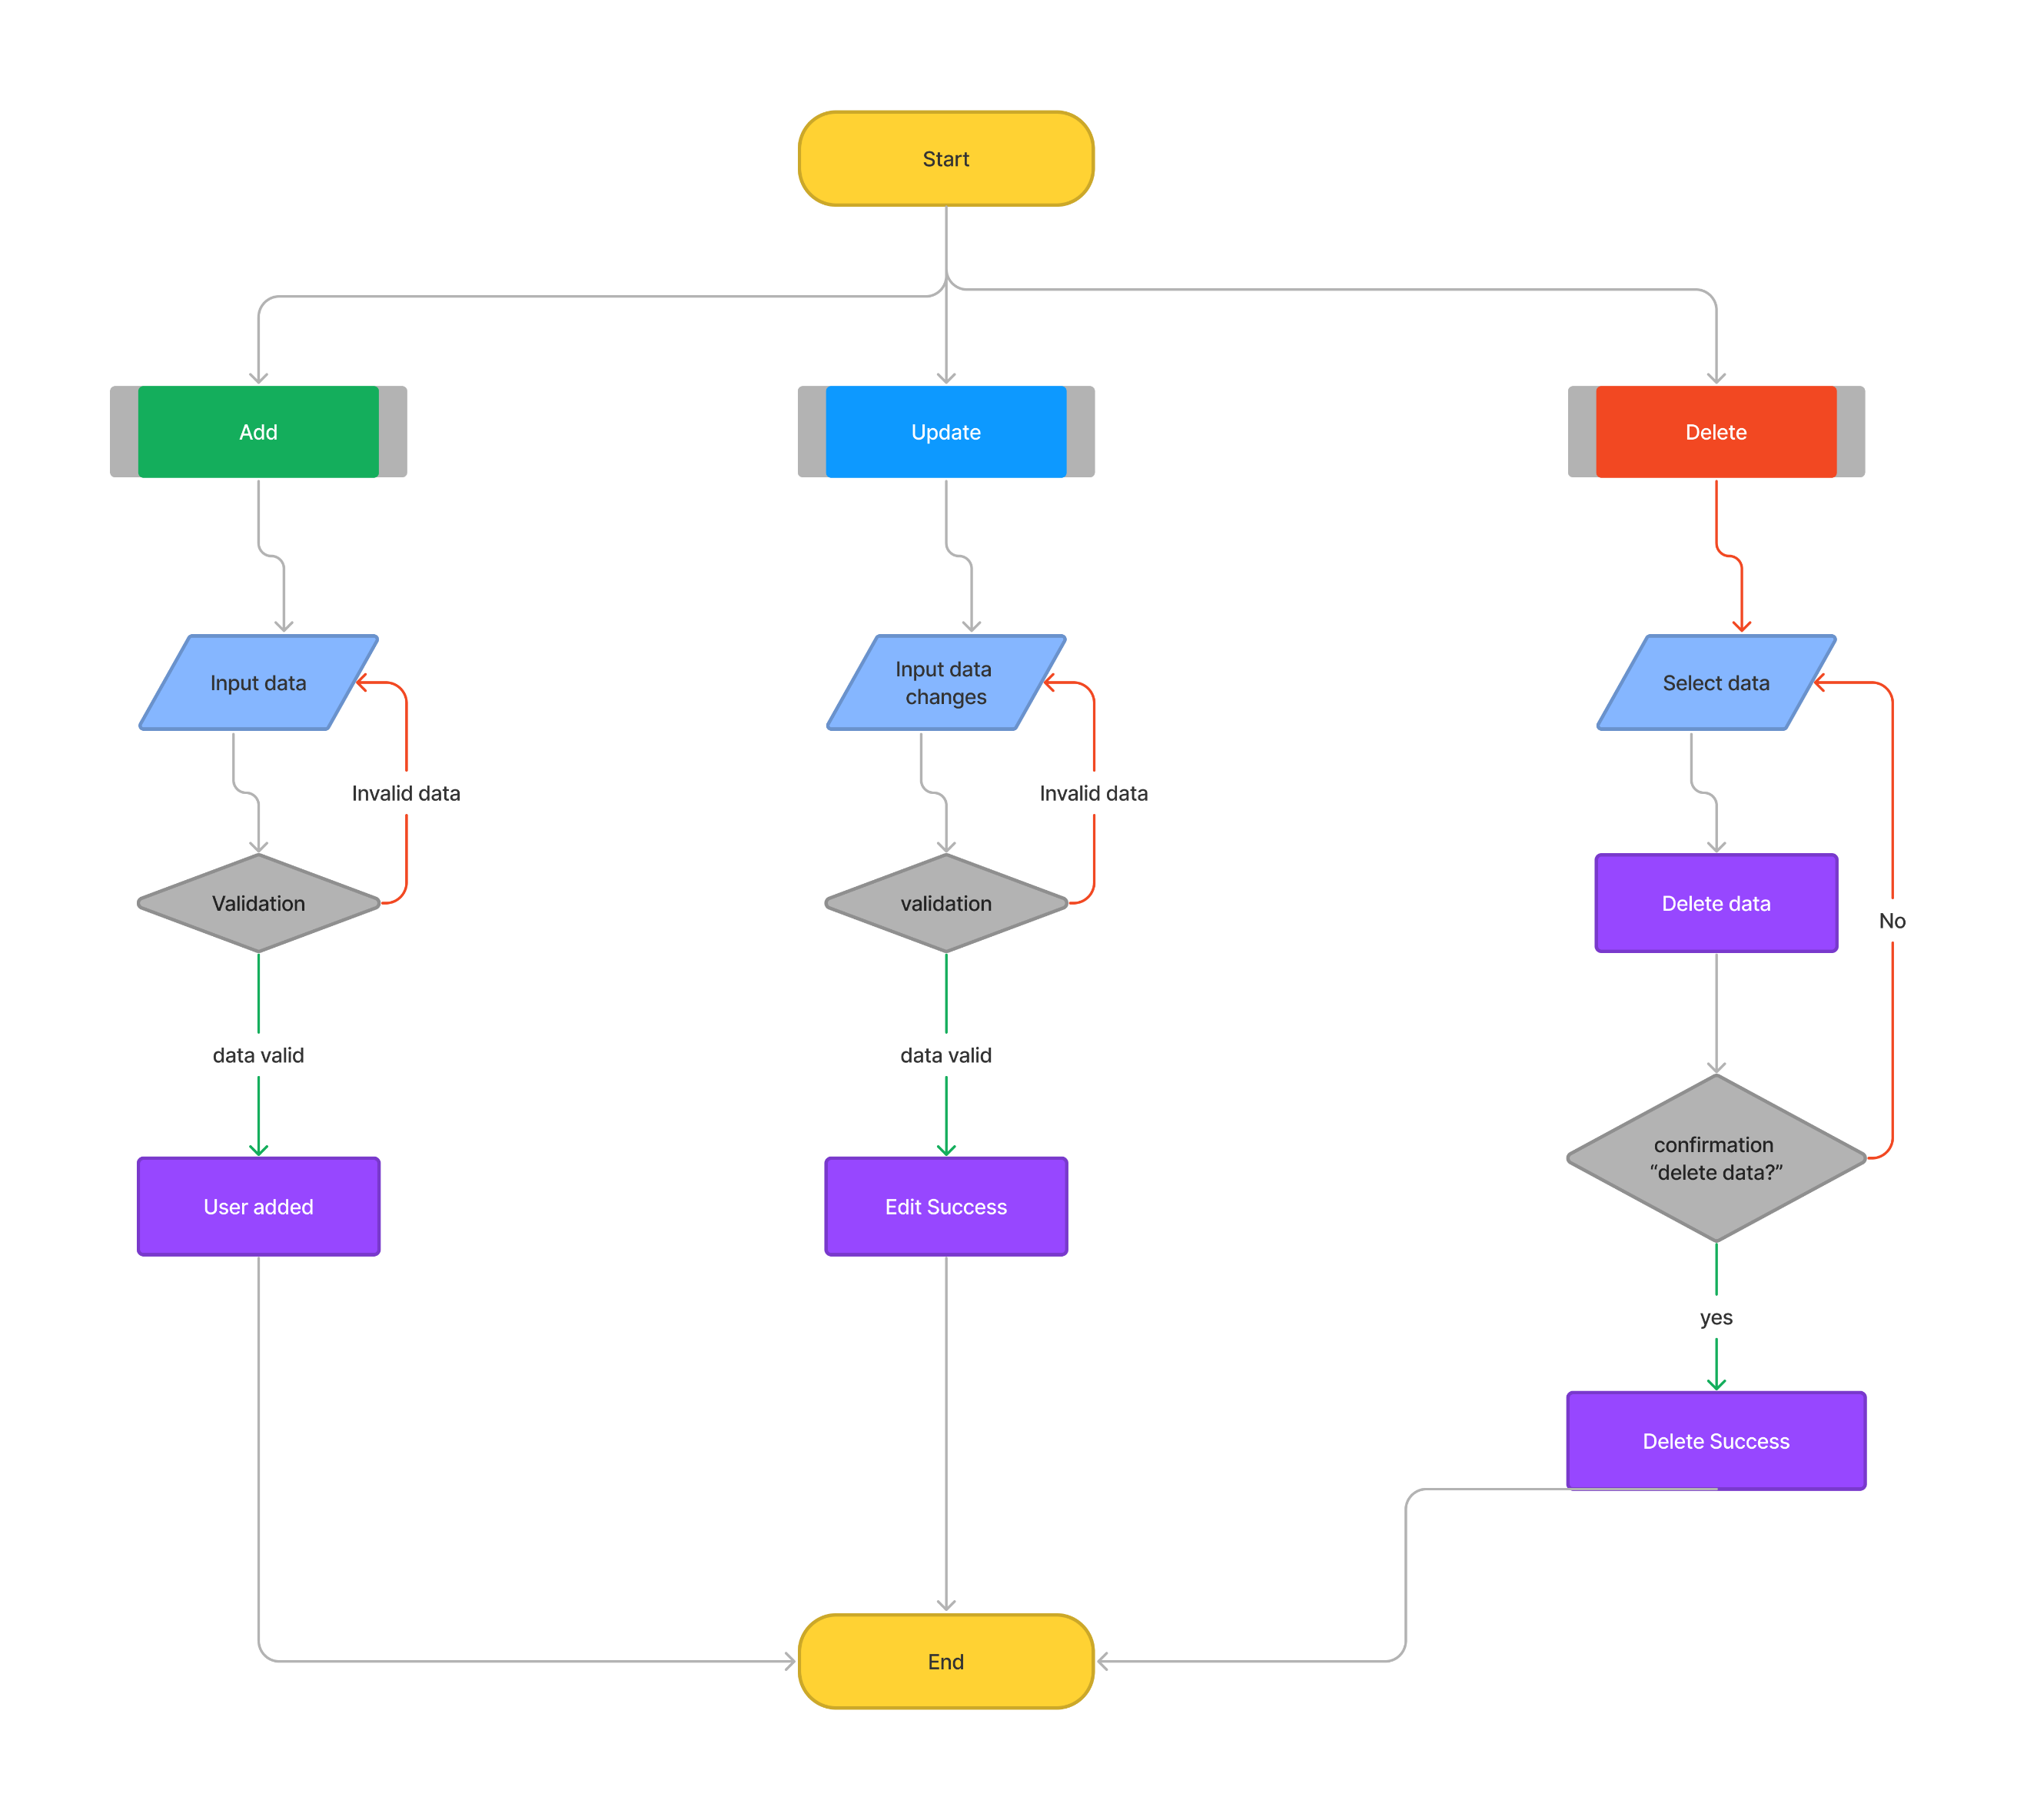

* + - * **Admin feedback & donation history**

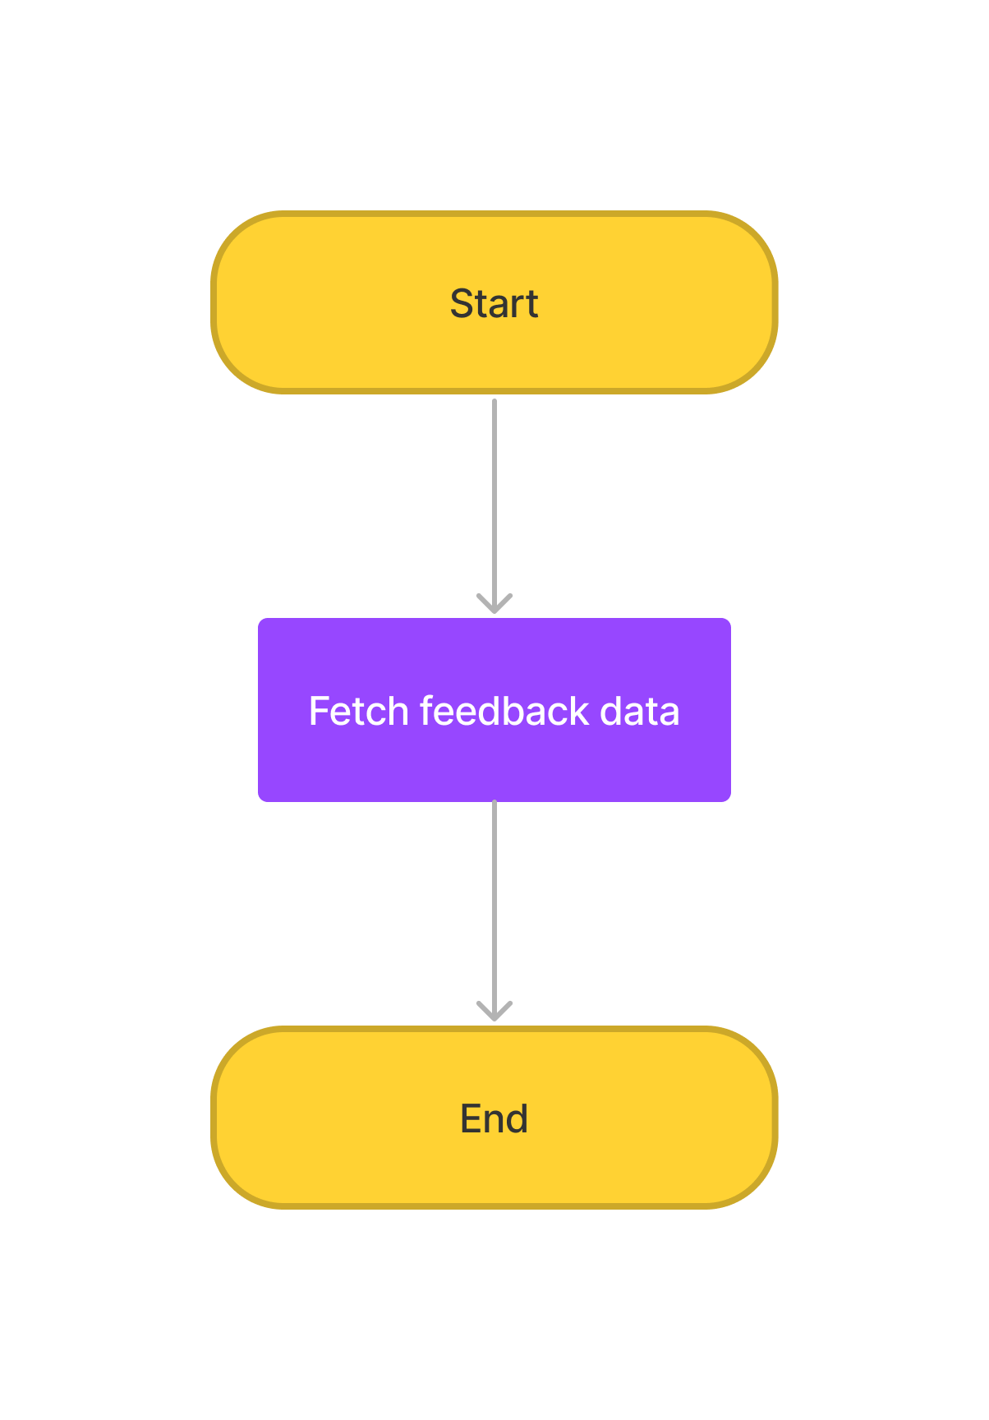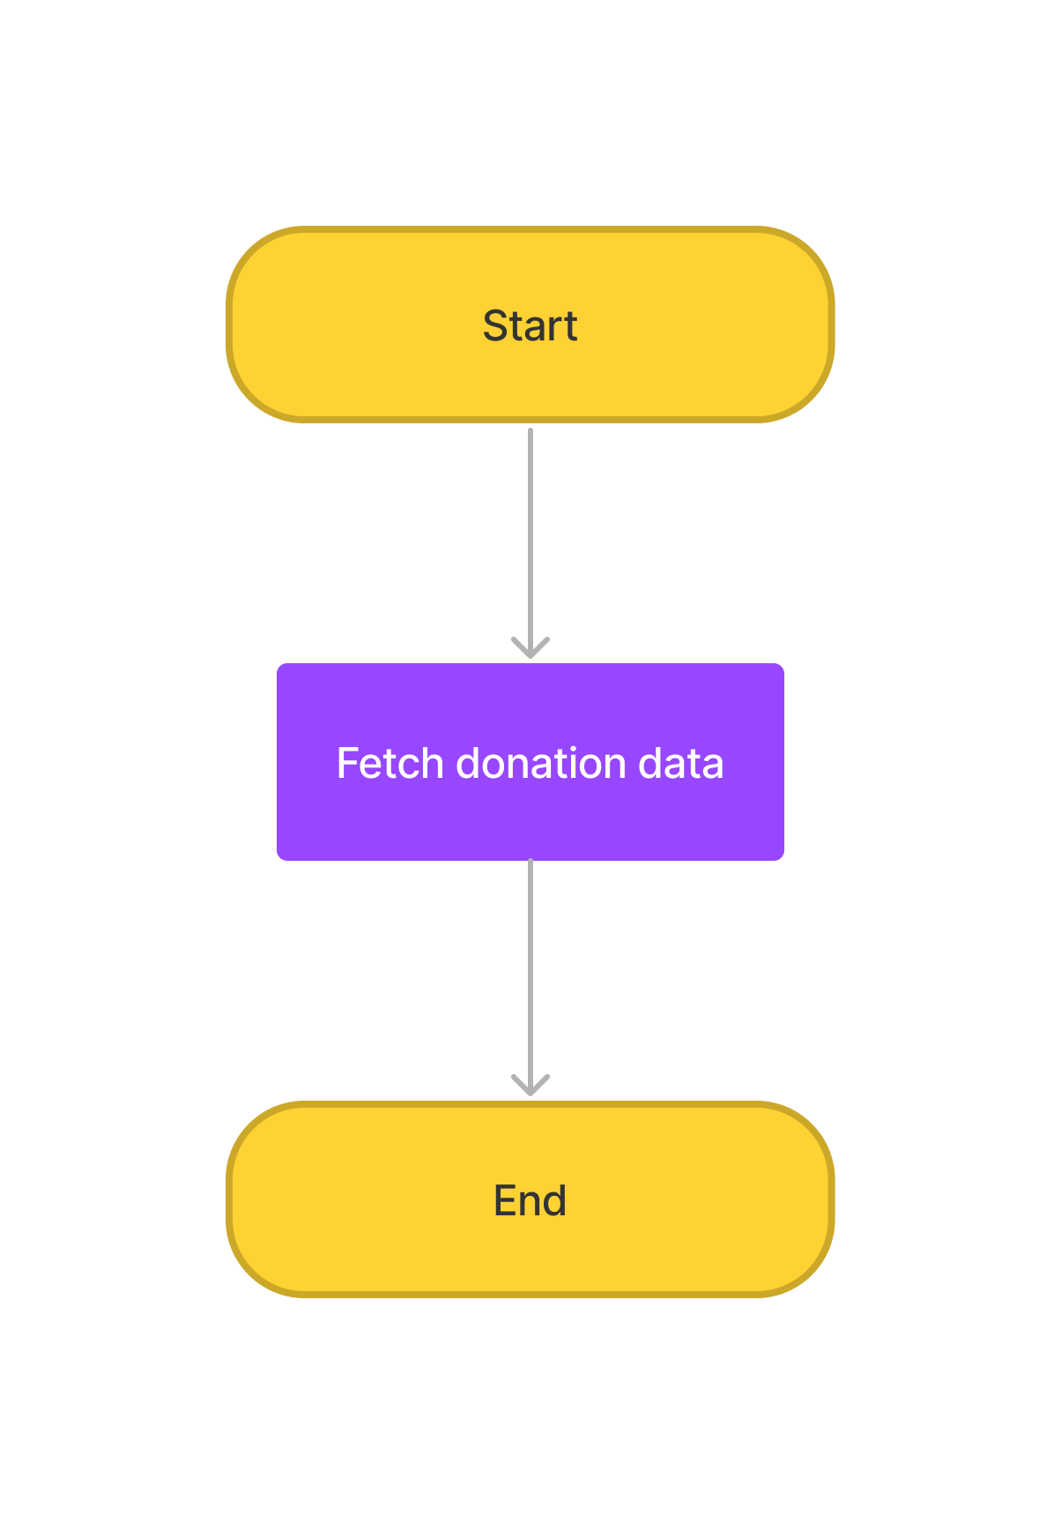

* + - **Volunteer Flowchart**
      * **Volunteer registration**

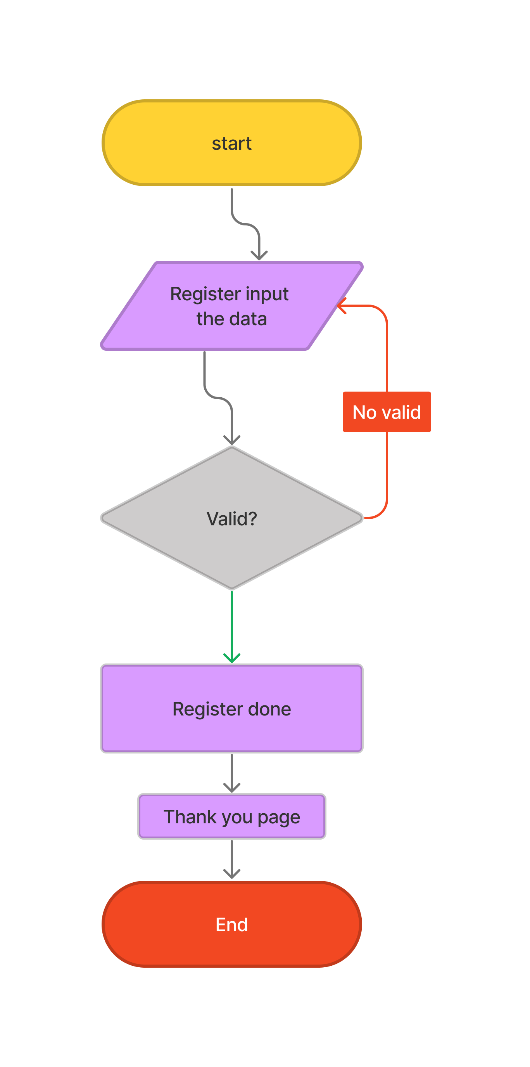

* + - * **Volunteer login**

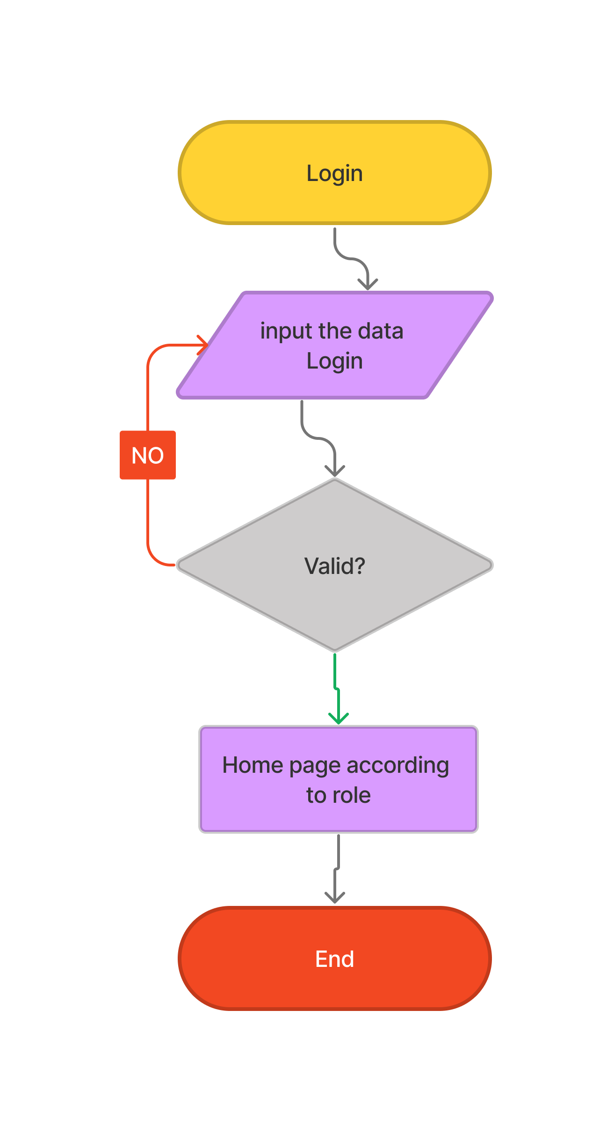

* + - **Driver Flowchart**

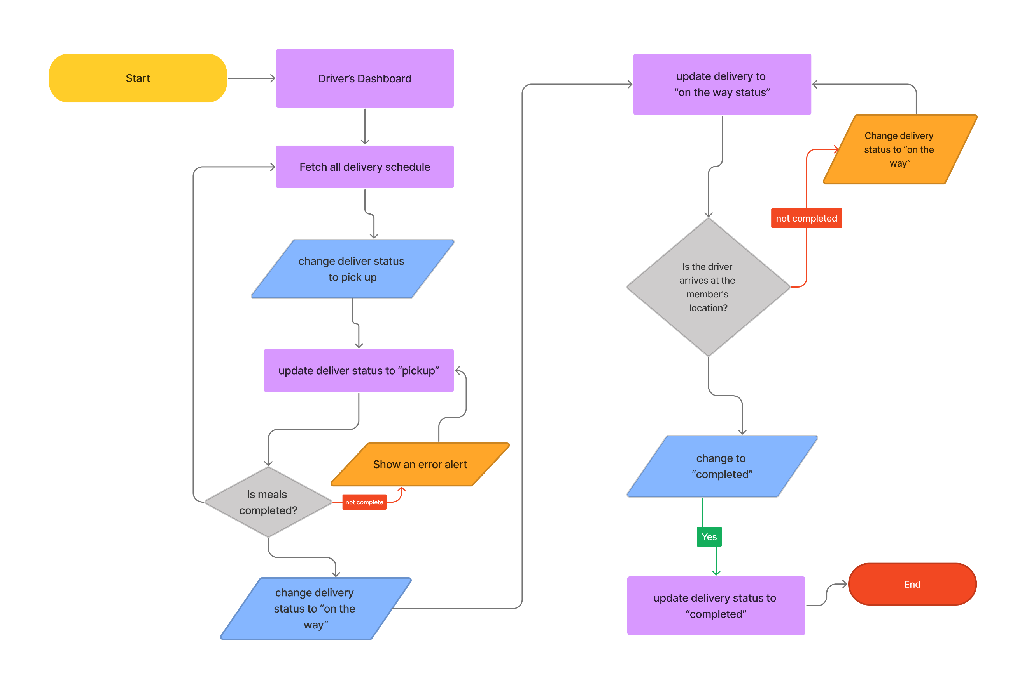

* + - **Partner Flowchart**

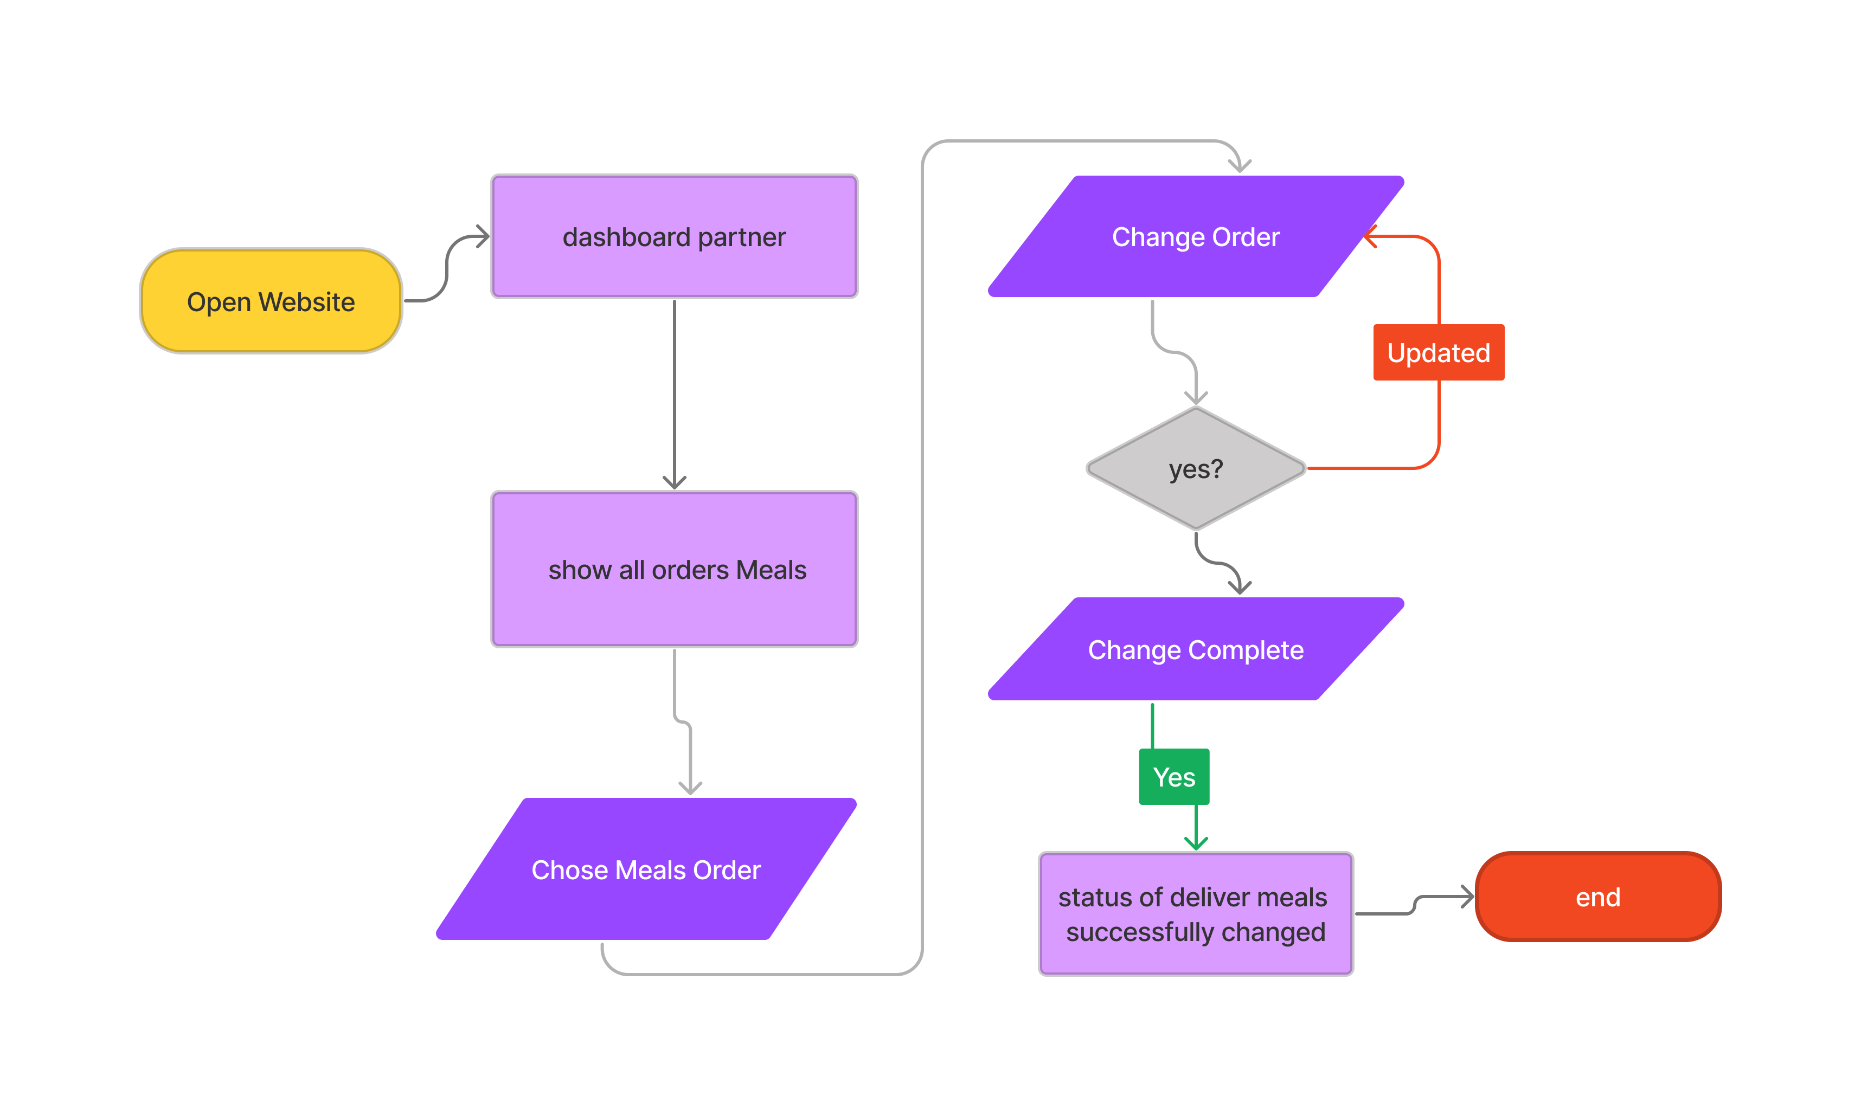

* + - **Member Flowchart**
      * **Member Registration**

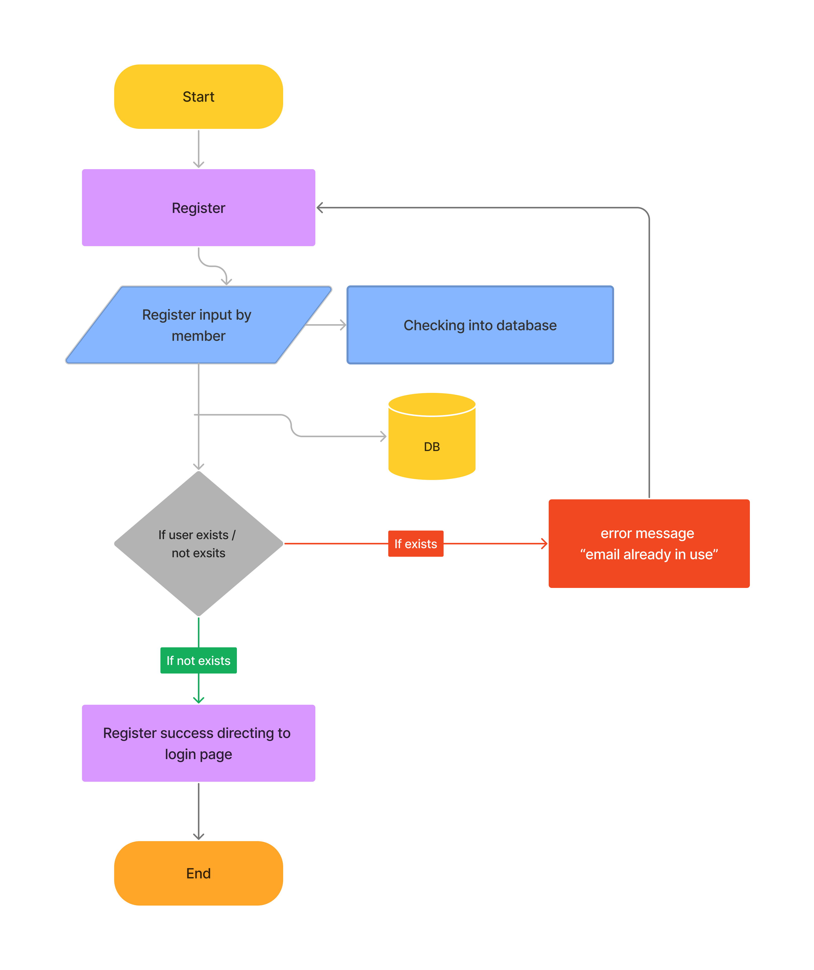

* + - * **Member Login**

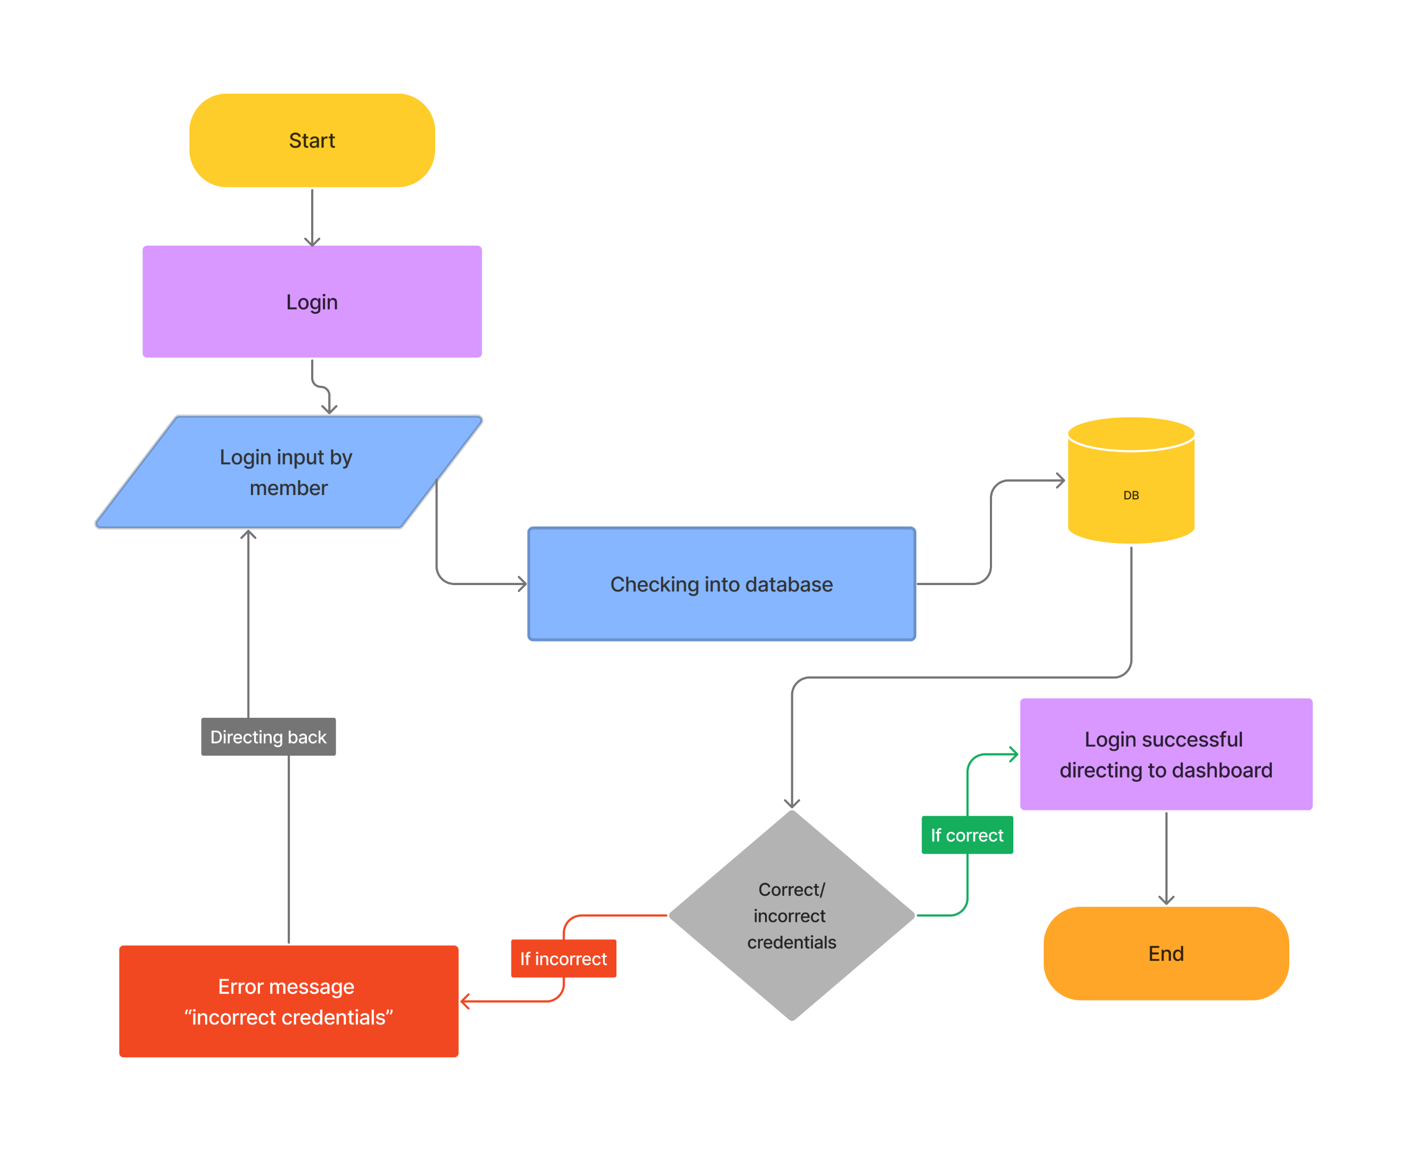

* + - * **Member Order**

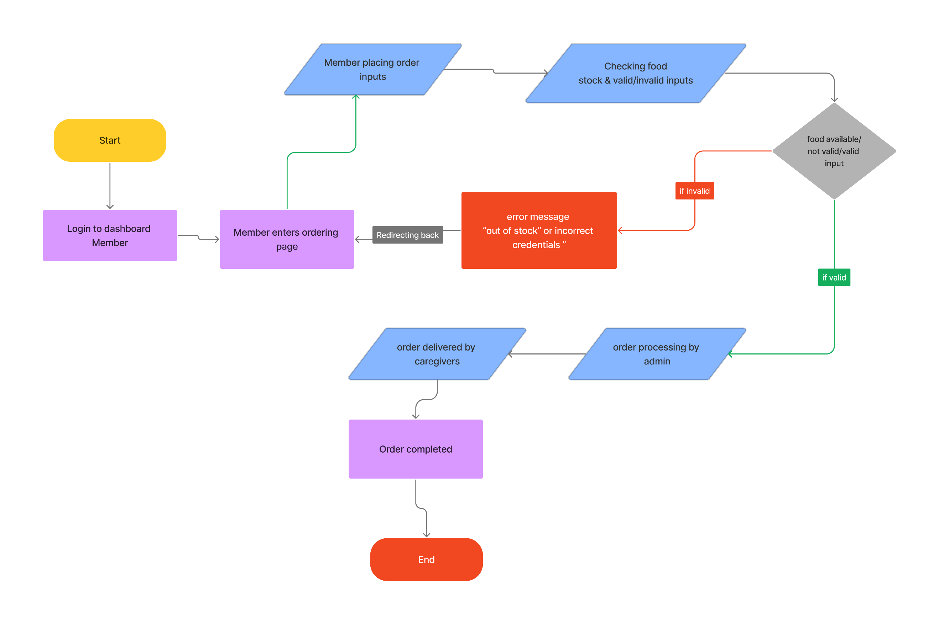

* 1. Use Case Diagram

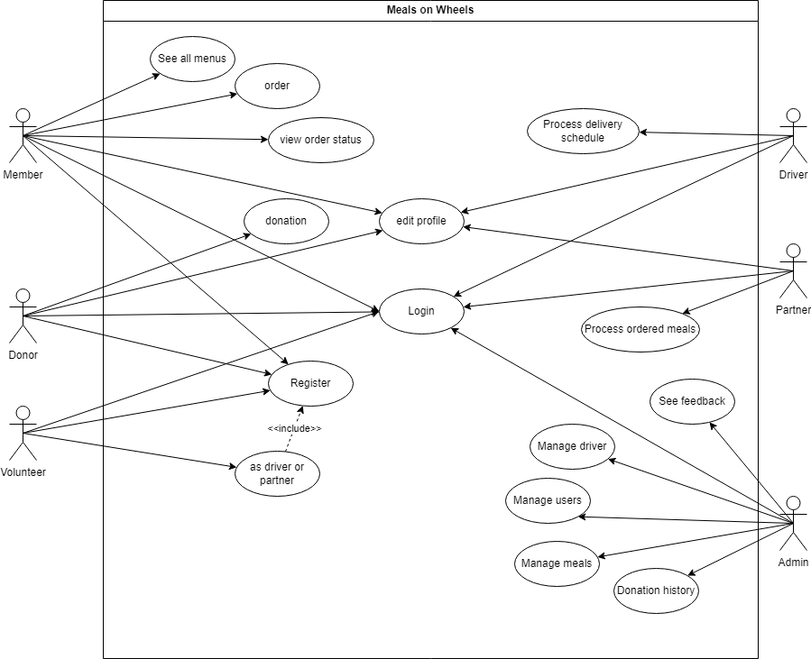

* 1. Storyboard

Admin Storboard

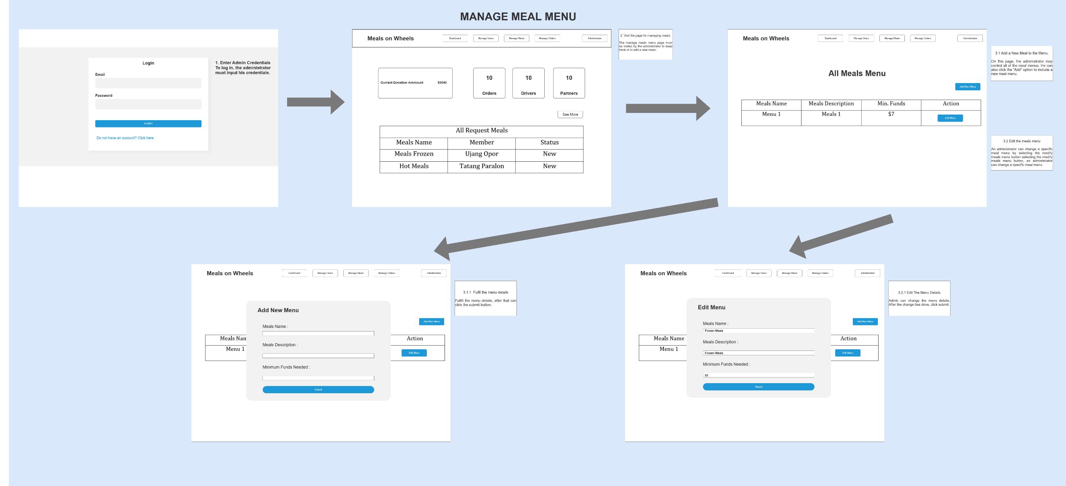

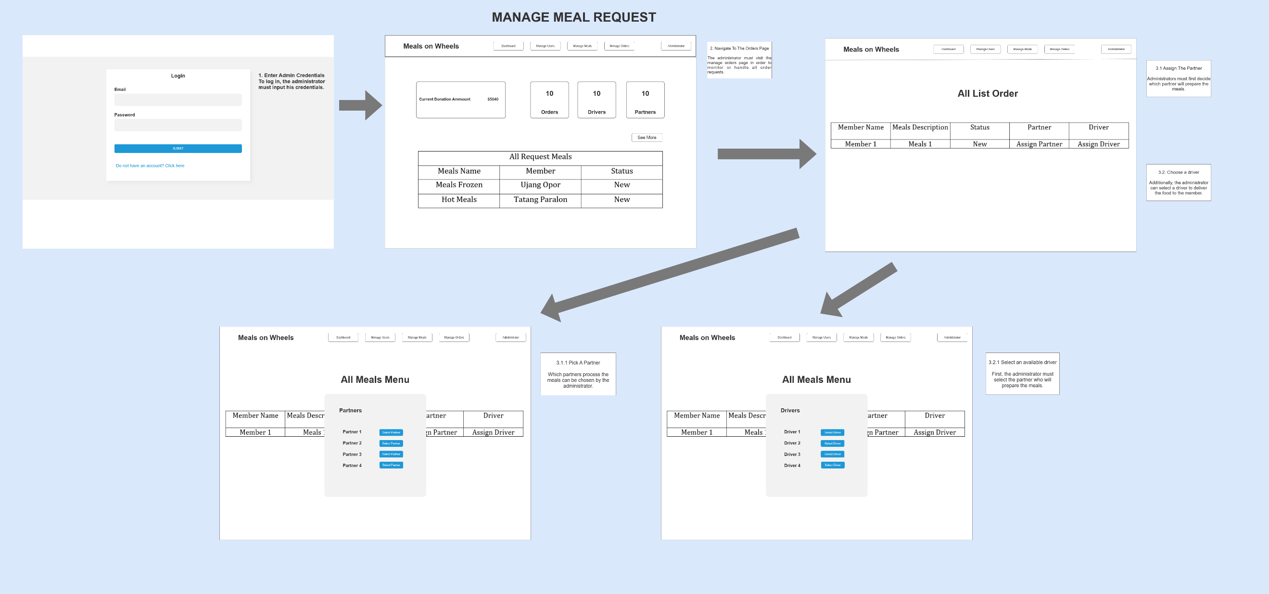

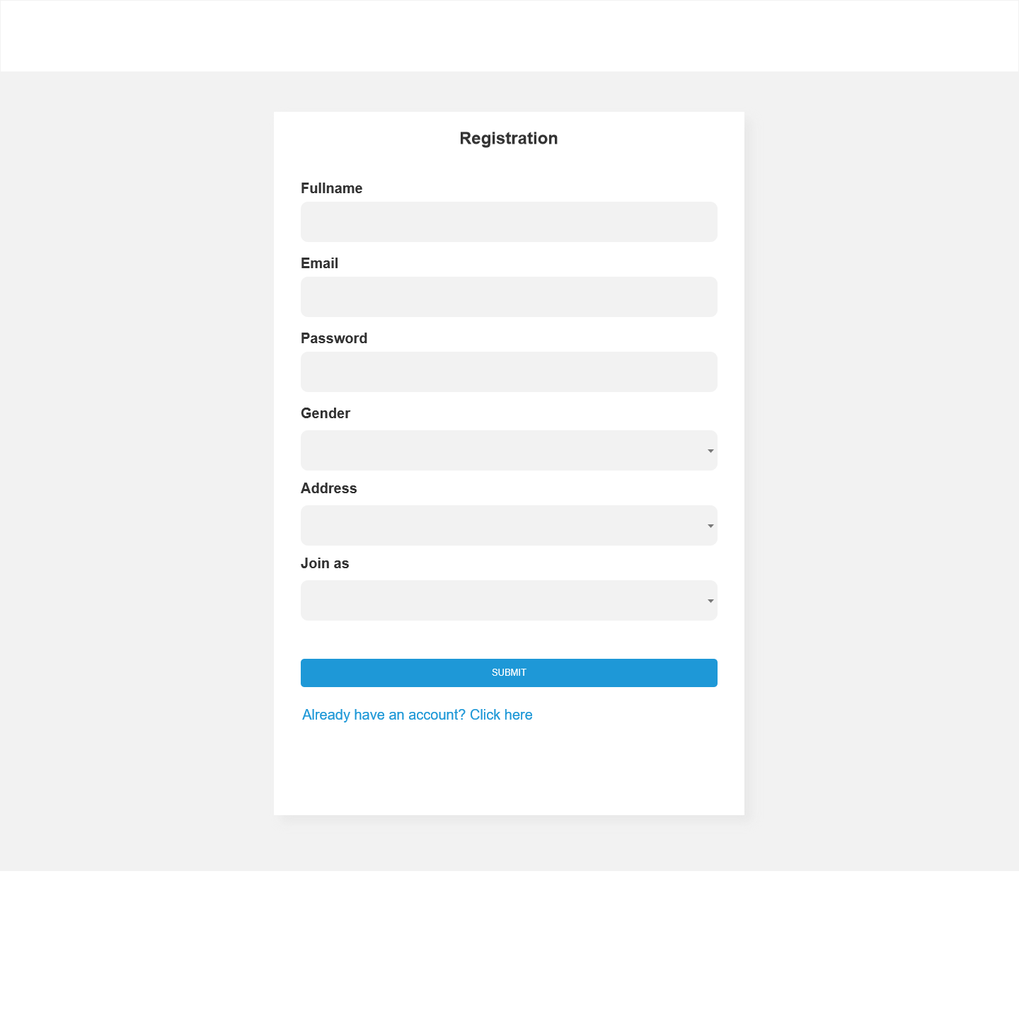**Member**

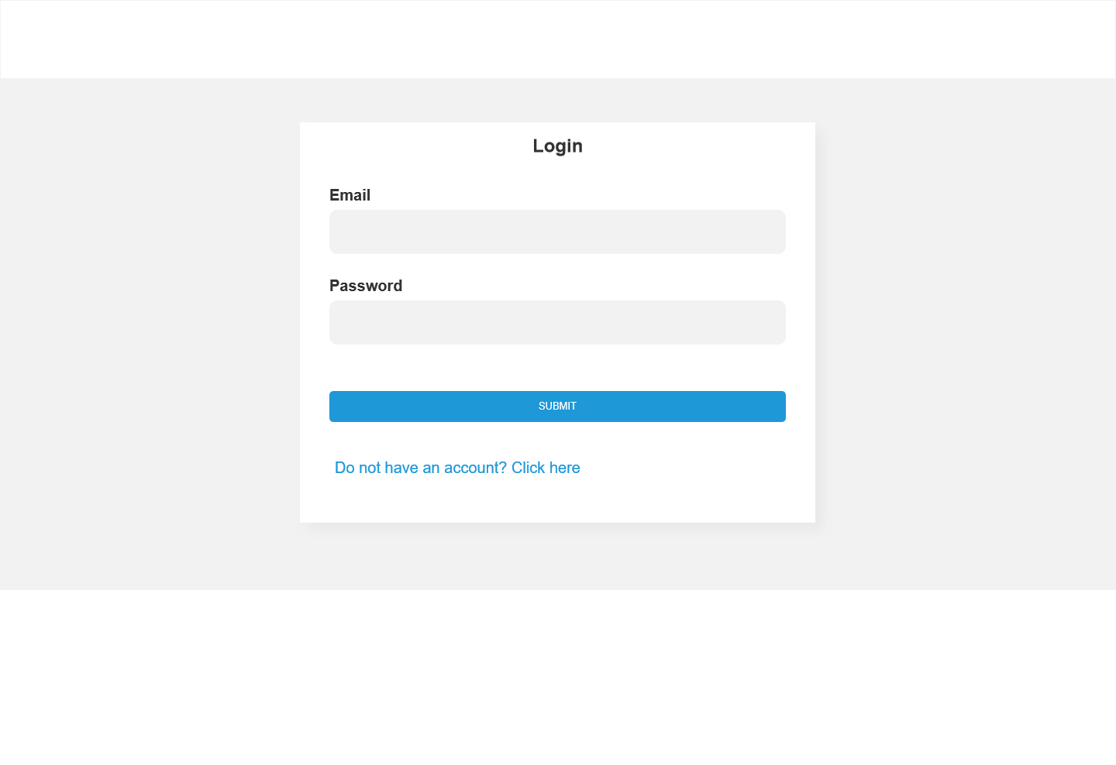

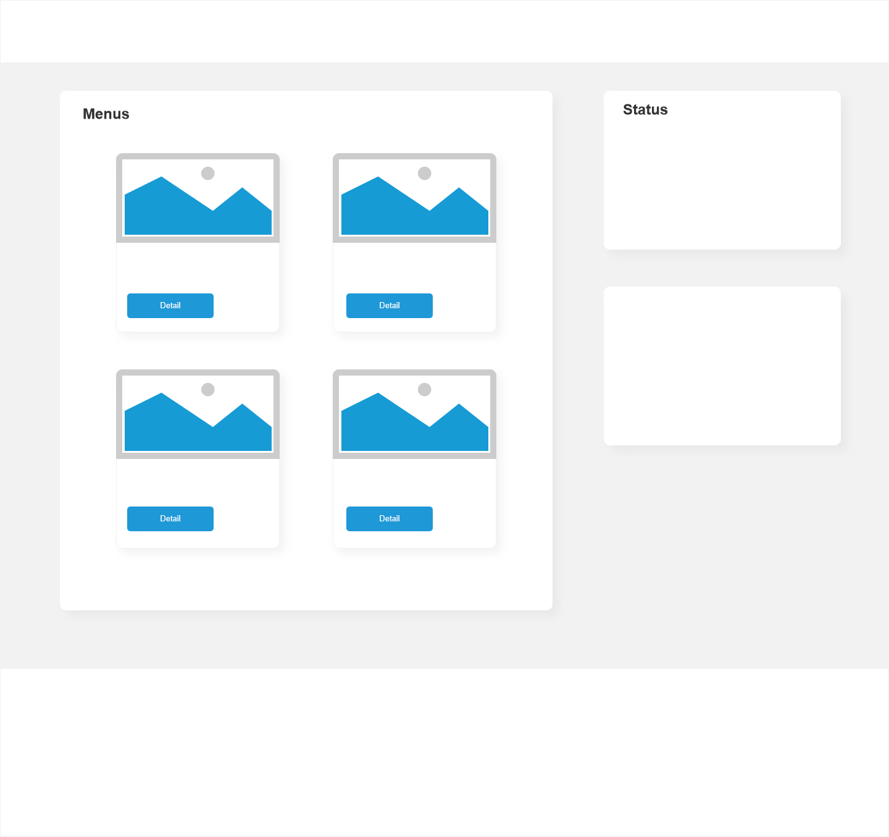

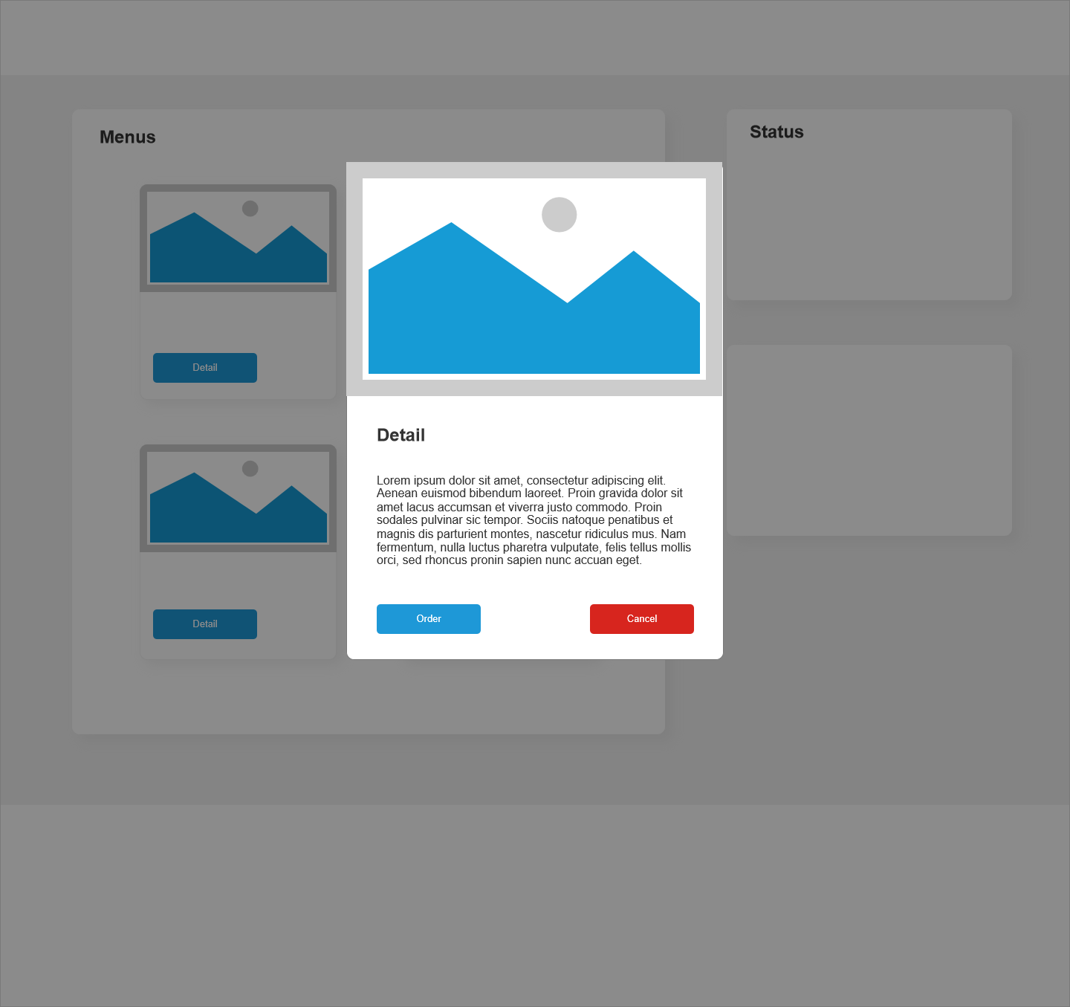

**Donor**



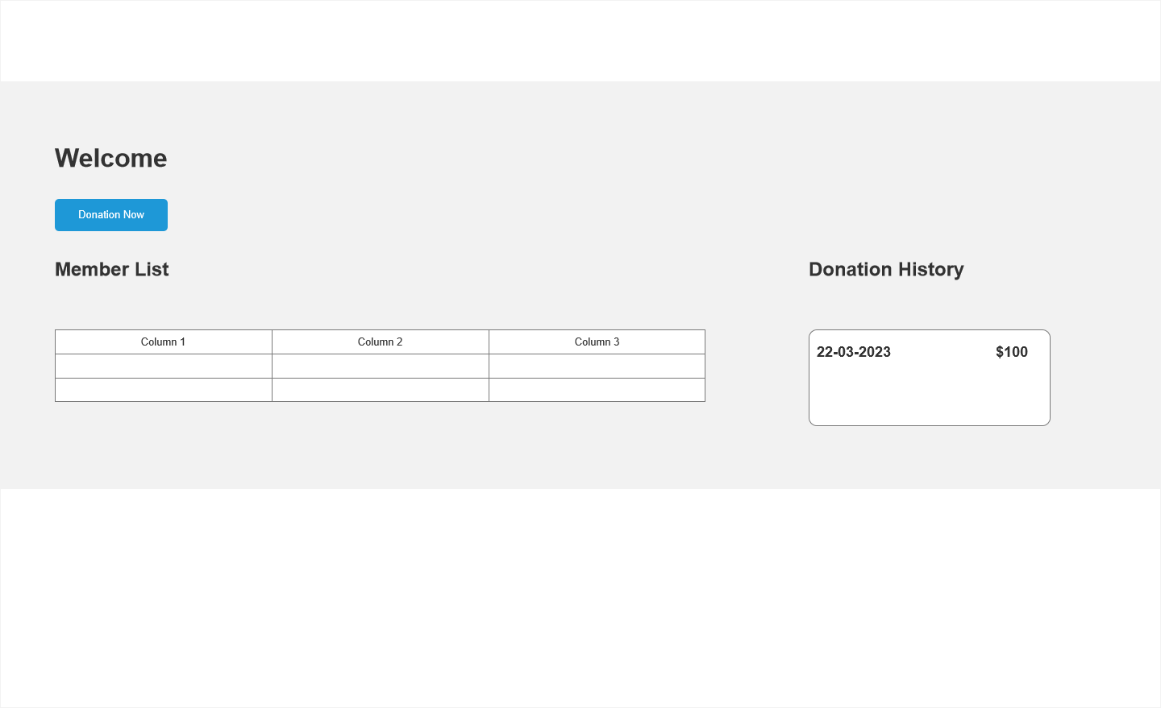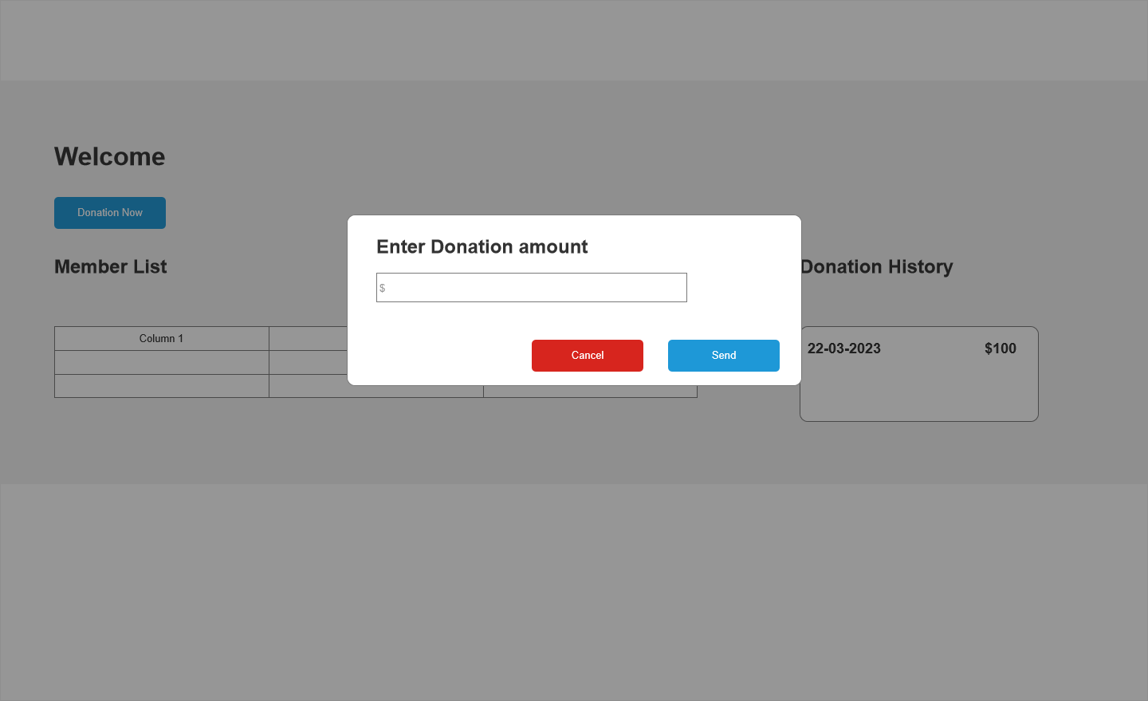

Partner Storyboard

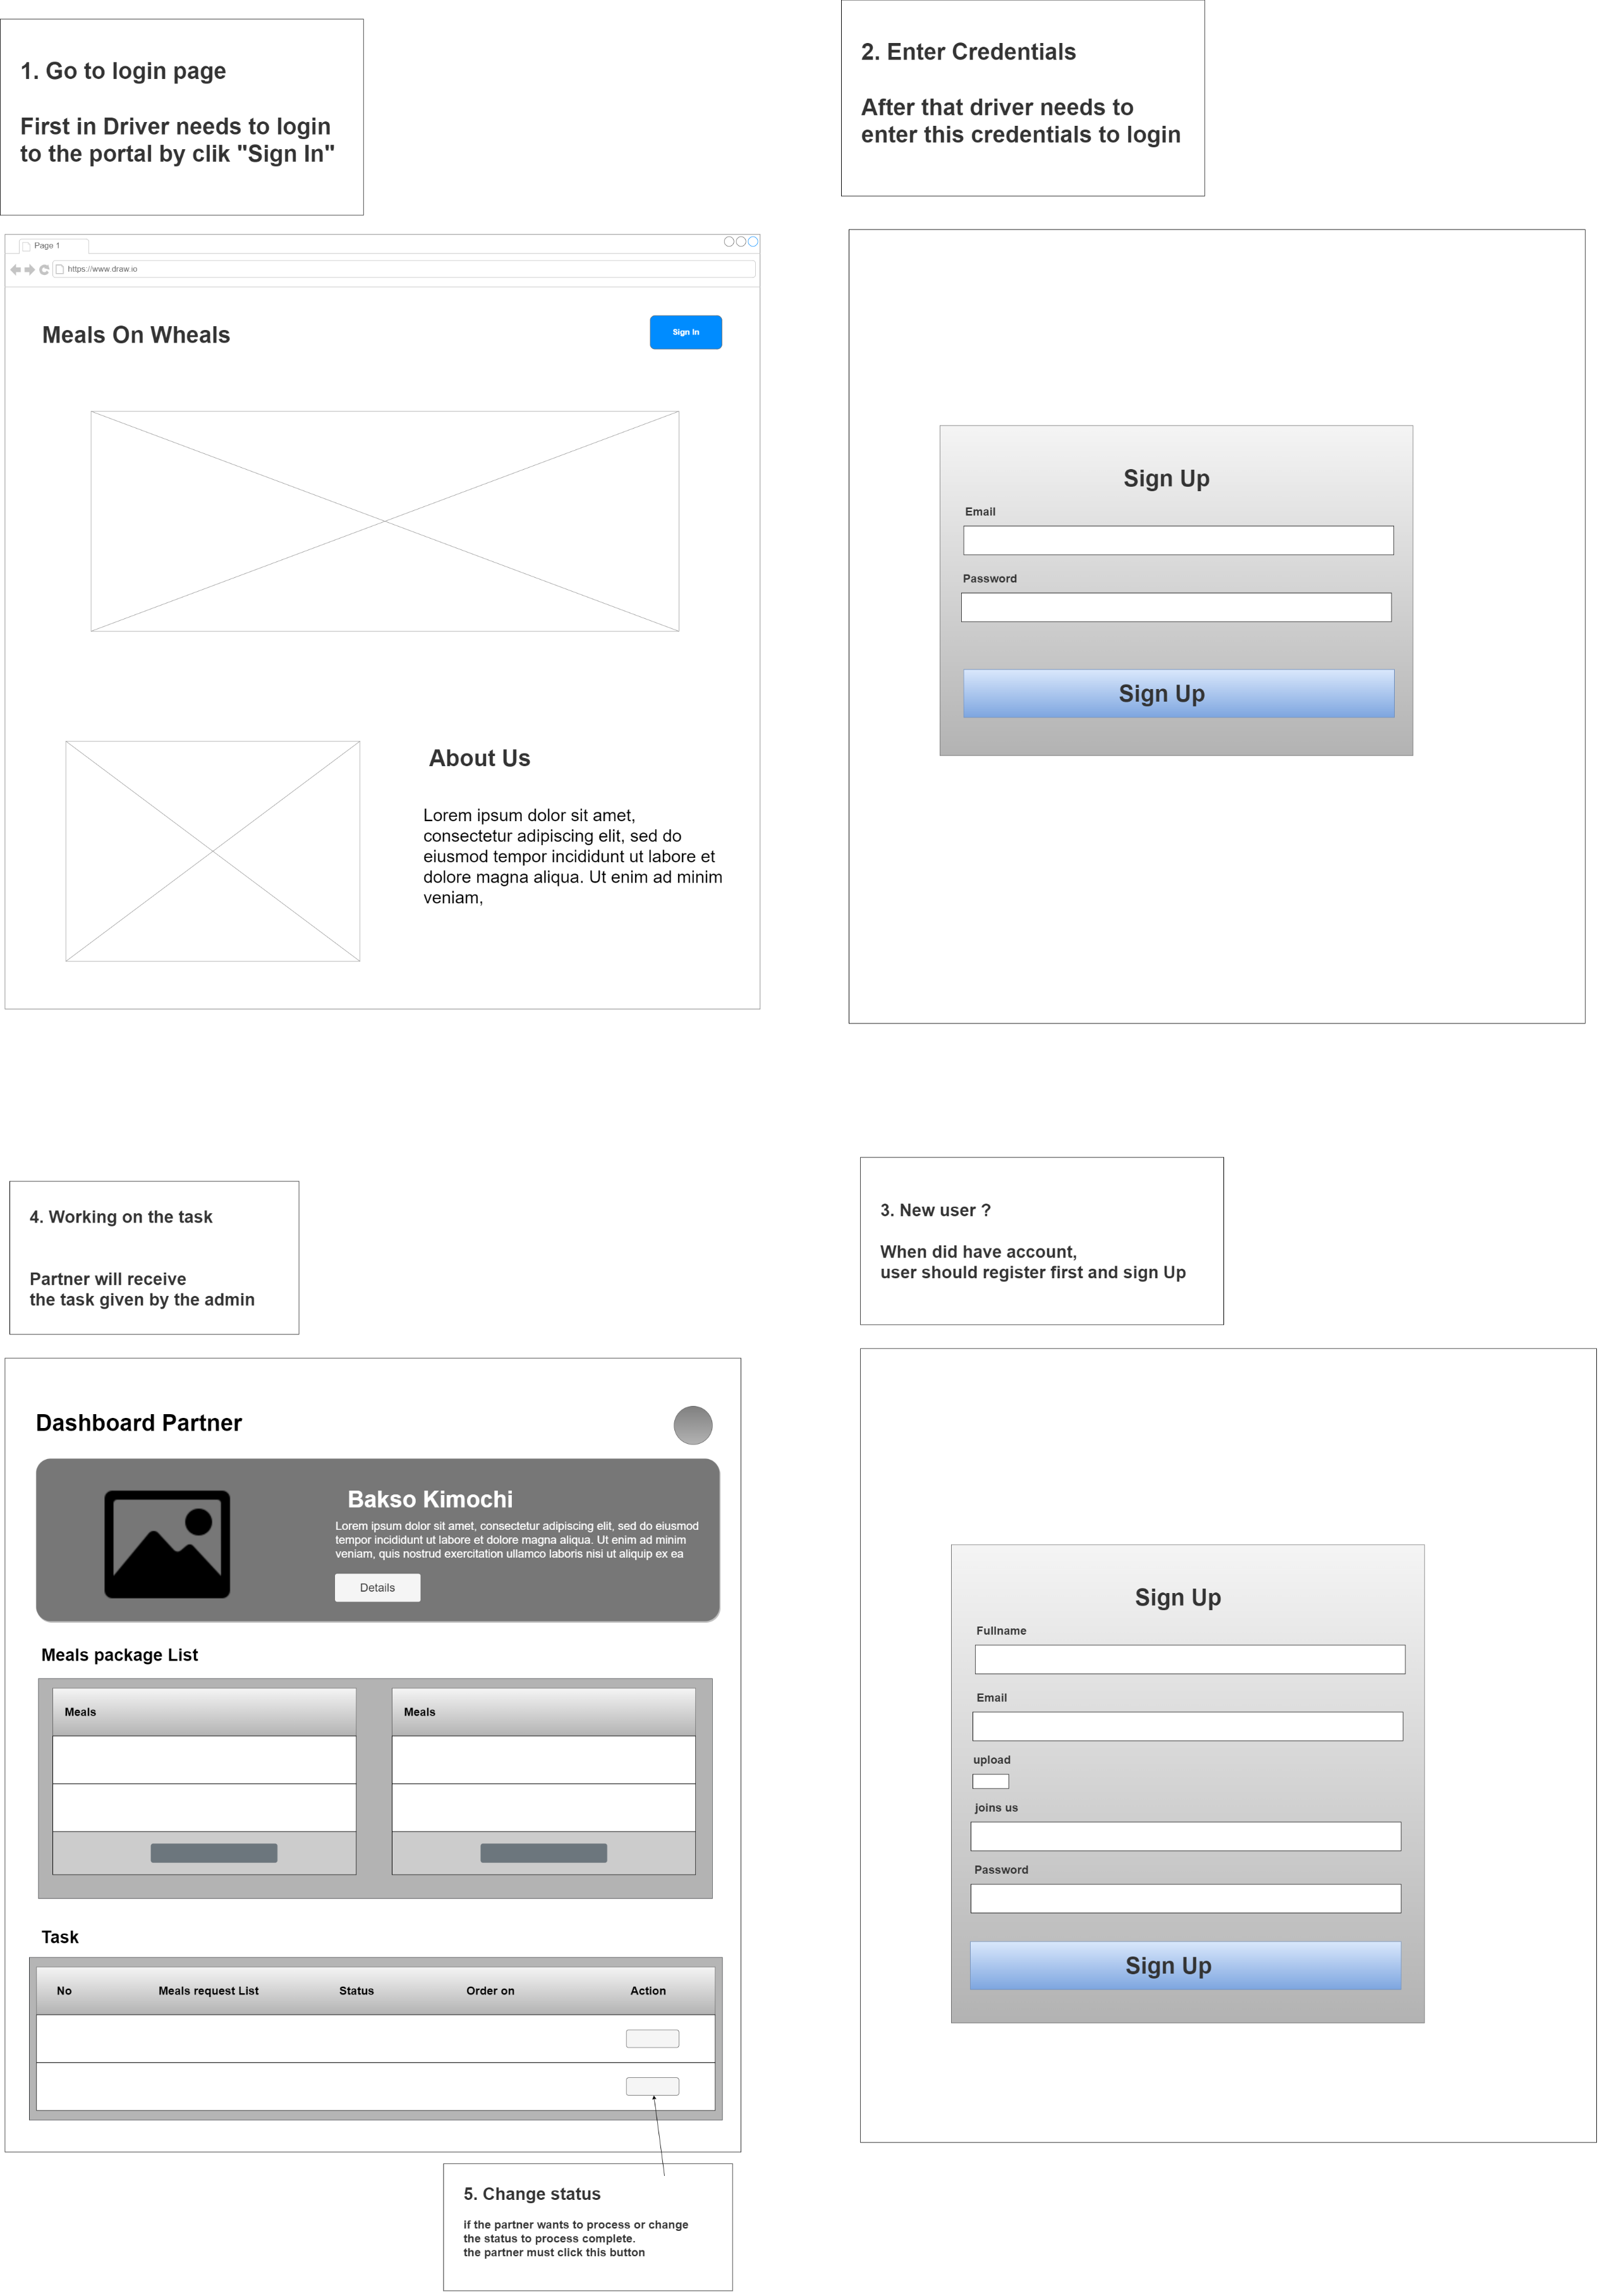

Volunteer Registration

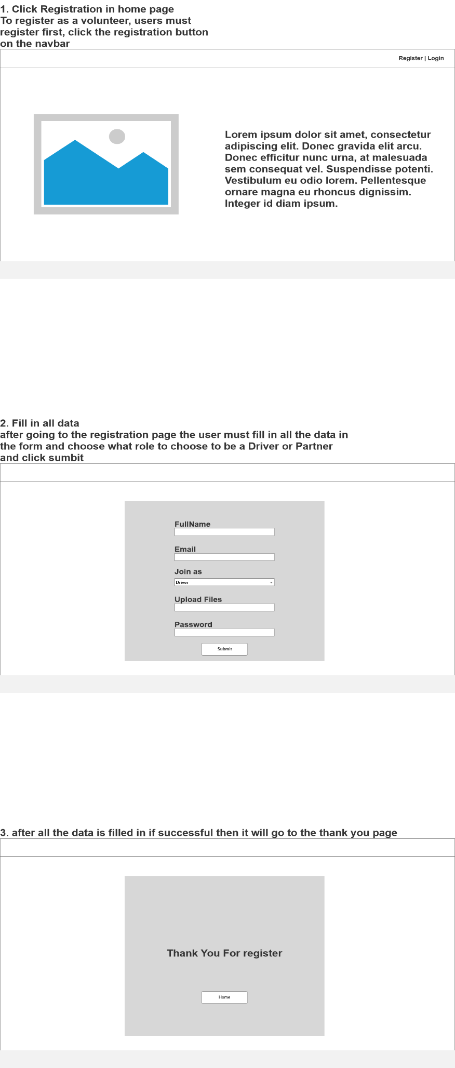

Volunteer Login

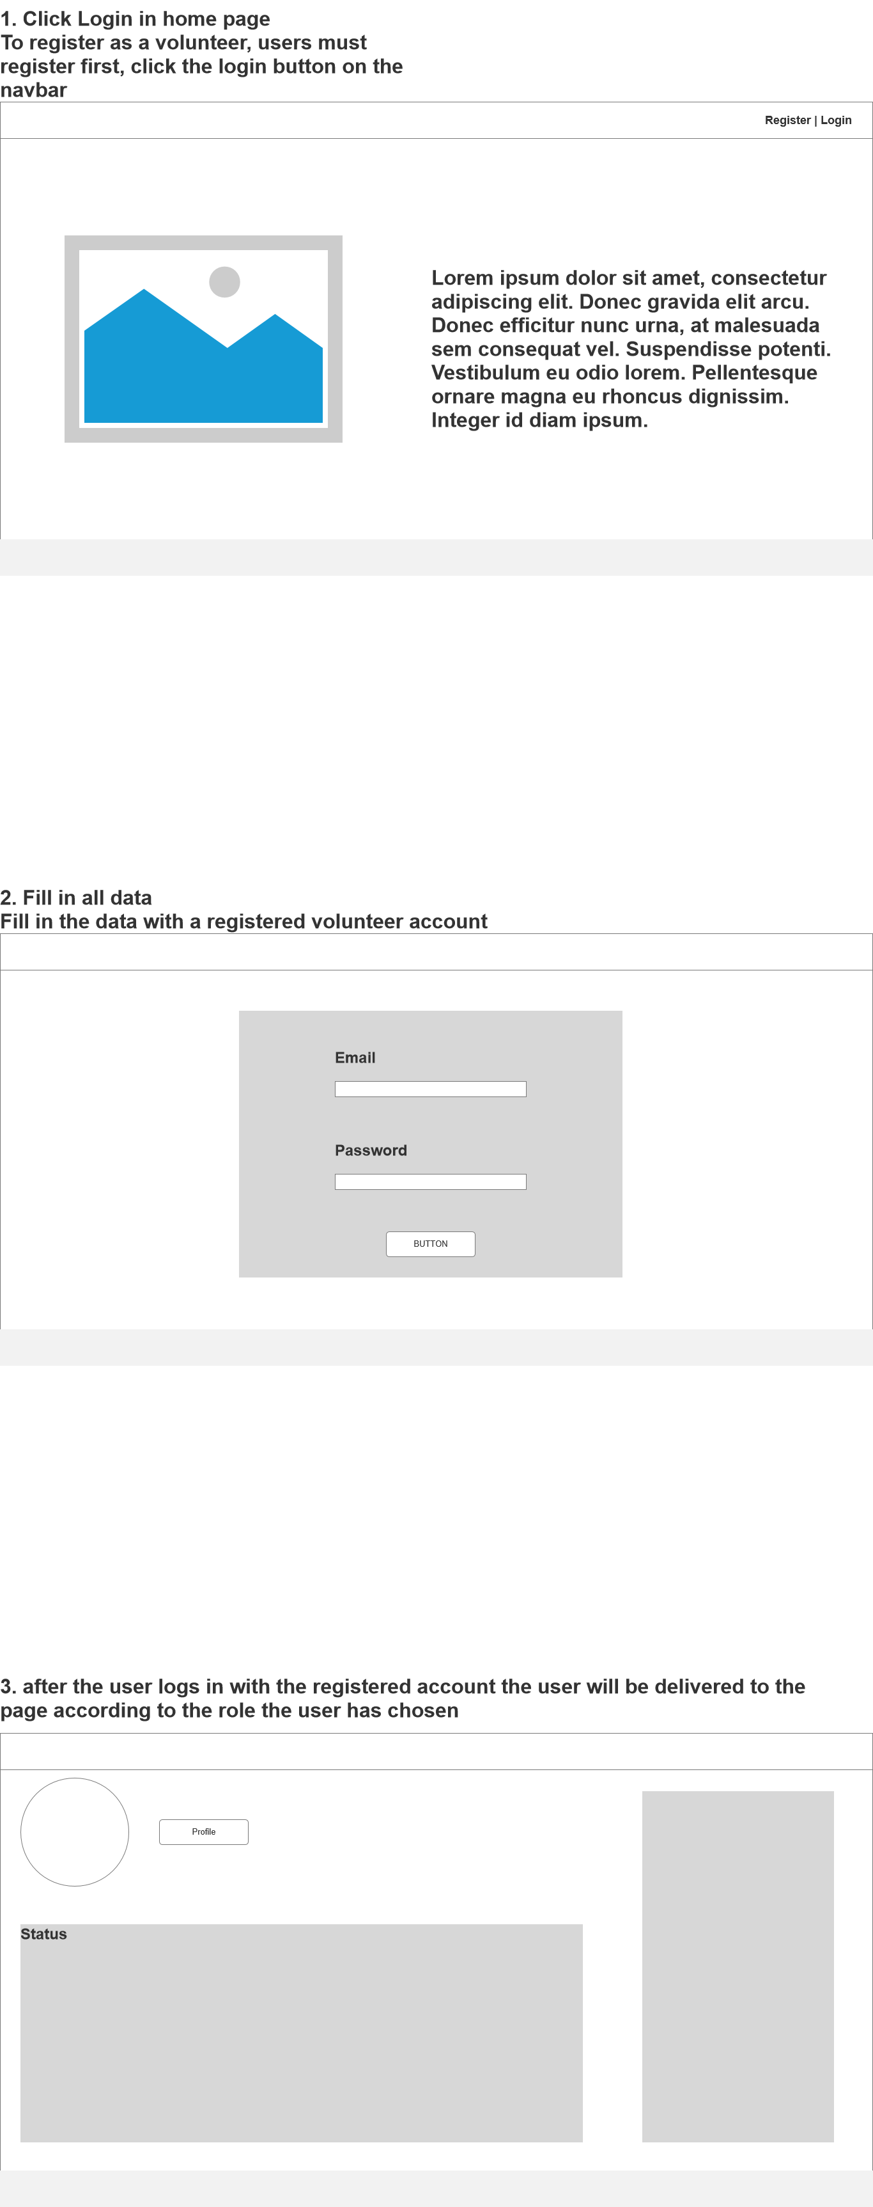

* 1. EERD

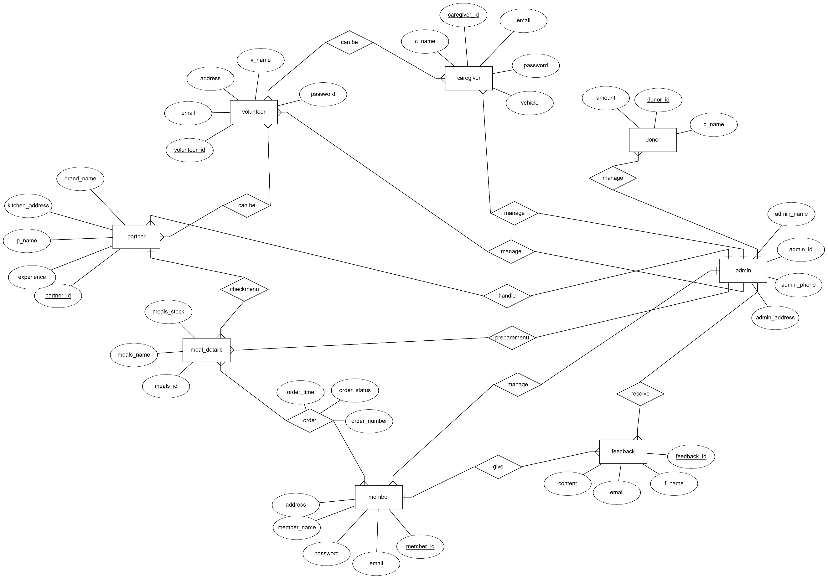

* 1. Physical Design

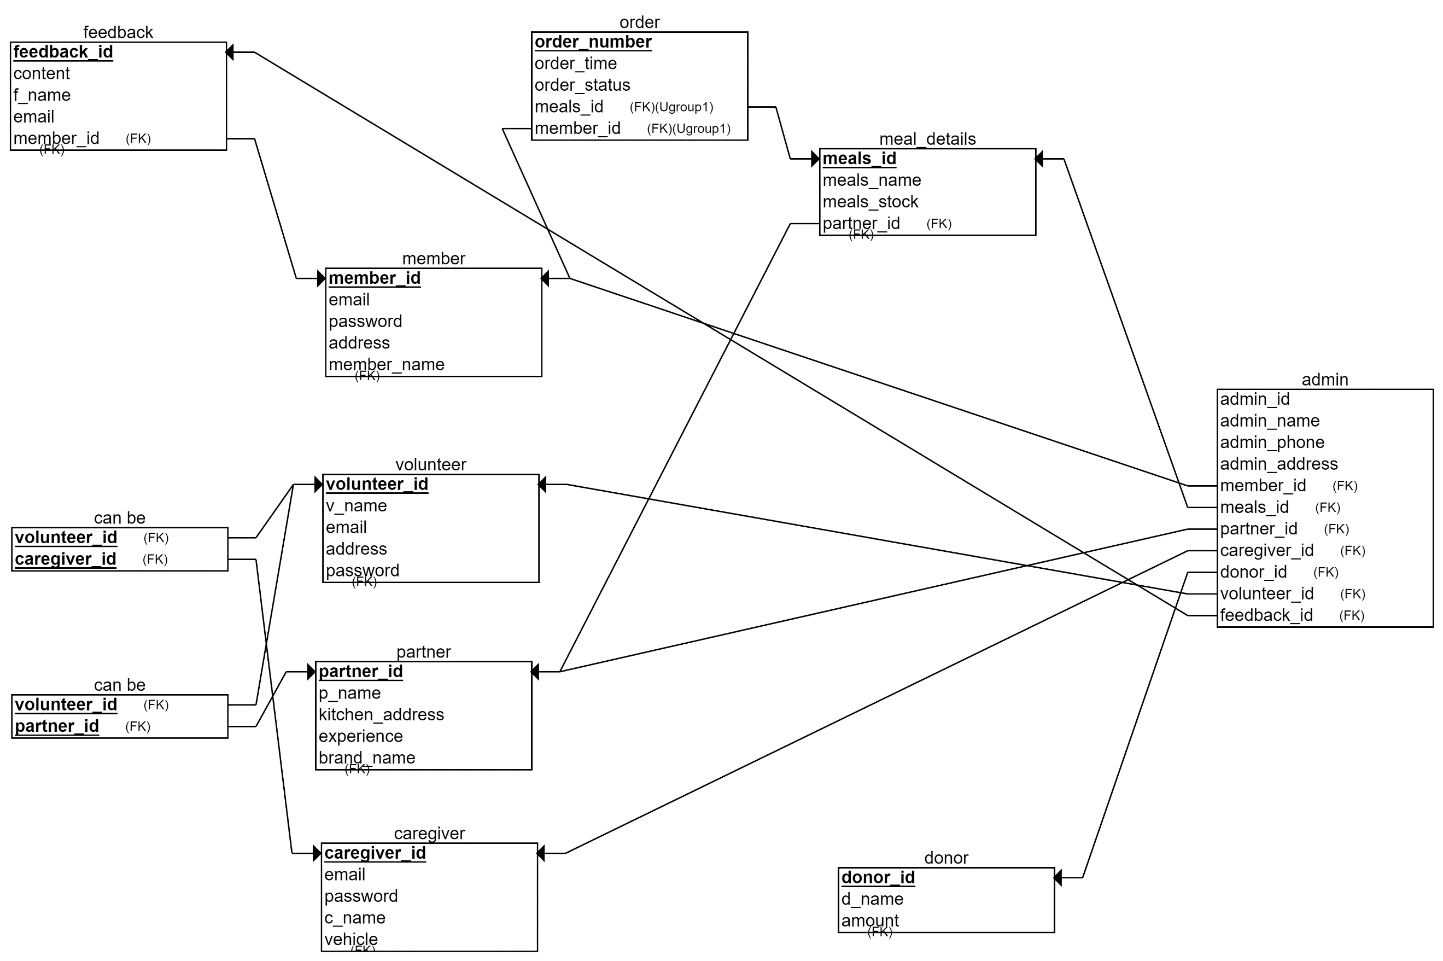

1. Schedule plan
   1. WBS



* 1. Gantt chart



## **5.0.2 Budget analysis**

|  |  |  |  |
| --- | --- | --- | --- |
| No. | Type | Cost | Total |
| 1 | System Aspect |  |  |
|  | - Hardware |  |  |
|  | Processor | $2,000 | $2,000 |
|  | Memory | $500 | $500 |
|  | Hard Drive | $300 | $300 |
|  | SSD | $500 | $500 |
|  | Network | $200 | $200 |
|  | Monitor | $300 | $300 |
|  | PSU | $400 | $400 |
|  | Keyboard & Mouse | $100 | $100 |
|  | - Software |  |  |
|  | Windows 10 | $100 | $100 |
|  | Bootstrap, CSS, React JS, Spring Boot | $1,000 | $1,000 |
|  | MySQL Workbench | $200 | $200 |
|  | Apache Tomcat / Apache Maven | $300 | $300 |
|  | Axure | $200 | $200 |
|  | Web Browsers | $0 | $0 |
|  | Sub Total |  | $6,200 |
| 2 | Infrastructure Aspect |  |  |
|  | - Hardware |  |  |
|  | Server | $5,000 | $5,000 |
|  | Client | $1,000 | $1,000 |
|  | - Network |  |  |
|  | Switch | $200 | $200 |
|  | UTP Cable | $50 | $50 |
|  | RJ 45 Connector | $20 | $20 |
|  | Sub Total |  | $6,270 |
| 3 | Maintenance Aspect, ETC |  |  |
|  | - Maintenance |  |  |
|  | Contractors | $10,000 | $10,000 |
|  | - Skills & Human Resource |  |  |
|  | UI/UX Designer | $1,000 | $1,000 |
|  | Web Developer | $4,000 | $4,000 |
|  | Sub Total |  | $15,000 |
| Total |  |  | $27,470 |
|  | Total Cost Excpected |  | $30,000 |

## **5.0.3 Communication matrix:**

|  |  |  |  |  |
| --- | --- | --- | --- | --- |
| **Speaker** | **Audience** | **Purpose** | **Method** | **Frequency** |
| Team Member | Mr. David | Development progress | MS. Teams Meeting & Face-to-Face Meeting | Twice a week |
| Mr. David | MerryMeal Org | Explain the current development process on the initial project objective to keep track if the project is still on what the stakeholder wants or not | MS. Teams Meeting & Face-to-Face Meeting | Once a week |

## **5.0.4 Module Test Plans**

**Test Scenarios:**

|  |  |  |
| --- | --- | --- |
| **Test Scenario ID** | **Test Scenario** | **Number of test cases** |
| TS001-Integration Testing | Ensure account authorization with JWT Token | 1 |
| TS002-UAT testing | 1. Ensure user navigation is easy | 3 |
| TS003-UAT testing | 1. Ensure partner can process the meals easily | 1 |
| TS004-UAT testing | Ensure SQLI is prevented | 3 |
| TS005-Cross Browser testing | Ensure application works across multiple major browsers | 6 |

**Scenario 1: Integration Testing**

|  |  |
| --- | --- |
| **Test Scenario** | Ensure account authorization with JWT Token |
| **TS001** |
| **Test Cases** | Integration Testing |
| **IT001** | Check if the user can access the website if there is no bearer token. |

#### 

|  |  |  |  |  |  |  |
| --- | --- | --- | --- | --- | --- | --- |
| Test Scenario ID | Test Case | Risk | Preconditions | Expected Result | Actual Result | Final Result |
| TS001 | IT001 | 5 | * Open Postman API * Register to get Bearer token | To access the website, the user must have authorization for their bearer token. |  |  |

**Scenario 2: User Acceptance Testing**

|  |  |
| --- | --- |
| **Test Scenario** | 1. Ensure user navigation is easy |
| **TS002** |
| **Test Cases** | UAT Test |
| **UAT001** | Check to see if member can navigate easily |
| **UAT002** | Check to see if caregiver can navigate easily |
| **UAT003** | Check to see if partner can navigate easily |

#### 

|  |  |  |  |  |  |  |
| --- | --- | --- | --- | --- | --- | --- |
| Test Scenario ID | Test Case | Risk | Preconditions | Expected Result | Actual Result | Final Result |
| TS002 | UAT001 | 3 | * Logged in as Member / Caregiver / Partner | After logging in, members may simply view meal card packages, order meals if they so wish, and provide comments on the meal. |  |  |
| UAT002 | 3 | Any delivery request can be seen by drivers on their dashboard. |  |  |
| UAT003 | 3 | Caregivers may simply observe the menu's order and their dashboard. |  |  |

**Scenario 3: User Acceptance Testing**

|  |  |
| --- | --- |
| **Test Scenario** | Ensure partner can process the meals easily |
| **TS003** |
| **Test Cases** | UAT Test |
| **UAT001** | Check to see if the partner can process a meal package easily. |

#### 

|  |  |  |  |  |  |  |
| --- | --- | --- | --- | --- | --- | --- |
| Test Scenario ID | Test Case | Risk | Preconditions | Expected Result | Actual Result | Final Result |
| TS003 | UAT001 | 3 | Logged in as Partner | The admin has previously created a food menu that caregivers may easily view and process. |  |  |

**Scenario 4: User Acceptance Testing**

|  |  |
| --- | --- |
| **Test Scenario** | Ensure Login Validation |
| **TS004** |
| **Test Cases** | UAT Test |
| **UAT001** | Check to see if the login validation able to function properly |

#### 

|  |  |  |  |  |  |  |
| --- | --- | --- | --- | --- | --- | --- |
| Test Scenario ID | Test Case | Risk | Preconditions | Expected Result | Actual Result | Final Result |
| TS004 | UAT001 | 5 | Type in URL  Click on login  Enter fields with test data  Click submit | If the account hasn't been activated yet, logging in will fail, and a pop-up notification will show. |  |  |
| UAT002 | 5 | If the password or email entered during login are incorrect, a popup notice will show. |  |  |
| UAT003 | 5 | If the user enters an email address without the @ symbol, a warning notice appears. |  |  |

**Scenario 5: Cross-Browser Testing**

|  |  |  |  |  |  |  |  |  |
| --- | --- | --- | --- | --- | --- | --- | --- | --- |
| **Test Scenario** | | | | Ensure the application works across multiple major browsers | | | | |
| **TS005** | | | |
| **Test Cases** | | | | Cross Browser Test | | | | |
| **CBT001** | | | | Check to see if register works on Firefox | | | | |
| **CBT002** | | | | Check to see if register works on Internet Explorer | | | | |
| **CBT003** | | | | Check to see if register works on Google Chrome | | | | |
| **CBT004** | | | | Check to see if login works on Firefox | | | | |
| **CBT005** | | | | Check to see if login works on Internet Explorer | | | | |
| **CBT006** | | | | Check to see if login works on Google Chrome | | | | |
| Test Scenario ID | Test Case | Risk | | Preconditions | Expected Result | Actual Result | Final Result | |
| TS005 | CBT001 | 3 | | Downloaded required browser | Register, save information in the database, and send users to the login page |  |  | |
| CBT002 | 3 | | Registration, data saving in the database, and user redirection to the login page |  |  | |
| CBT003 | 3 | | Register save data to database and redirect user to login page |  |  | |
| CBT004 | 3 | | Downloaded required browser | Login validate with database and redirect user to home page |  |  | |
| CBT005 | 3 | | Login validate with database and redirect user to home page |  |  | |
| CBT006 | 3 | | Login validate with database and redirect user to home page |  |  | |

# 

# **6.0: Project Design**

## **6.1 Application Flowchart**

* + 1. **Admin Flowchart**
       - **Admin Login**



* + - * **Admin Manage Order**



* + - * **Admin CRUD Manage user, driver and meals**



* + - * **Admin feedback & donation history**



* + 1. **Volunteer Flowchart**
       - **Volunteer registration**



* + - * **Volunteer login**



* + 1. **Driver Flowchart**



* + 1. **Partner Flowchart**



* + 1. **Member Flowchart**
       - **Member Registration**



* + - * **Member Login**



* + - * **Member Order**



## **6.2 Use Case Diagram**



## **6.3 Module Storyboard**

Admin Storboard





**Member**







**Donor**





Partner Storyboard



Volunteer Registration



Volunteer Login



# **7.0 Project Stakeholder presentation**

ppt slides

(Stakeholders review statements and document their feedback)

|  |  |  |  |  |
| --- | --- | --- | --- | --- |
| Stakeholder | Specific Areas to be improved | Actions to be taken to improve performance | Progress Status (Achieved and not achieved) | Screen capture ID (improvised design page) |
| Sr. Manager from Unity One solution, Merry Meal representatives |  |  | achieved |  |
| Sr. Manager from Unity One solution, Merry Meal representatives |  |  |  |  |

## **Observation And Witness Records**

# **8.0 Project execution**

Landing Page

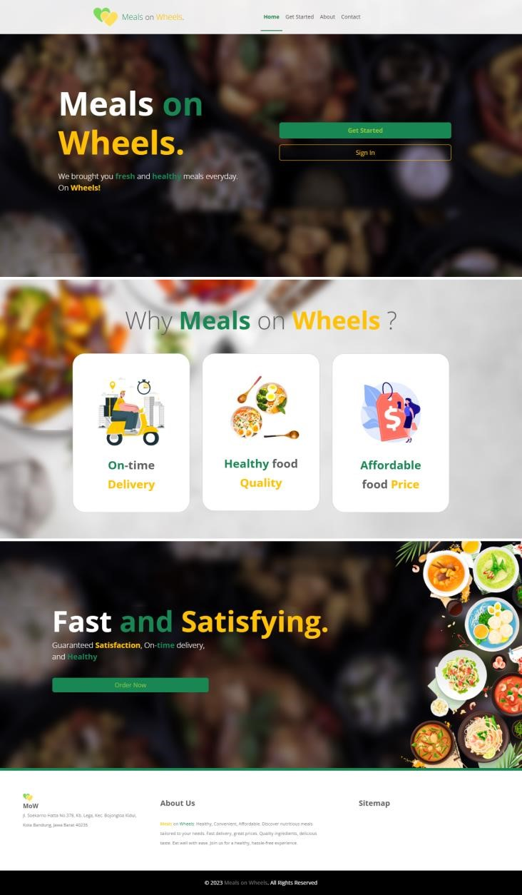

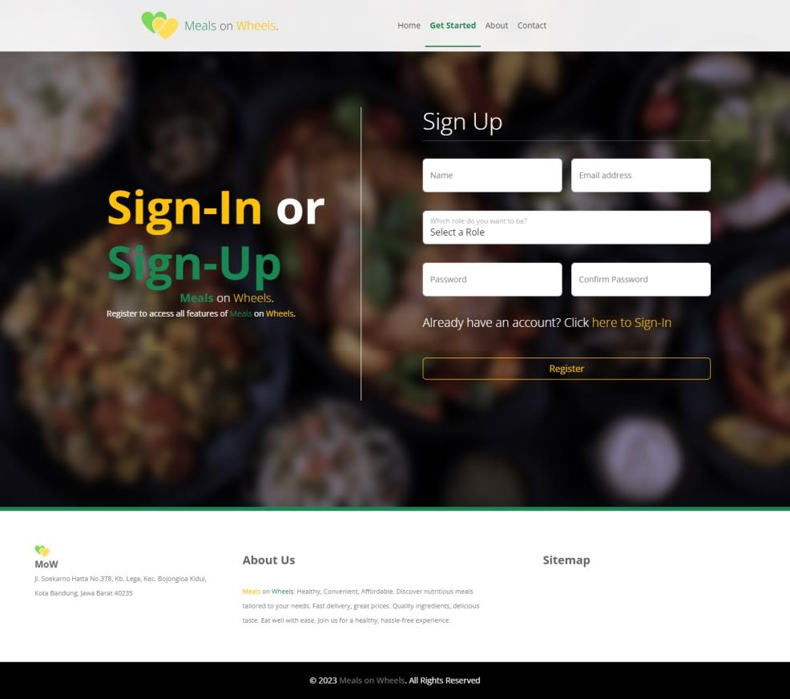 Sign Up

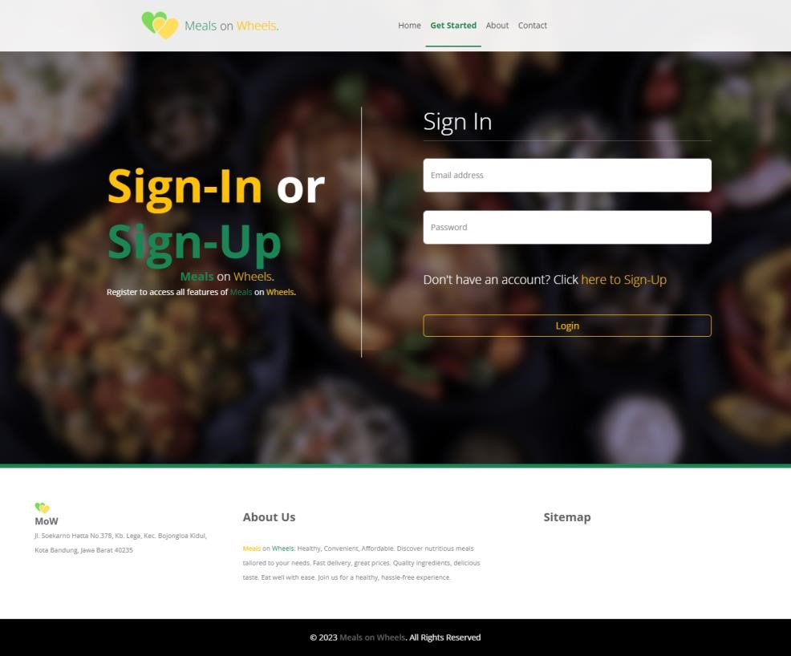Sign in

About Us

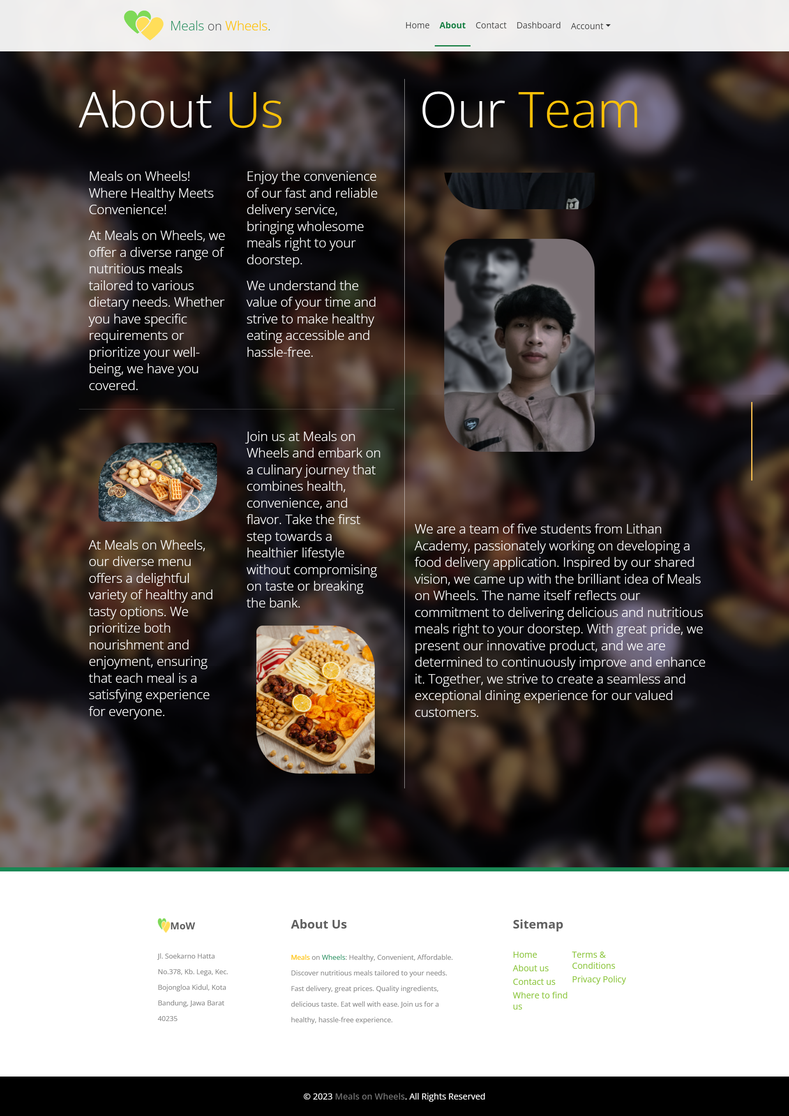

ContactUs

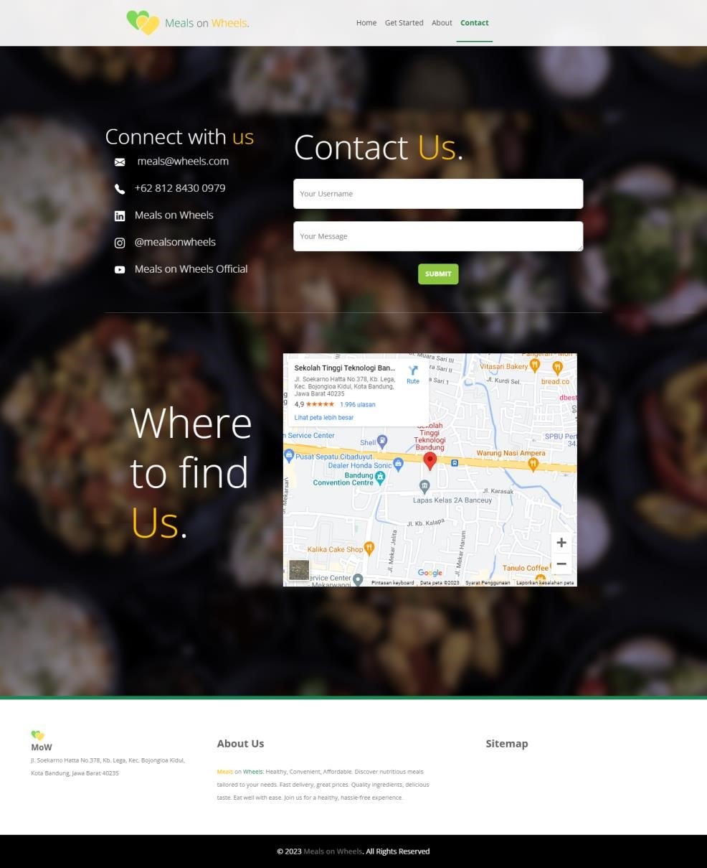

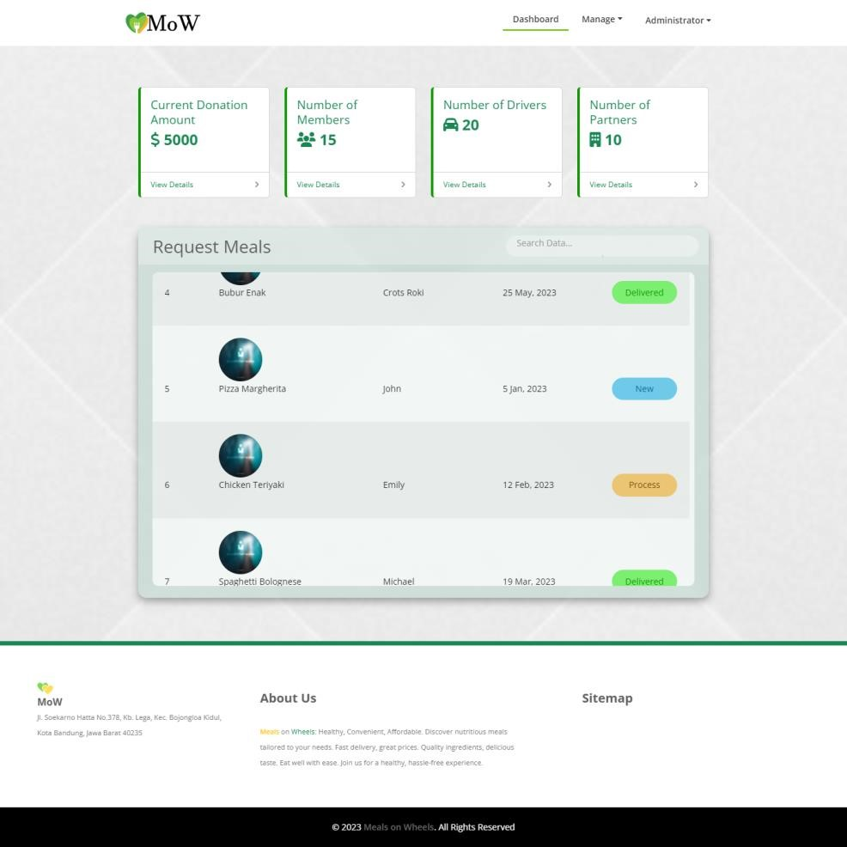Admin Dashboard

Admin Donation

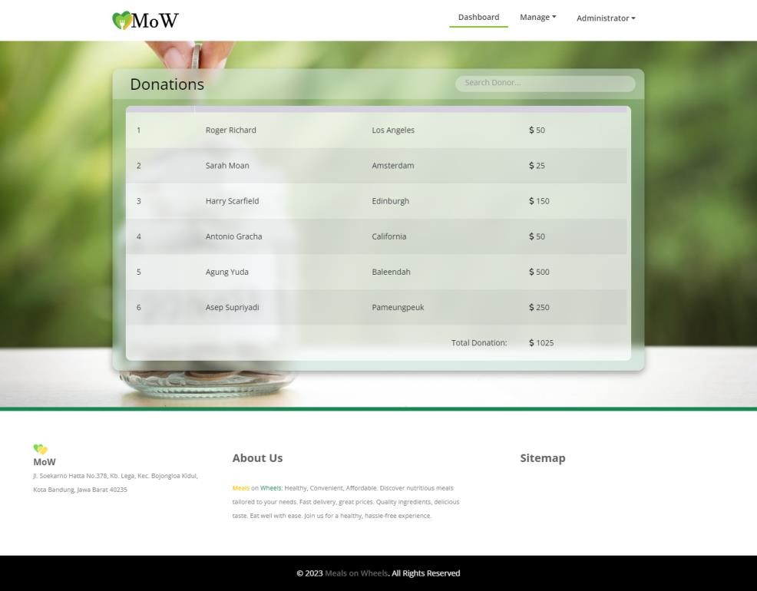

Admin Meals

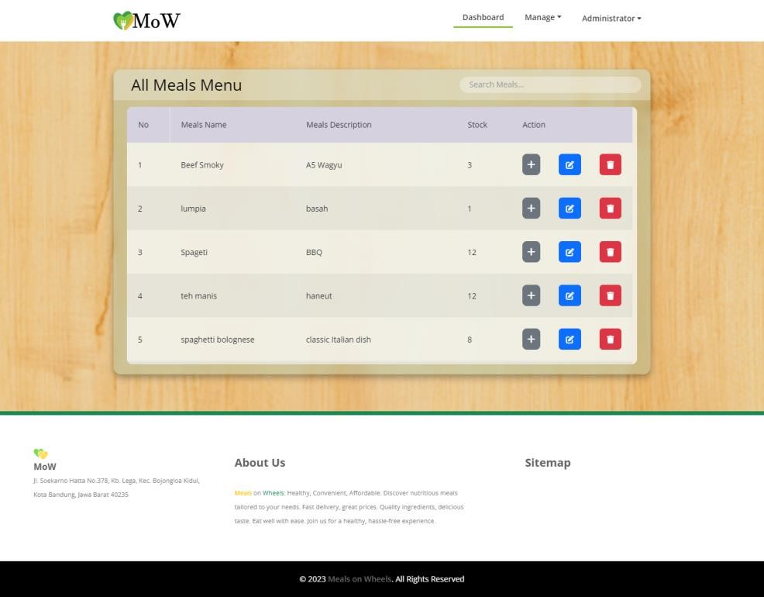

Admin Order

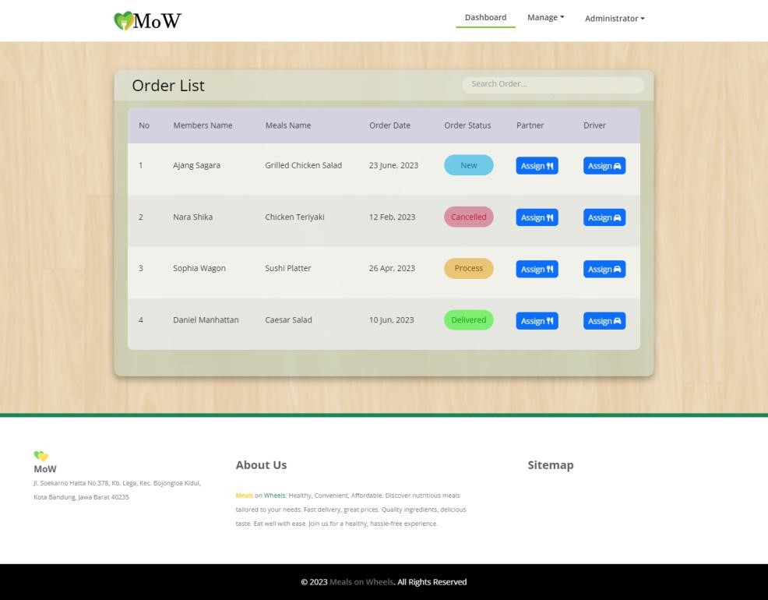

Admin Member

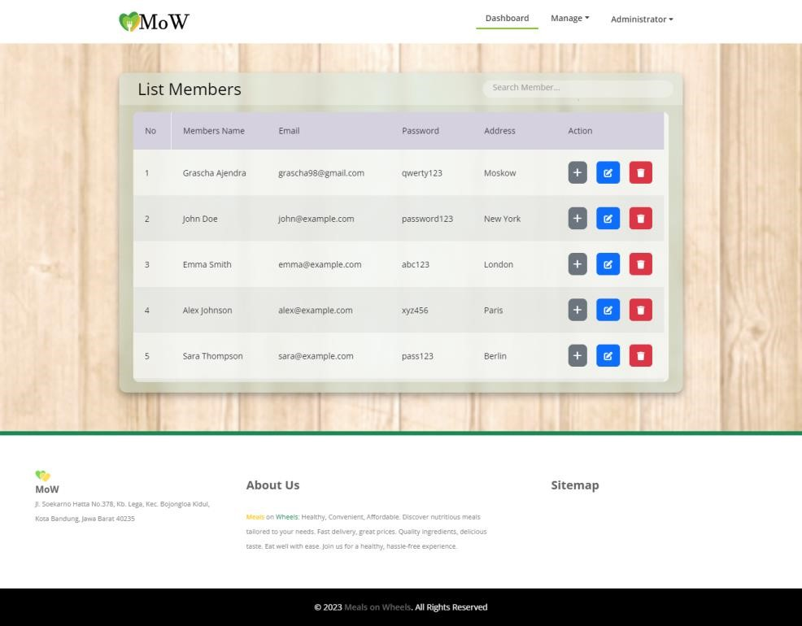

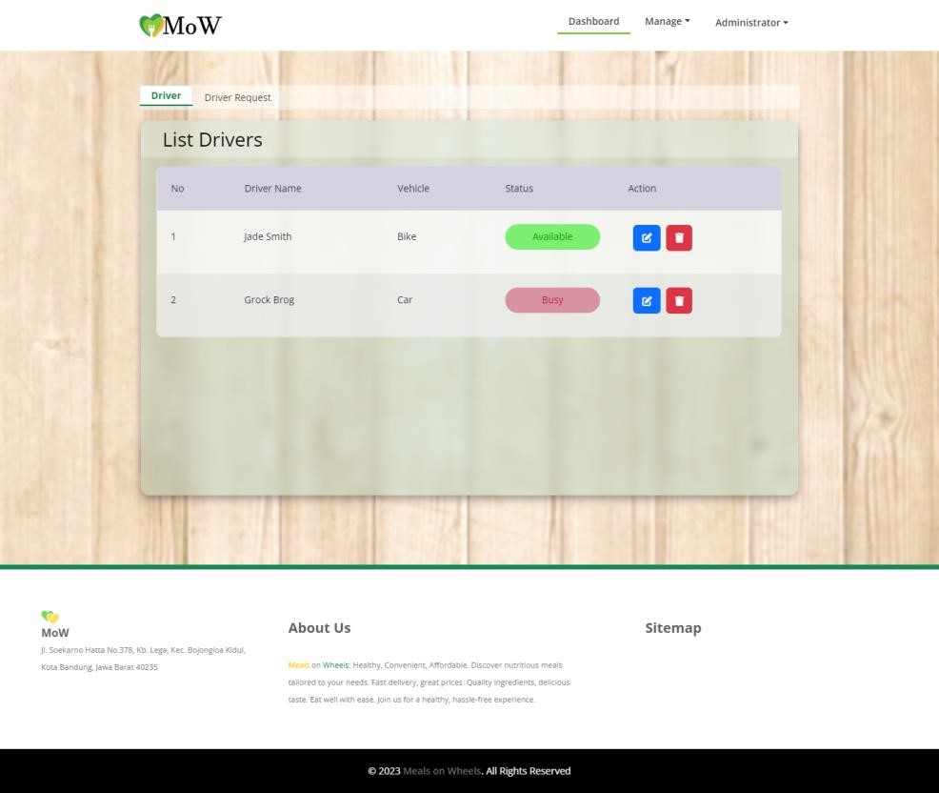Admin Driver / Caregiver

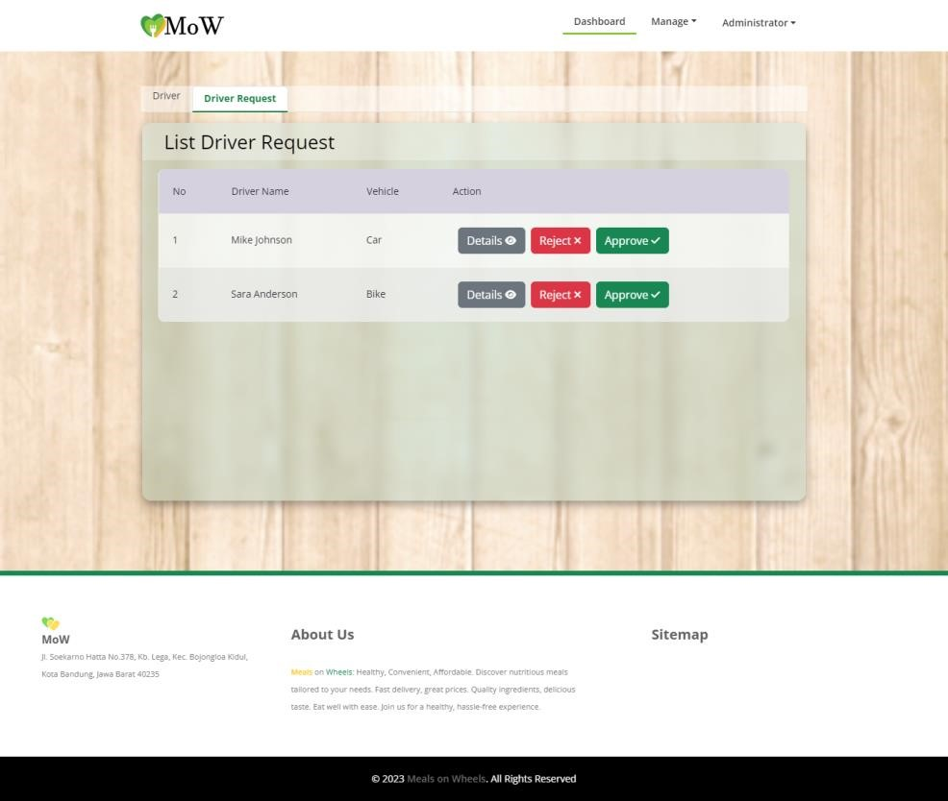

Admin partner

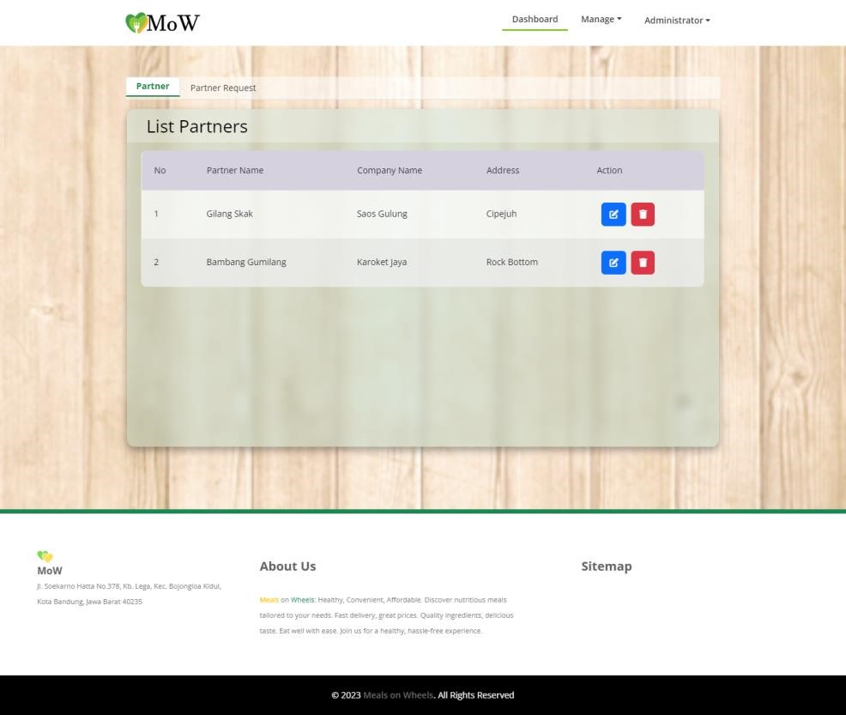

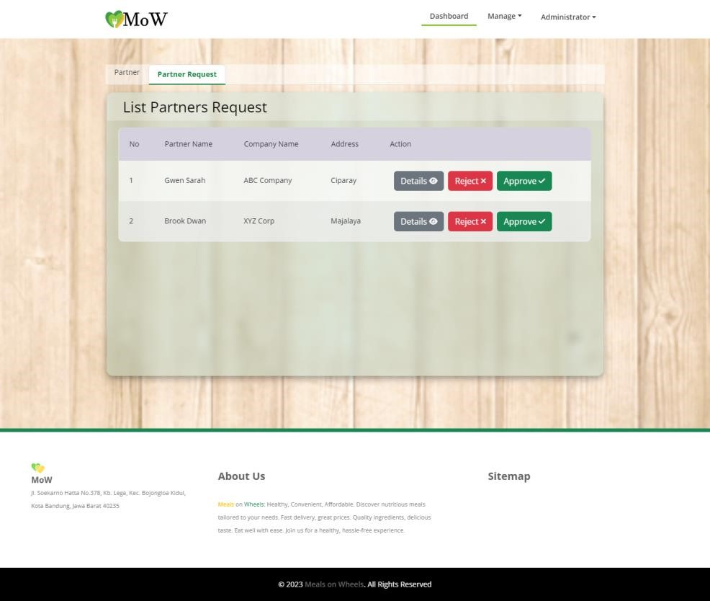

Member Dashboard

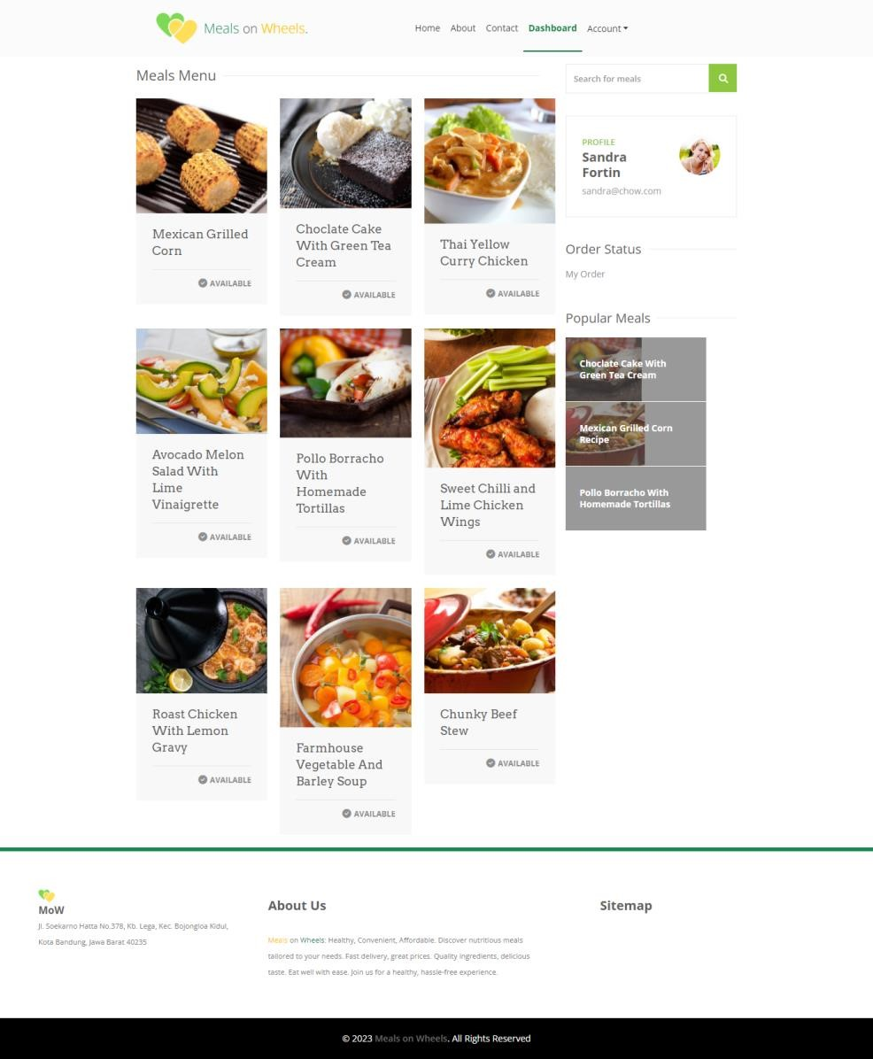

# **9.0 Unit Testing**

(min 5 to 7 unit testing for each module)

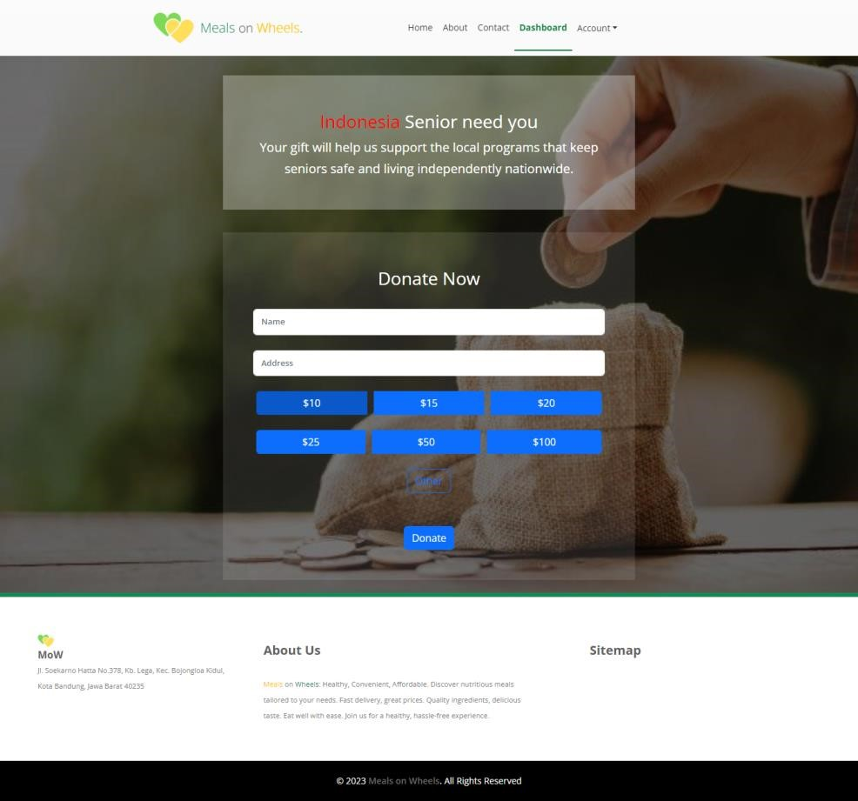Donor Dashboard

Driver / Caregiver Dashboard

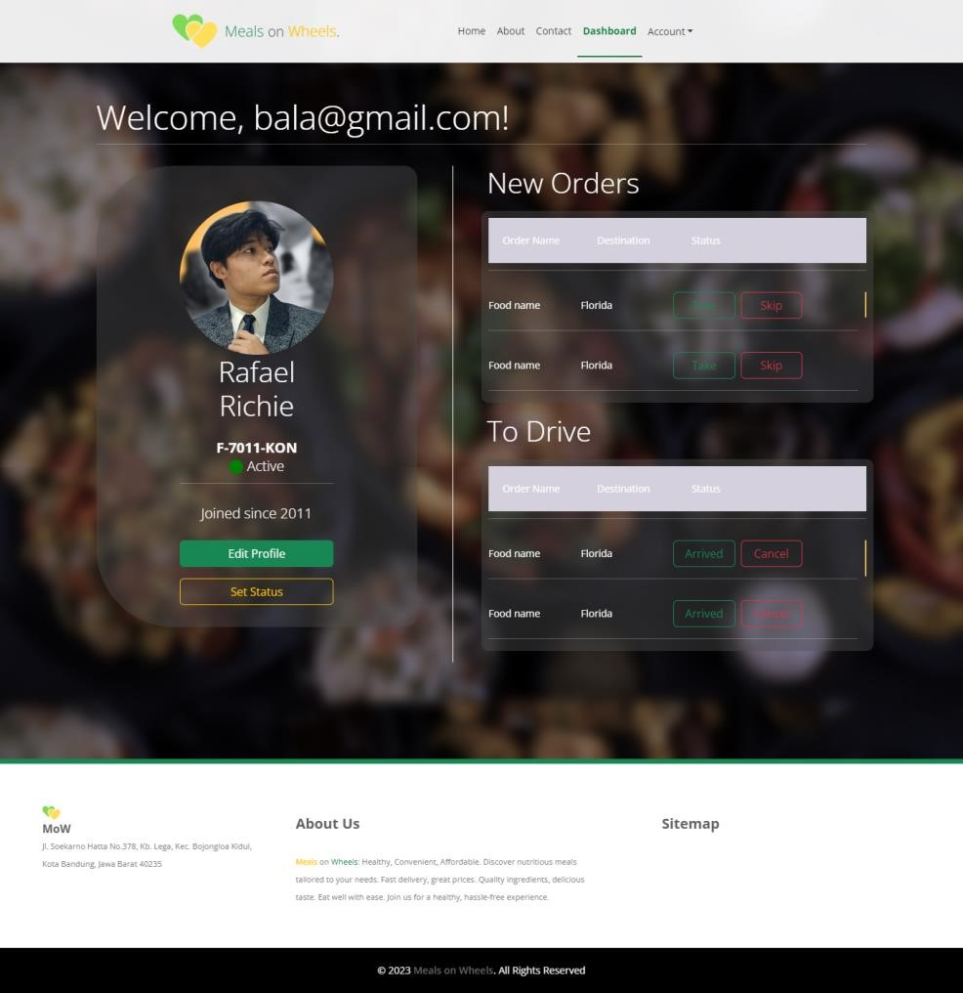

Partner Dashboard

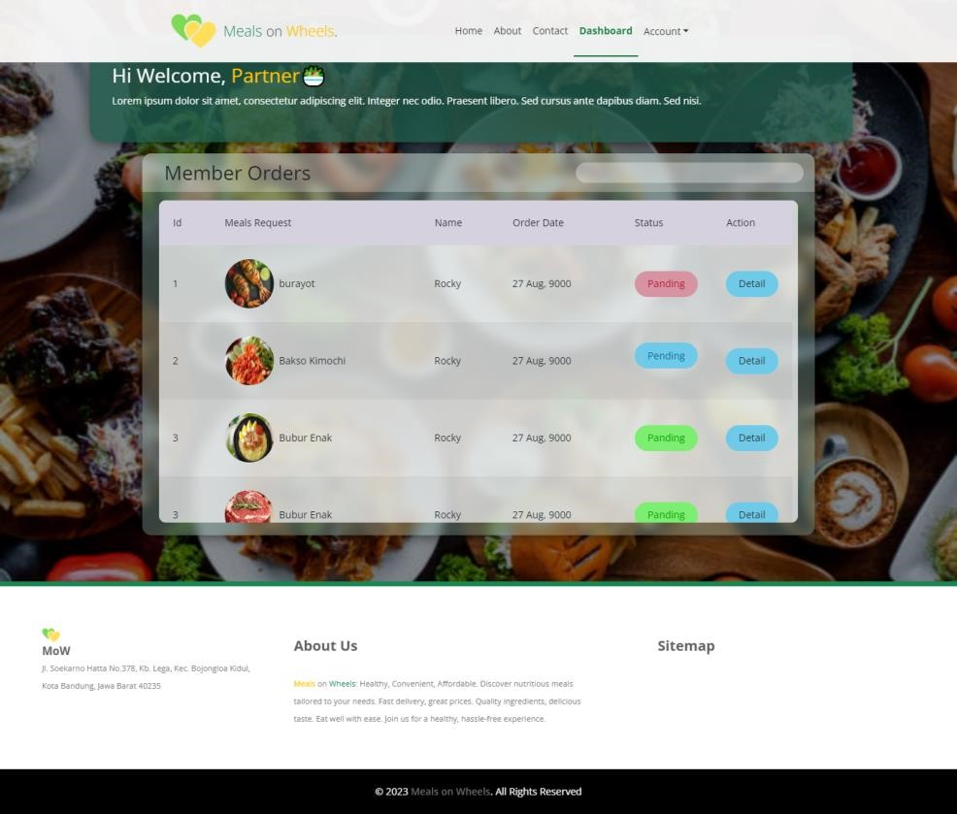

# **9.0 Unit Testing**

Test Scenario

Scenario 1 : Integration Testing

|  |  |
| --- | --- |
| **Test Scenario** | Ensure account authorization with JWT token |
| **TS001** |
| **Test Cases** | Integration Testing |
| **IT001** | Check if the user can access the website if there is no token |

|  |  |  |  |  |  |  |  |
| --- | --- | --- | --- | --- | --- | --- | --- |
| Test Scenario ID | Test Cases | Risk | Precondition | Test Data | Expected Result | Actual Result | Final result |
| TS001 | IT001 | 5 | Open Postman  Login to get barer token | Open Postman API, change method to post and type URL  Email : [admin2@gmail.com12534ssas.com](mailto:admin2@gmail.com12534ssas.com)  Password : admin2 | The user must have their barer token authorization to be able access the website | After we login, we cane get bearer token in postman | pass |

|  |  |
| --- | --- |
| **Test Case ID** | **Evidence** |
| **IT001** |  |

Scenario 2:Performance Testing

|  |  |
| --- | --- |
| **Test Scenario** | Testing the performance of application |
| **TS002** |
| **Test Cases** | Performance Test |
| **PT001** | Testing the performance of Landing page |
| **PT002** | Testing the performance of Register page |
| **PT003** | Testing the performance of Login page |

|  |
| --- |
|  |

|  |  |
| --- | --- |
| **Test Case ID** | **Evidence** |
| **Pt001** |  |

|  |  |
| --- | --- |
| Pt002 |  |
| PT003 |  |

Scenario 3: user Acceptance Testing

|  |  |
| --- | --- |
| **Test Scenario** | Ensure login Validation |
| **TS003** |
| **Test Cases** | UAT |
| **UAT001** | Check to see if the login validation able to function |

|  |
| --- |
|  |

|  |  |
| --- | --- |
| **Test Case**  **ID** | **Evidence** |
| **UAT002** |  |
| **UAT002** |  |
| **UAT003** |  |

|  |  |
| --- | --- |
| **Test Scenario** | Ensure the application works across multiple major browsers |
| **TS004** |
| **Test Cases** | Cross Browser Test |
| **CBT001** | Check to see if register works on Firefox |
| **CBT002** | Check to see if register works on Edge |
| **CBT003** | Check to see if register works on Google Chrome |
| **CBT004** | Check to see if login works on Firefox |
| **CBT005** | Check to see if login works on Edge |
| **CBT006** | Check to see if login works on Google Chrome |

|  |  |
| --- | --- |
| **Test Case ID** | **Evidence** |
| **CBT001** | **Before Register**    **After Register** |
|  |  |
|  |  |
| **CBT004** |  |
| **CBT005** |  |
| **CBT006** |  |

|  |  |
| --- | --- |
| **Test Scenario** | Ensure the code work with the testing |
| **TS005** |
| **Test Cases** | Unit Testing |
| **UT001** | Validating registration functionality |
| **UT002** | Validating Login functionality |
| **UT003** | Check if meal data can be added |
| **UT004** | Check if meal data can be deleted |

Scenario 5 : Unit Testing

|  |  |  |  |  |  |  |  |
| --- | --- | --- | --- | --- | --- | --- | --- |
| Test  Scenario  ID | Test Case | Risk |  | Preconditions | Expected Result | Actual Result | Final Result |
| TS005 | UT001 | 3 | - | The Backend is ready to test | User can register and see the success message | As Excpected | Pass |
| UT002 | 3 | After checking, junit should return a passing result as user data exist/present in the system | As Excpected | Pass |
| UT003 | 3 | After checking, JUnit should add the meals on database | As Excpected | Pass |
|  | UT004 | 3 |  |  | After checking, JUnit should delete meals on database | As Excpected | Pass |

|  |  |
| --- | --- |
| **Test**  **Case ID** | **Evidence** |
| **UT001** |  |
| **UT002** |  |
| **UT003** |  |
| **UT004** |  |

# **Test Analysis**

discuss results in detail and explain that module outcomes are meeting the initial set objectives of the application.

# **Conclusion**

1. Enhanced User Experience:

Implement intuitive and user-friendly navigation to help customers easily find food and navigate the website.

1. Improved Food Search and Screening:

Integrates facet search to allow users to filter search results based on multiple criteria.

Improve search functionality by implementing advanced search algorithms and supporting filters for attributes such as price range, size, and color.

1. Integrated Customer Reviews and Ratings:

Implement a system for customers to ask questions about food and enable quick responses from stores or other customers.

Enable customer reviews and ratings for food to build trust and help shoppers make informed purchasing decisions.

1. Responsive Design:

Ensure the website is fully responsive and adapts to different screen sizes, providing a seamless experience across devices such as desktops, tablets, and smartphones

# **Application Future recommendations**

1. Enhance Data Security and Privacy:
   * Ensure effective security controls are in place to safeguard client data, such as secure payment gateways, SSL certificates, and adherence to data protection laws.
   * Clearly explain your privacy policy to clients to foster trust in the way their personal inform ation is handled.
2. Implement Chatbots and AI-powered Customer Support:
   * Use chatbots to respond quickly to consumer questions, help with product recommendations, and deal with simple support issues.

Use AI-driven solutions for customer care that can assess client sentiment, foresee needs, and offer pro-active assistance.

# **Bibliography**

1. Mind Tools Content Team. (n.d.). The VMOST Analysis: A Tool for Strategic Planning. Retrieved from <https://www.mindtools.com/ayw5pjp/vmost-analysis>
2. Lucidity. (n.d.). The Complete Guide to VMOST Analysis. Retrieved from <https://getlucidity.com/strategy-resources/guide-to-vmost-analysis/>
3. Inmarketing.id. (2022, 08 July). Apa itu MOST Analysis? Retrieved from <https://inmarketing.id/most-analysis-adalah.html>
4. Nicholas J. (n.d.). The MOST Analysis. Retrieved from <https://businessanalystmentor.com/most-analysis/>
5. Fauziyah R.N. (2022, 06 June.). Analisa SWOT (Edisi Revisi). Retrieved from <https://www.gramedia.com/best-seller/analisa-swot/>
6. Raeburn A. (2022, 28 November). How to Conduct a SWOT Analysis. Retrieved from <https://asana.com/id/resources/swot-analysis>
7. Mind Tools Content Team. (n.d.). SWOT Analysis: Discover New Opportunities, Manage and Eliminate Threats. Retrieved from <https://www.mindtools.com/amtbj63/swot-analysis>
8. TechTarget. (2023, February). SWOT analysis (strengths, weaknesses, opportunities, and threats analysis). Retrieved from <https://www.techtarget.com/searchcio/definition/SWOT-analysis-strengths-weaknesses-opportunities-and-threats-analysis>
9. WordStream. (2018, February 28). What Are Pain Points? (And How to Solve Them). Retrieved from <https://www.wordstream.com/blog/ws/2018/02/28/pain-points>
10. Oliver A. (2022, 31 January). Feasibility Study: Pengertian, Fungsi, Contoh, Tahapan, dan Manfaatnya. Retrieved from <https://glints.com/id/lowongan/feasibility-study-adalah/>
11. Simplilearn. (2023, 15 June). Feasibility Study: What, Why, How and When? Retrieved from <https://www.simplilearn.com/feasibility-study-article#:~:text=In%20scheduling%20feasibility%2C%20an%20organization,%2C%20Budget%2C%20Resource%2C%20etc>.
12. Law Insider. (n.d.). Operational Feasibility. Retrieved from <https://www.lawinsider.com/dictionary/operational-feasibility>
13. Investopedia. (2023, 17 March). Feasibility Study. Retrieved from <https://www.investopedia.com/terms/f/feasibility-study.asp>
14. Malsam W. (2021, 20 October). How to Create a Risk Response Plan. Retrieved from <https://www.projectmanager.com/blog/risk-response-plan-strategies-tips>
15. Dictio. (2018, 2 February). Apa yang Dimaksud dengan Matriks Risiko atau Risk Matrix? Retrieved from <https://www.dictio.id/t/apa-yang-dimaksud-dengan-matriks-risiko-atau-risk-matrix/15041/2>
16. Corporate Finance Institute. (2020, 23 January). Risk Management. Retrieved from <https://corporatefinanceinstitute.com/resources/risk-management/risk/>
17. InterDev. (n.d.). External Versus Internal Risk and How the Wrong Definition CanHarm Your Business. Retrieved from <https://www.interdev.com/external-versus-internal-risk-and-how-the-wrong-definition-can-harm-your-business/>